**Unit 1. Vocabulary Building: (3 Hours)**

**A brief History of Words:**

The basis of Modern English is Old English or Anglo Saxon, a Germanic language spoken by the invaders of British Isles in the fifth century AD. Over the centuries English has been influenced by languages of many other people- Including Scandinavian, Norman, French, Greek and Latin. As language has grown and developed, words have undergone transformations in their spelling and meaning. The pronunciation of old English words differs considerably from that of their modern English equivalents. Eg. *Bat* became *boat, fot* became *foot, fyr* became *fire* and *riht* became *right.* Also over a period of time words stop being used in a particular context. Instead they would crop up in a new context. This resulted in a change of meaning. The words have either expanded or restricted to convey a new meaning in modern context. For example the word *manuscript* initially meant *handwritten* but now has expanded to include *any written and printed material.* *Place* earlier meant the *town square* and now covers a wider range*. Wife* initially meant *women* but is now restricted to *a particular relation*. *Liquor* originally meant any *liquid* but is now restricted to a particular *drink.* Sometimes the words have acquired either an abstract or a concrete meaning with the passage of time. An example could be the word humour, which in mediaeval medicine was thought to be one of the four fluids responsible for one’s health and disposition. This word now refers to temperament and mood, thus shifting from a concrete to an abstract meaning. The abstract Latin word fructus (derived from the latin word furor meaning to enjoy) originally meant enjoyment , but even in classical Latin , it was frequently used in the sense of profit, income, fruit (fruits of one’s labour). Later it became restricted to enjoyment of tangible objects such as apples and oranges.

Words also undergo pejoration (degeneration in meaning) and amelioration (elevation of meaning). Words like *boor, churl silly* have degenerated to convey less respectable connotations from their original counterparts *peasant, freeman*, and *soul* respectively. Similarly adjectives like *fond, nice* and *naughty* have undergone a process of amelioration. *Fond* as used by Shakespeare meant *foolish*. *Nice* (origin *nescius*, meaning *ignorant*) meant *stupid*, and *naughty* literally meant *naught*- like i.e. *worthless*. Later it was used in a sense of *wicked* and now a days it has weakened to a mild term of reproach. Some of the recent trends include SMS and wts app motivated abbreviations. Slang is another category of language that has invaded the English Vocabulary. Another recent development is the widespread use of Hinglish. Some of the Hinglish words are actually incorporated into Oxford English dictionary every year. So throughout history English language has continued to evolve and is said to be in a continuous state of flux. We have British English, American English, and Australian English etc. Our efforts are towards learning Standard English that is the universally recognized form.

**English Vocabulary:**

Most Speakers use words without conscious thought ­­­­-- until they are stuck for the right word use or for the precise meaning of a word we have read. While it is true that we all have vocabulary of many thousands words, our ability to use the words we know varies considerably. Thus as a speaker of English one is normally aware of the following group of words:

1. Those we know and use every day in conversation and casual writing.
2. Those we use with confidence when doing ‘more formal and structured’ writing.
3. Those we use but need to think about a bit before committing myself to using-even to the extent of checking their meaning in a dictionary.
4. Those we understand clearly when we read them, but we rarely or never use them in speech or writing.
5. Those we understand well enough (We presume) not to hesitate over when we read them
6. Those we have come across before, but the meaning of which we are very hazy about ( we should refer to a dictionary)
7. Those we have never encountered before.

We rarely encounter words in isolation; they are normally in context of a sentence and often in a paragraph or longer text. The context offers sufficient clues to help the reader with the meaning of a difficult word. Dictionaries, Thesauruses, and vocabulary books help us understand exact word meanings.

In order to understand English language better a knowledge of word formation and structure is ideal. It also helps in understanding of unfamiliar words.

1. **Word Structure:**
2. All words have a root/stem
3. Some also have affixes: a prefix and/or a suffix
4. A knowledge of prefixes help in understanding the meaning of a word
5. Suffixes are used:

- Grammatically to modify certain words before using them in a sentence

- In word formation

1. **Compounding:**
2. Classical compounds are derived from Greek or Latin words, or parts of them. One excellent way of enhancing vocabulary is creating derivatives using roots or learning words etymologically.
3. Words and their Connotations:
4. Social Attitudes also have an important impact on which words can and cannot be used in different social contexts, especially in areas of-taboo, slang and informal language.
5. Caution is also required when using language that can be described as jargon.
6. Our use of language can also betray social attitude and bias, especially towards defined and vulnerable social groups
7. Even in more general situations language often carries emotional attitudes
8. **Word Structure:**
9. **Word Roots/ Stems:** The root or base form of the word is what is; left when any prefixes or suffixes have been removed. Words like grasp consist of only stem. Whereas a word like uncomfortable has comfort as root word

With the prefix *- un* and the suffix – *able.* Most root words in English are borrowed from foreign languages like Greek, Latin, and German.

Word List:

|  |  |  |
| --- | --- | --- |
| Root | Word | Meaning |
| CHRONOS- (Greek )  Meaning -Time | chronology | Arrangement of events in order of occurrence |
| chronicle | A Historical record |
| Chronograph | A stopwatch that records time with great accuracy |
| chronic | Lasting a long time (illness) |
| chronometer | Time piece |
| Asynchronous | Occurrence of two or more processes at different times |
| MACRO, MEGA- ( Greek)  Meaning- large, Big | Macroscopic | Visible to the naked eye |
| megaphone | Instrument needed to amplify voice |
| Mega star | Very great |
| Megalith | Huge stone |
| Mega hertz | One million hertz |
| Megalopolis | Universe, very large city containing many cities |
| MICRO-( Greek)  Meaning- small | Microbe | Tiny organism |
| microcosm | Miniature representation of something |
| microfilm | Miniature record of documents or a film |
| microlight | Very small, light aircraft with large wings |
| MORPH-(Greek)  Meaning-Form | Morphology | Form and structure of an organism; study of the form |
| Metamorphosis | Change of form |
| Morphogenesis | Development of species of an organism |
| POLYS-(Greek)  Meaning-Many | Polyglot | Competent in many languages |
| Polygon | A geometrical plane figure with three or more straight lines |
| Polynomial | Used to describe a mathematical expression with more than two terms |
| polymath | Knowledgeable in a variety of subjects |
| PAN-(Greek)  Meaning-all | Panhuman | For all humanity |
| Pantheism | Belief that God is everything |
| Panorama | An all-round view |
| Pantropic | Found throughout the tropics |
| METER -( Greek)  Meaning- Measure | Ammeter | Device used to measure current |
| Voltmeter | Device used to measure voltage |
| Optometry | Practice of measuring the vision |
| Altimeter | Device that measures altitude |
| Pedometer | Instrument used to measure distance covered by walking |
| NEOS- (Greek)  Meaning-new | Neophyte | Beginner; recent convert |
| Neologism | New word or meaning, newly coined word |
| neonate | A new born child |
| GYNE , ANDER- (Greek)  Meaning-woman, man | Androgen | Male hormone |
| gynecoid | Characteristic of a woman |
| polyandry | Having multiple husbands |
| PYR-(Greek)  Meaning- Fire | Pyre | Funeral fire |
| Pyrogenic | Producing heat |
| Pyromaniac | Persons who sets up fire to things |
| pyrotechnics | Relating to fireworks |
| ASTER-(Greek)  Meaning-Star | Astronomy | Science of stars |
| Astrologer | Person who practices and studies astrology |
| astronaut | Space traveller |
| Ped-(Greek)  Meaning- child | Paediatrician | Doctor who treats children |
| Pedodontics | Concerned with child dentistry |
| pedology | Study of physical and mental development of children |
| SOMA-(Greek)  Meaning-Body | Somato Type | Body type |
| Somatic | Of body |
| Psychosomatic | Physical illness which is mentally induced |
| Somatology | Study of physiology and anatomy of body |
| GAMUS-(Greek)  Meaning-Marriage | Monogamy | Married to one person |
| Bigamy | Practice of two people married to one person |
| polygamy | Practice of multiple marriages |
| THEOS-(Greek)  Meaning-God | Theology | Study of God or religion |
| Theocracy | Government by Gods |
| Theomacy | Battle amongst Gods |
| ONYM-(Greek)  Meaning-Name | Pseudonym | Pen name |
| Antonym | Word opposite in meaning |
| Synonym | Word similar in meaning |
| Toponym | Word derived from name of a place |
| homonym | Word with same spelling or sound |
| PATHOS-( Greek)  Meaning-Pain or emotion , feeling | Sympathy | Compassion for someone else’s pain |
| Pathology | Study of human body in pain |
| Empathy | Feel someone else’s pain as if it’s yours |
| Apathy | Indifference, lack of feeling |
| BIBILO-(Greek)  Meaning-Book | Bibliopole | Book seller |
| Bibliophile | Lover of books or collector of books |
| Bibliography | A list of books and articles consulted, book sources |
| Bibilomania | Extreme fondness or obsession for books |
| SOPH- (Greek)  Meaning-Wisdom | Philosophy | Love of wisdom |
| Sophist | Ancient Greek philosopher |
| sophisticated | Urbane,classy |
| MISEIN-(Greek)  Meaning- to hate | Misanthropist | One who hates mankind |
| Misogynist | One who hates women |
| Misogamist | One who hates marriage |
| ANTHROPOS-(Greek)  Meaning-Mankind | Anthropology | Study of development of human race |
| Philanthropist | One who loves mankind and therefore works for their betterment |
| PHILEIN-( Greek)  Meaning-To love | Philology | Love of language/words |
| Philosophy | Love of wisdom |
| Philanthropy | Love of mankind |
| Philadelphia | City of brotherly love |
| Philharmonic | Love of music/harmony |
| Bibliophile | Lovers of books |
| Anglophile | Admirer of British culture |
| philatelist | One who collects or studies stamps |
| LOGOS-(Greek)  Meaning- Study of/Science of | Anthropology | Study of human race |
| Biology | Study of living things |
| Astrology | Study of the sun moon and planets |
| Archaeology | Study of buildings graves etc. of past |
| Climatology | Study of climate |
| Psychology | Study of human mind and behaviour |
| Graphology | Study of handwriting |
| gerontology | Study of problems of elderly |
| PSYCHE –( Greek)  Meaning-Mind, spirit, soul | Psychosis | A mental disorder |
| Psychiatrist | A mind healer |
| Psychotic | One who loses touch with reality |
| Psychedelic | That which affects the mind |
| Psychic | Having special mental (knowing) ability |
| Psycho kinesis | Change the physical state or position of a physical object by the power of the mind |
| CEDE, CEED, CESS –(Latin)  Meaning- go or movement | Precede | Come before |
| Proceedings | Course of action |
| Process | Method of doing something |
| Succeed | Go ahead |
| Proceed | Go before |
| Exceed | Go ahead of |
| Recede | Go back |
| recession | Depression in economic activity |
| SCRIBE-(Latin)  Meaning-To write | Prescribe | Order the use of |
| Inscribe | To write or engrave words on a surface |
| Scribble | Write illegibly |
| Describe | Write in detail |
| proscribe | To prohibit or ban something in writing |
| BREV-(Latin)  Meaning-Short | Abbreviation | Short end form |
| Brevity | Briefness |
| breviary | Summary, abridgement |
| OMNI-(Latin)  Meaning-all | Omniscient | All knowing |
| Omnipotent | All powerful |
| Omnipresent | Present everywhere |
| Omnibus | A single book contains separate works as a collection |
| omnificent | With limited power to create |
| RECT-(Latin)  Meaning-Straight | Rectify | Straighten or to correct |
| Rectitude | Righteousness |
| rectilinear | Straight line |
| CIDE-(Latin)  Meaning-to kill or cut | Ceticide | Killing of whales |
| Mariticide | Killing of husband |
| Parricide | Killing of parent |
| Filicide | Killing of children |
| Fratricide | Killing of brother |
| Patricide | Killing of father |
| Fungicide | Killing of fungi |
| Insecticide | Killing of insects |
| Uxoricide | Killing of wife |
| Tyrannicide | Killing of tyrants |
| Suicide | Killing of oneself |
| Sororocide | Killing of sister |
| Genocide | Killing of races |
| Homicide | Killing of people |
| Infanticide | Killing of babies |
| lapicide | Killing of pets |
| MORT, NEC-(Latin)  Meaning-Death | Mortal | Subject of death |
| Mortuary | Place for dead bodies |
| Necrology | List of the dead, obituary |
| Necromancy | Prediction using spirits |
| Necropolis | City of dead, cemetery |
| Necropsy | Autopsy |
| Mortification | Deep shame and humiliation |
| SOMN , SOMNI, DORM-(Latin)  Meaning-sleep | Dormant | Sleeping for the time being |
| Dormitory | Place to sleep |
| Insomnia | Inability to sleep |
| Somnambulist | One who walks in sleep |
| Somnambulism | Sleep walking |
| somnolent | Feeling sleepy |
| LUC-(Latin)  Meaning-light | Elucidate | Make clear |
| Lucid | Clear/transparent |
| pellucid | transparent |
| FLECT/ FLEX-(Latin)  Meaning-to bend | Inflect | Turn |
| Influx | Inward flow |
| Flexible | Adaptable |
| Flexography | Printing using a flexible plate |
| Genuflect | Bend in a gesture of respect |
| FRACT, FRAG-(Latin)  Meaning-break | Fracture | Break (in bones) |
| Fragile | Easily broken |
| Fragment | Break into small pieces |
| infraction | Failure to obey a low ot contract |
| TRACT/TANG-(Latin)  Meaning-touch | Intact | Untouched |
| Tangible | Real/can be touched |
| Intangible | Cannot be seen or touched |
| tactile | Of touch |
| LOQU/LOCUT-(Latin)  Meaning-to speak | Circumlocution | Evasive speech |
| Soliloquy | Speaking alone |
| Eloquence | Persuasive speech |
| Interlocution | Conversation |
| Somniloquy | Speak in sleep |
| Elocution | Public speaking |
| Grandiloquence | Speech |
| Colloquality | Informal speaking |
| Allocution | Formal speaking |
| Magniloquence | Bombastic speech |
| colloquium | Scholarly conference |
| BENE/BONE-(Latin)  Meaning-good | beneficial | Good for |
| Bonus | Premium |
| Benefit | Advantage |
| Benevolent | Kind |
| Benefactor | Somebody who helps a person or a cause |
| Benediction | Blessing, expression of approval |
| benign | harmless |
| MAL-(Latin)  Meaning -Bad | Malevolent | Harmful, wanting to cause harm |
| Malnutrition | Lack of healthy food in diet |
| Malignant | Evil, harmful |
| Malady | Illness, disease |
| Malinger | To pretend illness especially to avoid work |
| malediction | Curse or to utter a curse |
| CRED-(Latin)  Meaning- believe | Credible | Believable |
| Incredulous | Skeptical |
| Incredible | Astonishing, hard to believe |
| Credential | Proof to ability or trustworthiness, a certificate |
| credulous | Ready to believe |
| BEL-(Latin)  Meaning-War | Belligerent | Warring |
| Bellicose | Warlike |
| antebellum | Preceding a war |
| QUASI-(Latin)  Meaning-Resembling  Used as a combining word | Quasi-Judicial | Semi judicial powers |
| Quasi-Dictatorship | A dictatorship hiding under some other form |
| Quasi-Scientific | Supposedly scientific but not backed by facts |
| Quasi-Periodic | Something that is almost predictable |
| ALTER-(Latin)  Meaning-Other | Altruism | The philosophy practised by altruists |
| Alternate | Skip one and take other |
| Alternative | The other choice |
| Alteration | Change |
| Altercation | A verbal dispute |
| Alter ego | Other self |
| altruistic | Interested in the welfare of others |
| EGO-(Latin)  Meaning-Self | Egoist | Excessively high opinion of self |
| Egotist | Always talking about self |
| Egocentric | One who is excessively fixated upon his own needs, desires etc. |
|  | egomaniac | Morbidly, excessively wrapped up in oneself |
| VERT-(Latin)  Meaning-To turn | introvert | Thoughts turned inwards |
| Extrovert | Thoughts turned outwards |
| ambivert | Thoughts turned outwards and inwards both |

**List of Prefixes: (classical derivations)**

|  |  |  |
| --- | --- | --- |
| Prefix (Root) | Word | Meaning |
| ANTE (Latin)  Meaning : before | Antecedent | Preceding |
| Antediluvian | Before the flood, ancient |
| Antenatal | Of care before birth |
| Anterior | To the front, before |
| Ante-Meridian | Before noon |
| DIA ( Greek)  Meaning: across | Diagonal | Connecting line |
| Diaspora | The breaking up and scattering of people; people settled far from their ancestral homelands |
| Dialectic | Art of arguing |
| Dialect | Local variety of language |
| diameter | Straight line from side to side of figure |
| ULTRA-(Latin)  Meaning: beyond | Ultramarine | Very deep in blue |
| Ultra-modern | Very modern |
| Ultra violet | Beyond violet: at the violet end of spectrum |
| Ultra sonic | Sound waves beyond the range of human ear |
| TRANS-( Latin)  Meaning- Over, across | Transcend | Go beyond |
| Transverse | Eyeing across: at right angles |
| Transgress | Break(law) |
| transient | Fleeting; not permanent |
| SUPER-(Latin)  Meaning-Over, Beyond | Superior | Of greater rank |
| Supercilious | Displaying arrogant side |
| Supernumerary | In excess of normal number |
| Supersede | Take in place of; set aside |
| Supervise | Oversee; direct; inspect |
| Superlative | In/of highest degree or quantity |
| EPI-( Greek)  Meaning-over, on, of | Epiderm | Outer skin layer |
| Epiphany | Festival of the announcement of christ’s coming |
| Epigraph | Inscription |
| Epicentre | Focus of earthquake |
| HYPO-( Greek)  Meaning- under, below | Hypocrisy | False virtue |
| Hypodermic | Below the skin |
| Hypothesis | Suggested explanation of something |
| Hypogastric | Of or related to lower median region of abdomen |
| hypochondria | Morbid depression centered on imaginary physical ailments |
| HYPER-( Greek)  Meaning-over, above, excessive | Hyperactivity | Too much activity |
| Hyperesthia | Excessive sensory feeling |
| Hyperbole | Person prone to exaggerated speaking |
| Hyper kinesia | Excessive amount of spasms |
| Hyperventilation | Excessive breathing |
| Hyper baric | Greater than normal pressure |
| Hyperacid | The condition of containing more than normal acid |
| AB-(Latin)  Meaning- from, away | Absent | Not present |
| Abstemious | Sparing in food and drink |
| Abstraction | Preoccupation |
| Abnegate | Give up. Renounce |
| Abolish | Do away with |
| abrade | Scrape away |
| AD-( Latin)  Meaning- to, towards | Adhere | Stick to |
| Adumbration | To suggest or disclose partially; give a vague indication |
| Ad hoc | For a particular purpose only |
| Ad infinitum | Endlessly |
| Ad interim | For the meantime |
| Adjunct | Added, joined |
| Adjudge | Decide, declare |
| Adlib | Improvise and speak spontaneously |
| Adjourn | Postpone temporarily |
| Ad rem | To the point |
| Ad valorem | According to the value |
| Advert | Turn the mind or attention towards |
| Adulterate | Make impasse by adding |
| adumbrate | Give outline of, indicate |
| AMBI-(Latin)  Meaning- both sides | Ambient | On all sides |
| Ambiguity | Obscure |
| Ambivalent | Simultaneous existence of two different opinions |
|  | ambidextrous | Able to use both hands |
| PERI-( Greek)  Meaning-around, about | Peripatetic | Walking around |
| Periphery | Circumference |
| Perimeter | Outer boundary |
| perihelion | Point in orbit of planet or comet nearest to sun |
| RE/ RETRO ( Latin)  Meaning- back | Return | Go back |
| Retrospect | look back |
| Retroflex | Curved backwards |
| Retrograde | Going backwards |
| Retard | Make slow |
| retort | Retaliate, reply |
| CIRCUM-( Latin)  Meaning-path, orbit | Circumpolar | Circles around the polar region |
| Circumsolar | Circles around the sun |
| Circumspect | Circles around the fences |
| circumlocution | Round about or evasive speech |
| A/AN-( Greek)  Meaning-without | Anaemia | Blood deficiency |
| Amoral | Not moral |
| Anaesthetic | Causing loss of sensation |
| Achromatic | Without colour |
| anachronism | Mistake of time |
| ANTI-( Greek)  Meaning-against | Antidote | Remedy |
| Antipathy | Dislike, aversion |
| Antipyretic | Effective against fever |
| Antiseptic | Preventing infection |
| Antigen | Substance stimulating production of antibodies |
| COUNTER,CONTRA-(Latin)  Meaning-against | Counterfeiter | Forger |
| Contrary | Opposite |
| Constrain | Force ,compel |
| contraband | Illegal, smuggled goods |
| DYS-( Greek)  Meaning-bad | Dysfunctional | Badly functioning |
| Dyspepsia | Indigestion |
| Dyslexia | Impaired ability to read |
| EU-( Greek)  Meaning-Good, well | Euphony | Sweet sounding |
| Eulogy | Speech or writing in praise of |
| Euphoria | Sense of wellbeing or elation |
| INTER-(Latin)  Meaning-between | Interloper | Intruder |
| Interlude | Interval |
| intermediate | Coming between |
| META-( Greek)  Meaning-Besides, with | Metamorphose | Transform |
| Metathesis | Transposition |
| Metaphorical | figurative |
| SYM/SYN-(Greek)  Meaning- together | Synergy | Unified action |
| Symmetrical | Balanced |
| Synchronise | Happen at the same time |
| Symbiotic | Living together for mutual benefit |
| Symphony | Harmony of sounds |
| BE-(German)  Meaning-around, on | Beside | By side of |
| Bespatter | To splash with |
| Besiege | To surround on all sides |
| MIS-(German)  Meaning- bad, wrong | Mistake | Error |
| Misnomer | Wrong name |
| Mishap | Minor accident |
| Misfit | Not a suitable person |

List of suffixes:

|  |  |  |
| --- | --- | --- |
| Suffix | Word | Meaning |
| AGE-(Latin)  Meaning-Place /collection | Parsonage | Minister’s house |
| Steerage | Cheapest accommodation on a ship |
| Peerage | Bodies or groups of peer |
| ARIUM/ARY-( Latin)  Meaning-Place | Aquarium | Place for keeping live fish |
| Library | Place for keeping books |
| Sanatorium | Hospital for chronically ill |
| Seminary | College for priests |
| Apiary | Place where bees are kept |
| IST-(Greek)  Meaning-experts | Verbalist | Expert in words |
| Purist | Expert in traditions |
| Geneticist | Expert in gene science |
| Arborist | Tree care expert |
| Agronomist | Crop production expert |
| Entomologist | Insect expert |
| Numismatist | Coin collection(expert) |
| Philatelist | Stamp collector |
| Toxicologist | Expert in areas of Poison and toxicity |
| Semantiscist | Well-read in Word meaning |
| Meteorologist | Weather expert |
| SIS-( Greek)  Meaning-State of, process | Synthesis | Formation of whole from different parts |
| Osmosis | Diffusion of fluids through the membrane |
| Prognosis | Forecasted recovery from illness |
| Necrosis | Death of live tissue |
| Dialysis | Separation of substances in a solution |
| Hypnosis | Physically induced sleep like state |
| Metastasis | Spread of disease in a body |
| ANCY-( Latin)  Meaning-state, action, process-frequently used to foretell the future | Bibliomancy | Forecasting future through biblical books |
| Anthropomancy | Forecasting through studying human entrails |
| Cubomancy | Forecasting through use of dice |
| Osteomancy | Forecasting through observing bones |
| Cheiromancy | Forecasting through reading palms |
| graphomancy | Forecasting through observing handwriting |
| ENT-(Latin)  Meaning-being, manifesting, possessing | Truculent | Having Aggression |
| Imminent | Pending danger |
| Flocculent | Wooliness |
| Innocent | Possessing Purity |
| Indigent | Need/poverty |
| Intransigent | Stubbornness |
| Diligent | Having Earnestness |
| Effulgent | Manifesting Radiance |
| Plangent | Expressive sound |
| Nocent | Harm |
| Continent | Possessing Restraint |
| Ambivalnent | Uncertain |
| prudent | Possessing Wisdom judiciousness |
| DOM-(German)  Meaning-state/Quality | Freedom | Liberty |
| Kingdom | State ruled by king |
| Officialdom | State ruled by officials |
| dukedom | State ruled by duke |
| ARD-(German)  Meaning-one who/Characteristic of | Dullard | Stupid person |
| Pollard | Hornless animal |
| HOOD-(German)  Meaning-State/Quality | Brotherhood | Alliance |
| Widowhood | State of being a widow |
| Ling-( German)  Meaning-having the characteristic of/minor | Yearling | Year old animal |
| Fingerling | Baby fish |
| NESS-(German)  Meaning-Condition/ State | Goodness | Decency |
| Populousness | State of large population |
| Business | Occupation |
| Wickedness | Being bad |
| SHIP-(German)  Meaning- state/rank/skill | Penmanship | Art of writing |
| Craftsmanship | Art of making crafts |
| Township | Unit of local government |
| Swordsmanship | Skill of sword fight |
| FULL-(German)  Meaning-full of/providing | Healthful | Promoting health |
| Plentiful | Having plenty |
| Earful | Lot of information |
| FOLD-(German)  Meaning- increased by | Tenfold | Multiplied by ten |
| Manifold | Many times |
| ISH-(German)  Meaning-somewhat like | Childish | Child like |
| Churlish | Ill bred, rustic |
| Impish | Imp like, naughty |
| WISE-(German)  Meaning-in the manner of/with regard to | Dollarwise | With respect to dollars |
| Weatherwise | With regard to weather |
| Moneywise | With respect to money |
| Healthwise | With respect to health |

1. **Synonyms:** A synonym is word or expression that has same or nearly the same meaning as another in the same language. Words that are synonyms are said to be synonymous. If you talk about a long time or an extended time, long and extended become synonymous. In the figurative sense, two words are often said to be synonymous if they have the same connotation. For example, dark is synonymous to gloomy as merry is to happiness.

Synonyms can be any part of speech (e.g. nouns, verbs, adjectives, adverbs or prepositions), as long as both members of the pair are the same part of speech. Some examples include:

* Beaker and receptacle (noun)
* Opening and aperture (noun)
* Wash and clean(verb)
* Beautiful and attractive ( adjective)
* Saturnine and woebegone (adjective)
* Quickly and rapidly (adverb)
* In and into (preposition)

Synonyms are defined with respect to certain senses of words; for instance, pupil as the aperture in the iris of the eye is not synonymous with student. Similarly, the word expired meaning, having lost validity (as in medicines) does not necessarily mean death. The word usage therefore is very important. Even words similar in meaning like close and shut may have slightly different nuances. Closing a shop implies that the shop is no longer operational, but shutting the shop means that shop is being made secure so that nothing can be taken out.

It is an accepted fact that no synonyms have exactly the same meaning because of several reasons such as etymology, orthography, phonic qualities, ambiguous meanings and usage. Only in some situations, the synonyms identical in meaning can be interchangeably used for practical purposes. Different words that are similar in meaning usually differ for a reason; for example, feline is more formal than cat. Long and extended are only synonymous in one usage and not in others, such as long arm and an extended arm, and in isolation long and extended are very different in meaning.

Synonyms are also a source of euphemisms. When one wants to say ‘he died’, one normally uses the expression ‘he passed away’. A close synonym of strong is muscular, but it places much more emphasis on physical strength. By contrast stalwart staunch are synonyms that emphasize more abstract meaning of its strength. Synonyms can sometimes be a group of words, as in gain and get one’s hands on.

Even if a word has innumerable synonyms, it is not necessary that the word in a given context can be substituted by a synonym. For example, the word alleviate has the synonyms abate, allay, assuage, mitigate, relieve, temper. To explain further to alleviate is to make something easier to endure (alleviate the pain after surgery); allay is often used interchangeably, but it also means to put the rest, to quiet or calm (to allay their suspicions). Assuage and allay both suggest calming or satisfying of a desire or an appetite, but assuage implies a more complete or permanent satisfaction (we allay our hunger by nibbling snacks, but a full meal assuages our appetite).To relieve implies reducing the misery or discomfort to the point where something is bearable (relieve the monotony of the cross-country car trip) and mitigate, which comes from a Latin word meaning to soften, usually means to lessen in force or intensity ( mitigate the storm’s impact). Abate suggests a progressive lessening in degree or intensity (her fever was abating). To temper is to soften or moderate (to temper justice with mercy), but it can also mean the opposite-to harden or toughen something (tempering steel).

Exercise/List of Synonyms:

**Choose a word which is a SYNONYM for the given words:**

1. Antithesis
2. Fixed dislike b. musical response c. lack of feeling d. direct opposite
3. Transitory
4. Short-lived b. idle c. unexpected d. clear
5. Entrenched
6. Fortified b. filled up c. followed by d. kept down
7. Amenable
8. Religious b. masculine c. proud d. agreeable
9. Disparage
10. Separate b. compare c. belittle d. refuse
11. Ludicrous
12. Profitable b. ridiculous c. disordered d. excessive
13. Intrepid
14. Middle b. tolerant c. fearless d. rude
15. Admonish
16. Warn b. escape c. worship d. distribute
17. Beset
18. Plead b. assail c. pertain to d. deny
19. Glib
20. Dull b. thin c. fluent d. weak
21. Grandiose
22. Imposing b. unpretentious c. boring d. lanky
23. Parley
24. Fraud b. paraphrase c. conclave d. spectacle
25. Ruse
26. Break b. stratagem c. maudlin d. guru
27. Aphorism
28. Prune b. wither c. aphis d. proverb
29. Scuttle
30. Rumour b. priority c. run hurriedly d. solemn
31. Utopia
32. Holiday home b. music c. vacant d. perfect state
33. Spry
34. Doubtful b. nimble c. chic d. leave
35. Simpleton
36. Dunce b. tattler c. genius d. quack
37. Vituperation
38. Moisture b. parallel c. malediction d. recover
39. Qualm
40. Concavity b. amplitude c. misgiving d. repute
41. Elation
42. Happiness b. naturalize c. poverty d. parsimony
43. Vaunt
44. Lack b. sufferance c. resign d. boast
45. Fetid
46. Comical b. ornament c. stinking d. regular
47. Pandemonium
48. Lock b. instrumental c. garment d. uproar
49. Manoeuvre
50. Upset b. inflict c. scheme d. slow
51. Relinquish
52. Abandon b. relish c. proceed d. defeat
53. Tumid
54. Humid b. revolting c. mean d. inflated
55. Veritable
56. Obedient b. approval c. genuine d. false
57. Canard
58. A bird b. spare c. offensive d. hoax
59. Idolatry
60. admiration b. sadness c. corruption d. faithless
61. Gratuitous
62. Correct b. unkind c. absurd d. given freely
63. Lethal
64. Conventional b. deadly c. averse demonstrative
65. Feint
66. Religious b. digress c. pretense d. swoon
67. Perambulate
68. Withdraw b. obstruct c. retail d. walk
69. Jettison
70. Throw b. travel c. collect d. sympathize
71. Expurgate
72. Enjoy b. clear c. display d. harbour
73. Surmount
74. Climb b. dwindle c. conquer d. repair
75. Nettle
76. Knit b. vessel c. irritate d. restore
77. Intercept
78. Display b. arrest c. allot d. amaze
79. Desultory
80. Changeable b. result c. hazardous d. rivalry
81. Salient
82. Skilful b. seasonal c. prominent d. solitary
83. Fester
84. Irritate b. illuminate c. challenge d. choice
85. Turbulent
86. Unbiased b. agitated c. orderly d. shiny
87. Putrid
88. Pure b. decayed c. shallow d. sweet
89. Cadence
90. Rhythm b. retreat c. fix d. final
91. Fumigate
92. Upset b. submit c. disinfect d. rankle
93. Bedraggle
94. Reduce b. soiled c. hypnotize d. sell
95. Penchant
96. Liking b. hatred c. naughty d. good
97. Scathing
98. Tossing b. damaging c. hating d. fat
99. Absolve
100. Accuse b. acquit c. bind d. colour
101. Coalesce
102. Fuel b. fiery c. amalgamate d. relate
103. Sycophantic
104. Circular b. symmetrical c. servile d. fertile

**Choose a word which is NOT A SYNONYM for the given words:**

1. Stingy
2. Amicable b. penurious c. parsimonious d. frugal
3. Persistence
4. Perilous b. sedulity c. pertinacity d. plodding
5. Relax
6. Rest b. unwind c. ease d. relegate
7. Accumulation
8. Collection b. conglomeration c. assemblage d. collagen
9. Incline
10. Trenchant b. slope c. acclivity d. gradient
11. Loafer
12. Vagrant b. lounger c. bantam d. idler
13. Emigrate
14. Depart b. elude c. relocate d. resettle
15. Eloquent
16. Elusive b. articulate c. fluent d. expressive
17. Abase
18. Adjourn b. degrade c. humiliate d. mortify
19. Aplomb
20. Ease b. ribald c. repose d. serenity
21. Eccentric
22. Aberrant b. atypical c. facile d. bizarre
23. Quagmire
24. Fen b. morass c. swamp d. palisade
25. Bestial
26. Feral b. feminine c. fiendish d. savage
27. Revelry
28. Jollity b. slough c. conviviality d. feasting
29. Fester
30. Putrefy b. ulcerate c. rot d. retrieve
31. Paddock
32. Filament b. glebe c. pasture d. mead
33. Heresy
34. Parole b. blasphemy c. dissent d. non conformity
35. Anchorite
36. Eremite b. recluse c. infirm d. hermit
37. Itinerant
38. Peripatetic b. nomadic c. wayfaring d. sprightly
39. Nimble
40. Adroit b. patrician c. nippy d. dexterous
41. clamorous
42. raucous b. blaring c. dissonant d. stately
43. Oracular
44. Clairvoyant b. soothsayer c. lineage d. sibyl
45. Tawdry
46. Gimmick b. gimcrack c. shoddy d. worthless
47. Escort
48. Convoy b. chattel c. entourage d. retinue
49. Entrails
50. Viscera b. Eocene c. guts d. Bowels
51. Quay
52. Jetty b. lurch c. wharf d. breakwater
53. Morose
54. Churlish b. sullen c. humble d. taciturn
55. Temporal
56. Transient b. ephemeral c. mortal d. melancholy
57. Satanic
58. Diabolical b. Mephistophelean c. burlesque d. demonic
59. Enchant
60. Raze b. bewitch c. ravish d. entrance
61. Titular
62. Nominal b. official c. putative d. causative
63. Vicarious
64. Surrogate b. second-hand c. atrocious d. indirect
65. Flail
66. Whip b. lash c. flog d. trellis
67. Lament
68. Dirge b. elegy c. lackey d. monody
69. Freight
70. Cargo b. consignment c. chafing d. shipment
71. Asperse
72. Calumniate b. traduce c. slander d. disconcert
73. Diligent
74. Assiduous b. appendage c. industrious d. persevering
75. Asylum
76. Shelter b. refuge c. sanctuary d. presage
77. Aureate
78. Brilliant b. gilded c. resplendent d. archaic
79. Bamboozle
80. Hoax b. mystify c. cheat d. gabble
81. Bastille
82. Fortress b. prison c. jail d. fop
83. Cabal
84. Plot b. machination c. portend d. conspiracy
85. Gallant
86. Quixotic b. chivalrous c. prudent c. honourable
87. Antonyms: Antonyms are the word pairs that are opposite in meaning such as dark and light, tall and short, and acme and abyss. Words may have different antonyms depending on the meaning. Both ling and tall are synonyms of short. There are different kinds of opposites as discussed below:
88. Absloute: such synonyms have no comparison or no middle ground eg. True and false. Logically a statement is either true or false, it cannot be either true or false.
89. Gradable: These are the opposites with gradations of meaning, e.g. hot and cold; it makes sense to say something is rather hot or very cold. There are many words to represent intermediate stages of hot or cold, such as tepid, cool and warm. So, hot and cold are at opposite ends of a continuum, rather than being absolutes.
90. Relational: The pairs such as buy and sell, pedagogue and protégé, where the relationship between two objects are described, fall in this category.
91. Auto: These are the words that mean the opposite in different contexts such as wind up (close, start), fast (quick movement, stuck firmly), stay (at a specific place, postpone), out (visible, invisible), and cleave (to split, to adhere).

Languages often have ways of creating antonyms as an easy extension of lexicon. Examples are the English prefixes *dis-* and *un-.*Respect is the antonym of disrespect and comfortable is of uncomfortable.

Exercises/List of Antonyms:

1. Amusing
2. Silent b. later c. boring d. nice
3. Egoism
4. Familial b. altruism c. fabianism d. Marxism
5. Ambiguity
6. Lucidity b. basal c. lovable d. necessity

4. Omega

1. Beta b. gamma c. delta d. alpha
2. Amass
3. Demote b. remote c. scatter d. better
4. Amplification
5. Abbreviation b. operation c. observation d. application
6. Hostile
7. Alluvial b. able c. amicable d. alterable
8. Ameliorate
9. Mar b. west c. stuff d. fade
10. Amnesty
11. Loyalty b. punishment c. depth d. dearth
12. Scanty
13. Ample b. sample c. adore d. afore
14. Anabolism
15. Metabolism b. catabolism c. quantity d. autism
16. Angelical
17. Magnanimous b. diabolical c. benevolent d. critical
18. Ecstasy
19. Anguish b. appeal c. amenable d. lucidity
20. Antidote
21. Medicine b. poison c. anodyne d. amity
22. Apex
23. Base b. zenith c. meridian d. median
24. Haughtiness
25. Unskilled b. affability c. adduce d. abject
26. Apocryphal
27. Apocalypse b. authentic c. amusing d. disgusting
28. Appeaseable
29. Antecedent b. incident c. unrelenting d. unloved
30. Disarray
31. Disorder b. order c. bore d. store
32. Badger
33. Bad b. sober c. pacify d. assure
34. Audacious
35. Silent b. Polite c. astute d. avarice
36. Befoul
37. Flounder b. cleanse c. buoyant d. flambé
38. Benign
39. Benevolent b. malevolent c. blessing d. curse
40. Bellow
41. Whisper b. tout c. stupor d. above
42. Blasphemous
43. Irreligious b. inferior c. reverent d. blarney
44. Abhorrent
45. Obnoxious b. attractive c. abeyance d. ablution
46. Abstruse
47. Esoteric b. obvious c. complex d. enigmatic
48. Proletariat
49. Rationalist b. evangelist b. bourgeoisie d. Marxist
50. Braggart
51. Modest b. harangue c. adept d. competent
52. Callow
53. Mature b. oppose c. bustle d. burly
54. Euphony
55. Concord b. symphony c. cacophony d. sync
56. Calumniate
57. Eulogise b. callous c. enervate d. temperate
58. Candour
59. Frankness b. cunning c. ingenious d. sincere
60. Manikin
61. Dwarf b. giant c. figure d. statue
62. Diffidence
63. Ascent b. confidence c. penchant d. prescription
64. Profane
65. Sacred b. denounce c. announce d. penance
66. Sprightly
67. Bright b. dull c. effulgent d. indulgent
68. Repudiate
69. Discharge b. disagree c. admit d. reject
70. Expedite
71. Extract b. distract c. admit d. defend
72. Lament
73. Languish b. anguish c. rejoice d. languor
74. Augment
75. Increase b. argument c. diminish d. delay
76. Agnostic
77. Euphoric b. putrid c. evangelical d. abhor
78. Tremulous
79. Fearful b. intrepid c. supplant d. whimsical
80. Prevaricate
81. Truth b. abate c. restrained d. tactful
82. Multifarious
83. Nonentity b. singular c. gallant d. invidious
84. Consanguinity
85. Affinity b. corpulent c. estrangement d. anarchy
86. Vapid
87. Insipid b. prosaic c. pithy d. relieve
88. Contemptible
89. Venerable b. barbarous c. jocose d. sickening
90. Inclination
91. Propensity b. aversion c. liking d. attenuated
92. Atrocious
93. Grievous b. serious c. trivial d. tirade
94. Garrulous
95. Loquacious b. talkative c. quiet d. weary
96. Gluttonous
97. Estrange b. abstemious c. sanctimonious d. contingency
98. Impetuous
99. Rash b. harsh c. cautious d. flighty
100. Lampoon
101. Mock b. satirize c. exalt d. energize
102. Sanguine
103. Pessimistic b. mitigate c. exhibitionist d. modest
104. Guileless
105. Hermit b. deceitful c. nebulous d. amorphous
106. Pernicious
107. Drone b. travesty c. benign d. false
108. Sardonic
109. Cheeky b. pleasing c. impetuous d. ironic
110. Quell
111. Subdue b. allay c. inflame d. deflate
112. Listless
113. Phlegmatic b. discredit c. spirited d. inanimate
114. Garrote
115. Strangle b. emancipate c. industrious d. impudent
116. Jaded
117. Excited b. deployed c. employed d. exploit

**Topic: Standard Abbreviations**

Abbreviations are used heavily in tables, charts, lists and forms. They’re used sparingly in prose. Some abbreviation rules are:

* In most cases do not use periods with acronyms (words formed from the initial letter or letters of parts of a term): CEO, CD-ROM, DOS,YWCA, FDA; but Ph D., M.A., M.D.
* Use periods with abbreviations such as MR., Ms. , Sr., Jr., a.m., p.m., B.C. and A.D.
* The trend is away from using periods with such units of measure as mph, mm, and lb.
* Use periods with such Latin abbreviations as e.g., i.e., et al., and etc. However, style guides recommend that you avoid using these Latin forms and instead use their English equivalents (for example, that is, and others, and so on respectively).If you must use theses abbreviations, such as in parenthetical expressions or footnotes, do not put them in Italics.
* Some companies have abbreviations as part of their names (Co., Inc., Ltd.). When you refer to such firms by name, be sure you double- check the preferred spelling, including spacing: AT&T; Barne & Noble, Carson Pirie Scott & Company, Pepsico, Spade Inc., US Airways, U.S. Business Reporter.
* Most Style guides recommend that you spell out United States as a Noun and reserve U.S. as an adjective preceding to the noun modified.

One way to handle an abbreviation that you want to use throughout a document is to spell it out the first time you use it, follow it with the abbreviation in parentheses, and then use the abbreviation in the remainder of the document.

**Unit 2. Basic Writing Skills**

**4. Sentence Structures; Use of Phrases and Clauses in Sentences**

* Sentence and its types

Sentence: a group of words that contains a statement that will stand by itself, make complete sense, and contain a subject and a verb.

* Subject: the part which names the ‘doer’ of the action or ‘who or what is being talked about’
* Predicate: the part of the sentence that tells something about the Subject
* Types of Sentences
* Declarative
* Interrogative
* Imperative
* Exclamatory

Classification of Sentences based on the number of clauses they contain:

* **Simple:** 1 clause
* **Compound:** more than 1 independent clauses
* **Complex:** 1 Main (Independent) Clause and 1 or more Subordinate (Dependent) Clauses
* **Compound-Complex**: 2 Main Clauses, out of which at least 1 has a Subordinate Clause.

**Use of Phrases and Clauses in Sentences**

* Phrase: a group of words that makes sense but not complete sense
* Clause: a group of words that forms part of a sentence and contains a Subject and a Predicate

The basic unit of English grammar is the **clause**:

[An unlucky student almost lost a 17th century violin worth almost £200,000]  
  
[when he left it in the waiting room of a London station.]  
  
[William Brown inherited the 1698 Stradivarius violin from his mother]  
  
[and had just had it valued by a London dealer at £180,000.]

Clauses are made up of **phrases**:

[An unlucky student] + [almost lost] + [a 17th century violin worth almost £200,000]  
  
[when] + [he] + [left] + [it] + [in the waiting room of a London station.]

[William Brown] + [inherited] + [the 1698 Stradivarius violin] + [from his mother]

[and] [had just had it valued] + [by a London dealer] + [at £180,000.]

We can join two or more clauses together to make **sentences**.

An unlucky student almost lost a 17th century violin worth almost £200,000 when he left it in the waiting room of a London station.

William Brown inherited the 1698 Stradivarius violin from his mother and had just had it valued by a London dealer at £180,000.

All clauses in English have at least two parts: a **noun phrase** and a **verb phrase**:

|  |  |
| --- | --- |
| **Noun phrase (subject)** | **Verb phrase** |
| The children All the people in the bus | laughed were watching |

But most clauses have more than two parts:

|  |  |  |  |
| --- | --- | --- | --- |
| **Noun phrase (subject)** | **Verb phrase** |  |  |
| The children John All of the girls This soup Mary and the family She | laughed wanted are learning tastes were driving put | a new bicycle English awful to Madrid the flowers | in a vase |

The first noun phrase is the **subject**of the sentence:

**The children** laughed.  
**John**wanted a new bicycle.  
**All the girls** are learning English.  
**She**put the flowers in the vase.

English clauses **always**have a subject:

His father has just retired. ~~Was a teacher~~. **He** was a teacher.  
I’m waiting for my wife. ~~Is late~~. **She** is late.

… except for the **imperative**which is used to give orders:

**Stop!  
Go away.**

… and for "**soft imperatives**" like invitations and requests:

Please **come**to dinner tomorrow.  
**Play**it again please.

If we have no other subject we use "**there**" or "**it**" as subject. We call this a ‘**dummy subject**’:

**There**were twenty people at the meeting..  
**There**will be an eclipse of the moon tonight.

**It**’s a lovely day.  
**It**’s nearly one o’clock.  
I have toothache. **It** hurts a lot.

**Worksheet**

1. **Combine the following sentences:**

**A**  
  
1. The president failed to explain the cause of the crisis. He did not offer any solutions.  
2. Akira’s wife was due to give birth to their first child in the next several days. He still worked overtime.  
3. Rekha had an intense headache all morning. She smiled and remained alert throughout the entire meeting.  
4. The last storm to come through the area ripped some of the siding off George’s garage. He visited the hardware store and invested in storm-proofing materials.  
5. Enrollment in the university has been dropping in recent years. Its facilites have been lacking proper maintenance.  
  
**B**  
  
1. Plans for renovating downtown into an upscale shopping center were finalized. Discussions began on budgeting city funds for the project.  
2. The nearest supermarket started to carry produce and spices that specifically matched the diets of many people in the community. Shoppers continued to be lured to the big-box store out on the highway.  
3. The main office has cut our printing and copying budget. We will need to rely more heavily on e-mail, Skype, and instant messaging.  
4. The professor suspected that the student was plagiarizing on the final paper. The student may have been plagiarizing since the beginning of the semester.  
5. Please respond to this e-mail at your earliest convenience, so that I can get started here. Include your notes as an attachment.  
  
**C**  
  
1. I had to hand the project over to Max. You didn’t respond to any of my e-mails.   
2. Another candidate with more qualifications applies in the next forty-eight hours. You should get the position without any difficulties.  
3. Viktor had prepared and practiced for the presentation thoroughly. The projector died and the presentation was not successful.  
4. Keep calling our customers from last year. You make your sales quota.  
5. The instructor copies his lesson directly from the textbook. The students lose interest and doze off.

**Answers:**

**A**

1. The president failed to explain the cause of the crisis.  He did not offer any solutions.  
  
The president failed to explain the cause of the crisis, nor did he offer any solutions.  
  
2. Akira’s wife was due to give birth to their first child in the next several days.  He still worked overtime.  
  
Akira’s wife was due to give birth to their first child in the next several days, but (or yet) he still worked overtime.  
  
3. Rekha had an intense headache all morning.  She smiled and remained alert throughout the entire meeting.  
  
Rekha had an intense headache all morning, yet (or but) she smiled and remained alert throughout the entire meeting.  
  
4. The last storm to come through the area ripped some of the siding off George’s garage.  He visited the hardware store and invested in storm-proofing materials.  
  
The last storm to come through the area ripped some of the siding off George’s garage, so he visited the hardware store and invested in storm-proofing materials.  
  
5. Enrollment in the university has been dropping in recent years.  Its facilities have been lacking proper maintenance.  
  
Enrollment in the university has been dropping in recent years, and its facilities have been lacking proper maintenance.

**B**

1. Plans for renovating downtown into an upscale shopping center were finalized.  Discussions began on budgeting city funds for the project.  
  
Plans for renovating downtown into an upscale shopping center were finalized; therefore (or consequently) discussions began on budgeting city funds for the project.  
  
2. The nearest supermarket started to carry produce and spices that specifically matched the diets of many people in the community.  Shoppers continued to be lured to the big-box store out on the highway.  
  
The nearest supermarket started to carry produce and spices that specifically matched the diets of many people in the community; nevertheless (or however), shoppers continued to be lured to the big-box store out on the highway.  
  
3. The main office has cut our printing and copying budget.  We will need to rely more heavily on e-mail, Skype, and instant messaging.  
  
The main office has cut our printing and copying budget; therefore (or consequently), we will need to rely more heavily on e-mail, Skype, and instant messaging.  
  
4. The professor suspected that the student was plagiarizing on the final paper.  The student may have been plagiarizing since the beginning of the semester.  
  
The professor suspected that the student was plagiarizing on the final paper; in fact (or indeed), the student may have been plagiarizing since the beginning of the semester.  
  
5. Please respond to this e-mail at your earliest convenience, so that I can get started here.  Include your notes as an attachment.  
  
Please respond to this e-mail at your earliest convenience, so that I can get started here; furthermore (or in addition or moreover), include your notes as an attachment.

**C**

1. I had to hand the project over to Max.  You didn’t respond to any of my e-mails.  
     
   I had to hand the project over to Max, because you didn’t respond to any of my e-mails.  (Also, “Since you didn’t respond to any of my e-mails, I had to hand the project over to Max.”)  
     
   2. Another candidate with more qualifications applies in the next forty-eight hours.  You should get the position without any difficulties.  
     
   If (or Unless) another candidate with more qualifications applies in the next forty-eight hours, you should get the position without any difficulties.  
     
   3. Viktor had prepared and practiced for the presentation thoroughly.  The projector died and the presentation was not successful.  
     
   Although (or Even though) Viktor had prepared and practiced for the presentation thoroughly, the projector died and the presentation was not successful.  
     
   4. Keep calling our customers from last year.  You make your sales quota.  
     
   5. You keep calling our customers from last year.  You make your sales quota.  
     
   If you keep calling our customers from last year, you will make your sales quota.  
     
   6. The instructor copies his lesson directly from the textbook.  The students lose interest and doze off.  
     
   Whenever the instructor copies his lesson directly from the textbook, the students lose interest and doze off
2. **Underline the independent clauses and double underline the dependent clauses in the following sentences.**

1. Because it is so frequently misunderstood, the last point merits restatement.

2. One is restricted to a tiny patch of boulders and a rainforest relic on two islands, while the

others are restricted to remnant areas on the North Island.

3. Although the [Lotto] win brought many nice things, it occasioned a period of transition that

meant loss, change and much painful growth.

4. Some investors, who are known as value investors, invest in companies that have share

prices close to or below the book value of the company.

**5. Importance of Proper Punctuation**

Usage of:

* Full Stop
* Comma
* Semicolon
* Colon
* Interrogation Mark
* Exclamation Mark
* Dash and hyphen
* Parantheses ( )
* Quotation Marks
* Apostrophe
* Ellipses …

In speaking, we use pauses and the pitch of the voice to make what we say clear. Punctuation plays a similar role in writing, making it easier to read.

**Capital Letters (B, D) and Full Stops (.)**

We use capital letters to mark the beginning of a sentence and we use full stops to mark the end of a sentence:

***W****e went to France last summer.****W****e were really surprised that it was so easy to travel on the motorways.*

***T****he Football World Cup takes place every four years.****T****he next World Cup will be held in South Africa.****I****n 2006 it was held in Germany.*

We also use capital letters at the beginning of proper nouns. Proper nouns include personal names (including titles before names), nationalities and languages, days of the week and months of the year, public holidays as well as geographical places:

***D****r****D****avid****J****ames is the consultant at****L****eeds****C****ity****H****ospital.*

*They are planning a long holiday in****N****ew****Z****ealand.*

*Can she speak****J****apanese?*

*The next meeting of the group will take place on****T****hursday.*

*What plans do you have for****C****hinese****N****ew****Y****ear?*

We use capital letters for the titles of books, magazines and newspapers, plays and music:

*‘****O****liver’ is a musical based on the novel ‘****O****liver****T****wist’ by Charles Dickens.*

*The****S****traits****T****imes is a daily English language newspaper in Singapore.*

*They are performing Beethoven’s****S****ixth****S****ymphony.*

In addition to closing sentences, we also use full stops in initials for personal names:

*G. W. Dwyer*

*David A. Johnston, Accountant*

Full stops are also used after abbreviations, although this practice is becoming less common:

|  |  |
| --- | --- |
| *Arr*. (arrival) | *etc*. (etcetera) |
| *Dr*. (doctor) | *Prof*. (professor) |

**Question Marks (?) and Exclamation Marks (!)**

We use question marks to make clear that what is said is a question. When we use a question mark, we do not use a full stop:

*Why do they make so many mistakes****?***

**A:**

*So you’re Harry’s cousin****?***

**B:**

*Yes. That’s right*.

We use exclamation marks to indicate an exclamative clause or expression in informal writing. When we want to emphasise something in informal writing, we sometimes use more than one exclamation mark:

*Listen****!***

*Oh no****!!!****Please don’t ask me to phone her. She’ll talk for hours****!!!***

**Commas (,)**

We use commas to separate a list of similar words or phrases:

*It’s important to write in clear, simple, accurate words.*

*They were friendlier, more talkative, more open than last time we met them.*

We do not normally use a comma before *and* at the end of a list of single words:

*They travelled through Bulgaria, Slovakia, the Czech Republic and Poland.*

We use commas to separate words or phrases that mark where the voice would pause slightly:

*I can’t tell you now. However, all will be revealed tomorrow at midday.*

*We had, in fact, lost all of our money.*

*James, our guide, will accompany you on the boat across to the island.*

Separating clauses with commas

When main clauses are separated by *and*, *or*, *but*, we don’t normally use a comma if the clauses have the same subject. However, we sometimes use commas if the clauses have different subjects:

*They were very friendly and invited us to their villa in Portugal.* (same subject)

*Footballers these days earn more money but they are fitter and play many more matches.* (same subject)

*It was an expensive hotel in the centre of Stockholm, but we decided it was worth the money.*(different subjects)

When a subordinate clause comes before the main clause, we commonly use a comma to separate the clauses. However, we do not always do this in short sentences:

*If you get lost in the city centre, please don’t hesitate to text us or phone us.*

*If you get lost just phone us.*

When we use subordinate or non-finite comment clauses to give further details or more information, we commonly use commas to separate the clauses:

*You do need to wear a darker jacket, if I may say so.*

*To be honest, I thought they were very very rude.*

Commas and relative clauses

We use commas to mark non-defining clauses. Such clauses normally add extra, non-essential information about the noun or noun phrase:

*The ambulance, which arrived after just five minutes, took three people to the hospital immediately.*

*Hong Kong, where the first ASEAN meeting was held, is a very different city now.*

The same is true for non-finite clauses:

*The storm, lasting as it did for several days, caused serious damage to villages near the coast.*

**Warning:**

We don’t use commas to mark defining clauses:

*Barcelona was the Spanish city that was selected for the Olympic Games.*

Not: … ~~the Spanish city, that was selected~~ …

Commas and speech forms

We commonly separate tags and *yes-no* responses with commas:

*They are going to the party, aren’t they?*

*No, thank you. I’ve already eaten too much.*

We also usually separate vocatives (a vocative is a word such as 'darling' or 'madam' which is used to address someone or attract their attention), discourse markers and interjections with commas:

*Open the door for them,****Kayleigh****, can you. Thanks.* (vocative)

***Well****, what do you think we should do about it?* (discourse marker)

***Wow****, that sounds really exciting.* (interjection)

We use commas to show that direct speech is following or has just occurred:

*He said in his opening speech, ‘Now is the time to plan for the future.’* (or *He said in his opening speech: ‘Now is the time to plan for the future*.’)

When the direct speech is first, we use a comma before the closing of the quotation marks:

*‘We don’t want to go on holiday to the same place every year,’ he said impatiently.*

**Colons (:) and Semi-colons (;)**

We use colons to introduce lists:

*There are three main reasons for the success of the government: economic, social and political.*

We also use colons to indicate a subtitle or to indicate a subdivision of a topic:

*Life in Provence****:****A Personal View*

We often use colons to introduce direct speech:

*Then he said****:****‘I really cannot help you in any way.’*

We commonly use a colon between sentences when the second sentence explains or justifies the first sentence:

*Try to keep your flat clean and tidy****:****it will sell more easily.*

We use semi-colons instead of full stops to separate two main clauses. In such cases, the clauses are related in meaning but are separated grammatically:

*Spanish is spoken throughout South America; in Brazil the main language is Portuguese.*

Semi-colons are not commonly used in contemporary English. Full stops and commas are more common.

**Punctuation: quotation marks (‘…’ or “…”)**

Quotation marks in English are ‘…’ or “…”. In direct speech, we enclose what is said within a pair of single or double quotation marks, although single quotation marks are becoming more common. Direct speech begins with a capital letter and can be preceded by a comma or a colon:

*She said,****“****Where can we find a nice Indian restaurant?****”*** (or *She said: ‘Where can we find a nice Indian restaurant?’*)

We can put the reporting clause in three different positions. Note the position of commas and full stops here:

*The fitness trainer said, ‘Don’t try to do too much when you begin.’* (quotation mark after comma introducing speech and after full stop)

***‘****Don’t try to do too much when you begin****,’****the fitness trainer said.* (comma before closing quotation mark)

***‘****Don’t try to do too much****,’****the fitness trainer said****, ‘****when you begin.****’*** (commas separating the reporting clause)

When we use direct speech inside direct speech, we use either single quotation marks inside double quotation marks, or double quotation marks inside single quotation marks:

***“****It was getting really cold,****”****he said,****“****and they were saying****‘****When can we go back home?****’”***

*Jaya said,****‘****They were getting really excited and were shouting****“****Come on!****”’****.*

We commonly use question marks inside the quotation marks unless the question is part of the reporting clause:

*‘Why don’t they know who is responsible?’ they asked.*

*So did they really say ‘We will win every match for the next three weeks’?*

We also use single quotation marks to draw attention to a word. We can use quotation marks in this way when we want to question the exact meaning of the word:

*I am very disappointed by his****‘****apology****’****. I don’t think he meant it at all.*

*NEW****‘****WAR****’****OVER NORTH SEA FISHING PLANS*

We sometimes use quotation marks to refer to the titles of books, newspapers, magazines, films, songs, poems, videos, CDs, etc:

*There’s a special report all about it in****‘****The Daily Mail****’****.*

We can use italics instead of quotation marks for these citations.

Articles or chapters within books, or titles of short stories, are normally punctuated by single quotation marks:

*The longest chapter in the book is the last one called****‘****The Future of Africa****’****.*

**Dashes ( – ) and Other Punctuation Marks**

Dashes are more common in informal writing. They can be used in similar ways to commas or semi-colons. Both single and multiple dashes may be used:

*Our teacher****–****who often gets cross when we’re late****–****wasn’t cross at all. No one could believe it!*

*Just wanted to thank you for a lovely evening****–****we really enjoyed it.*

Brackets have a similar function to dashes. They often add extra, non-essential information:

*Thriplow****(****pronounced ‘Triplow’****)****is a small village in the eastern part of England.*

We use brackets around dates and page numbers in academic writing:

*Heaton****(****1978****)****gives a convincing explanation of how hurricanes are formed****(****pages 27–32****)****.*

We often use forward slashes in internet addresses and to indicate *and/or* in academic references:

*You can find the figures you need on www.bbc.co.uk****/****finance*

*Binks (1995/1997) has already researched this aspect of Roman history.*

Ellipses are marks or a mark (such as … ) indicating an omission (as of words) or a pause.

**Numerals and Punctuation**

In British English, the date is usually given in the order day, month, year.

We use full stops in dates. Forward slashes or dashes are also commonly used:

*Date of birth: 1.8.1985* (or *1/8/1985* or *1–8–1985*)

In American English the day and the month are in a different order so that 8 January 1985 is written as follows:

*1–8–1985* (or *1/8/1985* or *1.8.1985*)

We don’t usually punctuate weights and measures and references to numbers:

*4kg (4 kilograms)10m (10 metres) 5m dollars* (5 million dollars)

Commas are used in numbers to indicate units of thousands and millions:

*7,980* (seven thousand, nine hundred and eighty)

*11,487,562* (eleven million, four hundred and eighty-seven thousand, five hundred and sixty-two)

We can punctuate times with full stops or colons:

*The shop opens at 9.30.* *(or 9:30)*

**Worksheet**

Put in semicolons, colons, dashes, quotation marks, Italics (use an underline), and parentheses where ever they are needed in the following sentences.

1. The men in question Harold Keene, Jim Peterson, and Gerald Greene deserve awards.

2. Several countries participated in the airlift Italy, Belgium, France, and Luxembourg.

3. There's no room for error, said the engineer so we have to double check every calculation.

4. Judge Carswell later to be nominated for the Supreme Court had ruled against civil rights.

5. In last week's New Yorker, one of my favorite magazines, I enjoyed reading Leland's article How Not to Go Camping.

6. Yes, Jim said, I'll be home by ten.

7. There was only one thing to do study till dawn.

8. Montaigne wrote the following A wise man never loses anything, if he has himself.

9. The following are the primary colors red, blue, and yellow.

10. Arriving on the 8 10 plane were Liz Brooks, my old roommate her husband and Tim, their son.

11. When the teacher commented that her spelling was poor, Lynn replied All the members of my family are poor spellers. Why not me?

12. He used the phrase you know so often that I finally said No, I don't know.

13. The automobile dealer handled three makes of cars Volkswagens, Porsches, and Mercedes Benz.

14. Though Phil said he would arrive on the 9 19 flight, he came instead on the 10 36 flight.

15. Whoever thought said Helen that Jack would be elected class president?

16. In baseball, a show boat is a man who shows off.

17. The minister quoted Isaiah 5 21 in last Sunday's sermon.

18. There was a very interesting article entitled The New Rage for Folk Singing in last Sunday's New York Times newspaper.

19. Whoever is elected secretary of the club Ashley, or Chandra, or Aisha must be prepared to do a great deal of work, said Jumita, the previous secretary.

20. Darwin's On the Origin of Species 1859 caused a great controversy when it appeared.

**Answers:**

1. The men in question **(**Harold Keene, Jim Peterson, and Gerald Greene**)**deserve awards.

2. Several countries participated in the airlift**:** Italy, Belgium, France, and Luxembourg.

3. "There's no room for error," said the engineer, "so we have to double check every calculation."

4. Judge Carswell**--**later to be nominated for the Supreme Court**--**had ruled against civil rights.

5. In last week's New Yorker, one of my favorite magazines, I enjoyed reading Leland's article **"**How Not to Go Camping.**"**

6. **"**Yes,**"**Jim said, **"**I'll be home by ten.**"**

7. There was only one thing to do**--**study till dawn.

8. Montaigne wrote the following**:** **"**A wise man never loses anything, if he has himself.**"**

9. The following are the primary colors**:** red, blue, and yellow.

10. Arriving on the 8**:**10 plane were Liz Brooks, my old roommate**;** her husband**;** and Tim, their son.

11. When the teacher commented that her spelling was poor, Lynn replied, **"**All the members of my family are poor spellers. Why not me?**"**

12. He used the phrase **"**you know**"** so often that I finally said, **"**No, I don't know.**"**

13. The automobile dealer handled three makes of cars**:** Volkswagens, Porsches, and Mercedes Benz.

14. Though Phil said he would arrive on the 9**:**19 flight, he came instead on the 10**:**36 flight.

15. **"**Whoever thought**,"** said Helen**,** **"**that Jack would be elected class president?**"**

16. In baseball, a **"**show boat**"** is a man who shows off.

17. The minister quoted Isaiah 5**:**21 in last Sunday's sermon.

18. There was a very interesting article entitled **"**The New Rage for Folk Singing**"** in last Sunday's New York Times newspaper.

19. **"**Whoever is elected secretary of the club**--**Ashley, or Chandra, or Aisha**--**must be prepared to do a great deal of work,**"** said Jumita, the previous secretary.

20. Darwin's On the Origin of Species **(**1859**)** caused a great controversy when it appeared.

**6 & 7. Principles of Effective Writing (including techniques for writing precisely)**

**&**

**Organizing principles of paragraphs in documents**

1. **Using the right words in the right context:**
   * **Prefer simple, familiar words to obscure, unfamiliar words.**

A sentence such as *The conclusion ascertained from a perusal of pertinent data is that a lucrative market exists for the product* would be more easilyunderstood by writing it thus: *The data studied shows that the product has good demand*.

The writer must keep the target readers in mind and cater to the lowest common denominator of this group.

Whereas using simple language and short sentences is the best way to communicate to all your readers, you could run the risk of irritating some of your audience who might feel you are ‘talking down to them’. You will always have to finetune your judgement of what your audience needs and understands.

* + **Prefer concrete and specific words to abstract and general words.**

Instead of saying ‘The company suffered a tremendous loss in the second quarter of last year’, it would make more sense to directly say ‘The company suffered a 70 per cent loss in profits in the second quarter of last year’.

As another example, consider this obscure instruction written on a bottle top: ‘Pierce with pin, then push off ’. Here too, the ambiguity inherent in the sentence mars the communication.

|  |  |
| --- | --- |
| Abstract | Concrete |
| Substantial amount | Rs 1,98,00,000 |
| In the near future | By Thursday noon |
| The majority | 73% |
| Good attendance record | 100% attendance record |
| An industrial worker | A welder |

* + **Use acronyms and abbreviations carefully and sparingly.**

An acronym is a word formed by combining the first letters of the words that make up the name of something. For example, WHO is the acronym for World Health Organization.

Abbreviations on the other hand are short forms of words, such as ‘St’ for ‘Saint’, ‘av.’ for ‘average’, etc.

* Certain acronyms and abbreviations are domain specific. Hence, may be difficult to be

understood by all readers. Thus, their use should be done carefully and minimally.

* + Introduce acronyms the first time you use them by defining them in full, parenthetically.
  + When addressing non-expert readers, try to avoid using more than one acronym in a sentence.
  + Nevertheless, many acronyms are familiar to the layperson and can be freely used. For example, RADAR (radio angular detecting and ranging), IIT (Indian Institute of Technology), AIDS (Acquired Immune Deficiency Syndrome).
  + Acronyms common in informal conversation (especially in online chatting and sms) should be strictly avoided in official mails.

|  |  |
| --- | --- |
| Brb | Be right back |
| U | You |
| Ttyl | Talk to you later |
| LOL | Laugh out loud |
| Gr8 | Great |
| Cu | See you |
| Btw | By the way |

* + **Avoid clichés.**

Cliches are overused words and phrases that have lost their appeal. For example, ‘food for thought’, ‘last but not the least’.

* + **Avoid excessive use of jargon.**

Jargon is often used due to the false assumption that complex ideas cannot be expressed without the use of highly technical language.

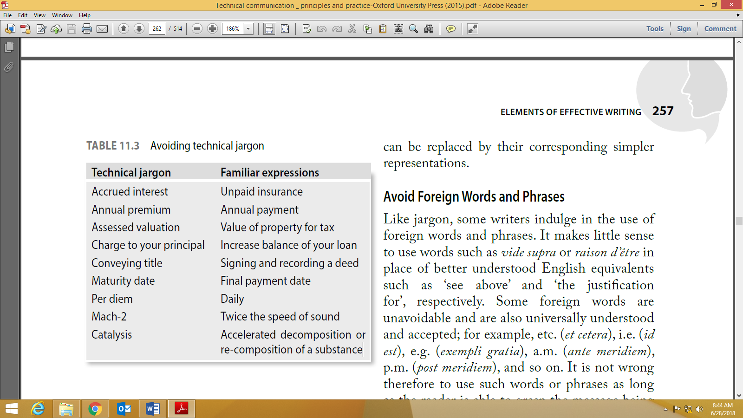

* + **Avoid foreign words and phrases.**
* It makes little sense to use words such as *vide supra* or *raison d’être* in place of better understood English equivalents such as ‘see above’ and ‘the justification for’, respectively.
* Some foreign words are unavoidable and are also universally understood and accepted; for example, etc. (et cetera), e.g. (exempli gratia), a.m. (ante meridiem), p.m. (post meridiem), and so on. It is not wrong therefore to use such words or phrases as long as the reader is able to grasp the message being conveyed.
  + **Avoid redundancy and circumlocution.**

Redundancy is the part of a message that can be eliminated without loss of much information. Some examples of redundant words: ‘basic fundamentals’, ‘return back’.

* + **Avoid discriminatory writing.**

Example:

A sentence such as ‘A student in BITS does his homework well before coming to class.’ shows gender bias, considering the fact that BITS is a co-educational institute.

The use of masculine pronouns can be eliminated in three ways:

1. Rewording the sentence: ‘A student in BITS does the assigned homework well before

coming to class.’

2. By making a dual reference: ‘A student in BITS does his or her home work …’

3. By making the reference plural ‘Students in BITS do their homework …’

Words that stereotype by race, nationality, or sexual orientation must also be avoided.

Terms such as ‘deaf and dumb’, ‘mentally retarded’, and ‘handicapped’ can be replaced with gentler and more humane words such as ‘physically challenged’ or ‘mentally challenged’.

1. **Effective Sentence Construction**

* **Using short sentences**
* Long sentences are usually harder to understand than the shorter ones, as readers can absorb only a few words per glance:

The members of the management of Bharat Textiles Ltd are unable to see their way through the crisis that has engulfed the company, though they are keeping it as a well-guarded secret, not even revealing what ails the company, as they think this necessary for the protection of the image of the company.

* However, using too many short sentences also makes the writing appear jerky and irritating. It will also give an impression of elementary writing (such as writing for children). It is, therefore, a writer’s job to bring in the right mix of simple and complex sentences.

Original: The tinder must be some soft, inflammable material. This may be dry grass, leaves, or wood shavings.

Revised: The tinder must be some soft, inflammable material such as dry grass, leaves, or wood shavings.

* 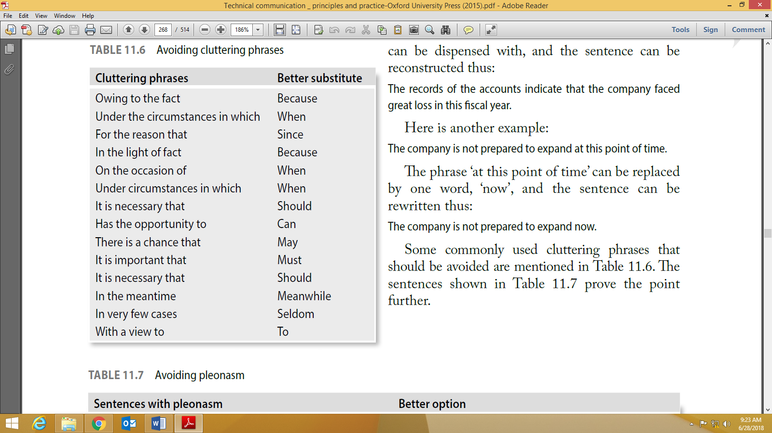
* **Right ordering of words**
* **Active versus Passive Voice**
* **Avoid ambiguous sentences**

*Original*: The delay in transit nearly drove the manager frantic.

*Revised*: The delay in transit drove the manager nearly frantic.

*Original*: Quick Information Systems has bought new computer chairs for the programmers with

more comfortable seats.

*Revised*: Quick Information Systems has bought new computer chairs with more comfortable seats

for the programmers.

1. **Stages of Writing**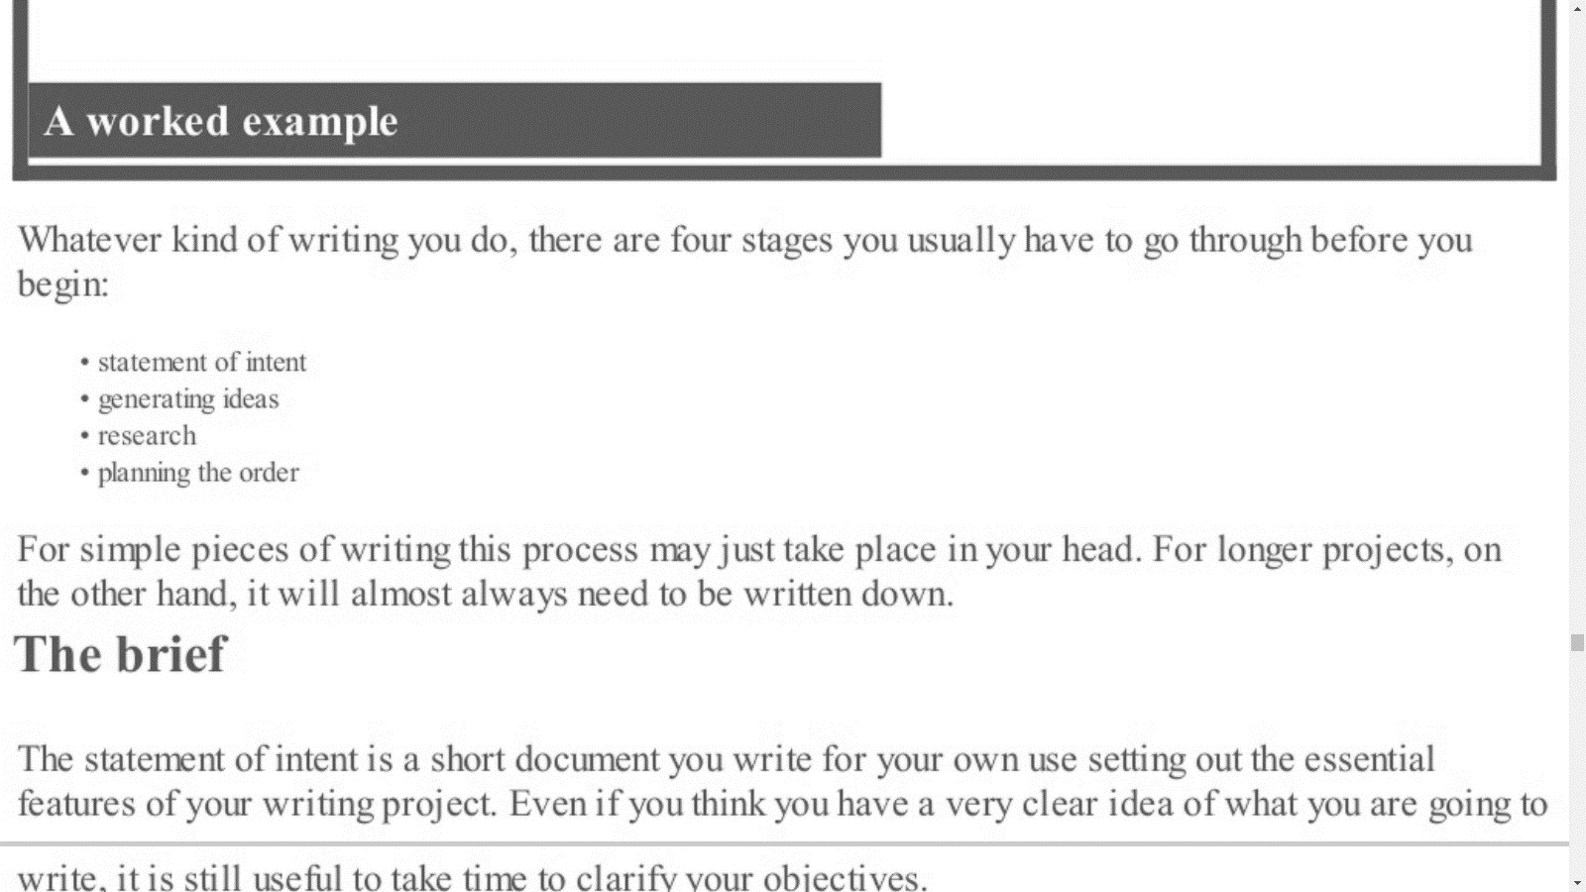
2. **Why and how to paragraph**

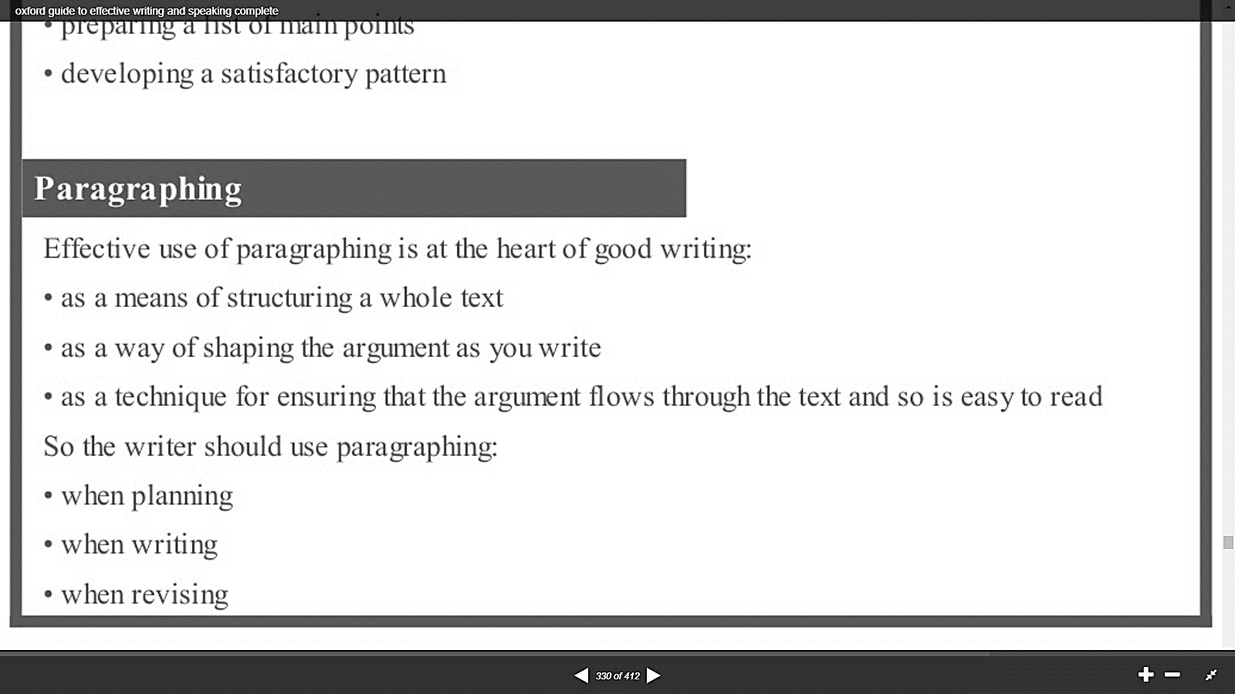

* **Deciding the main points**
* **Using Mind Maps**

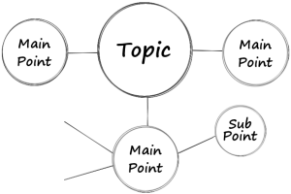

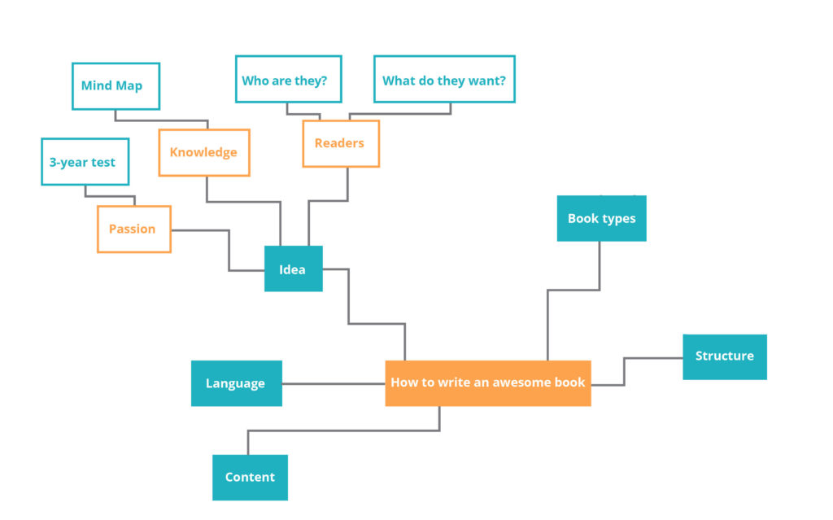

* **An example of paragraph organization:**

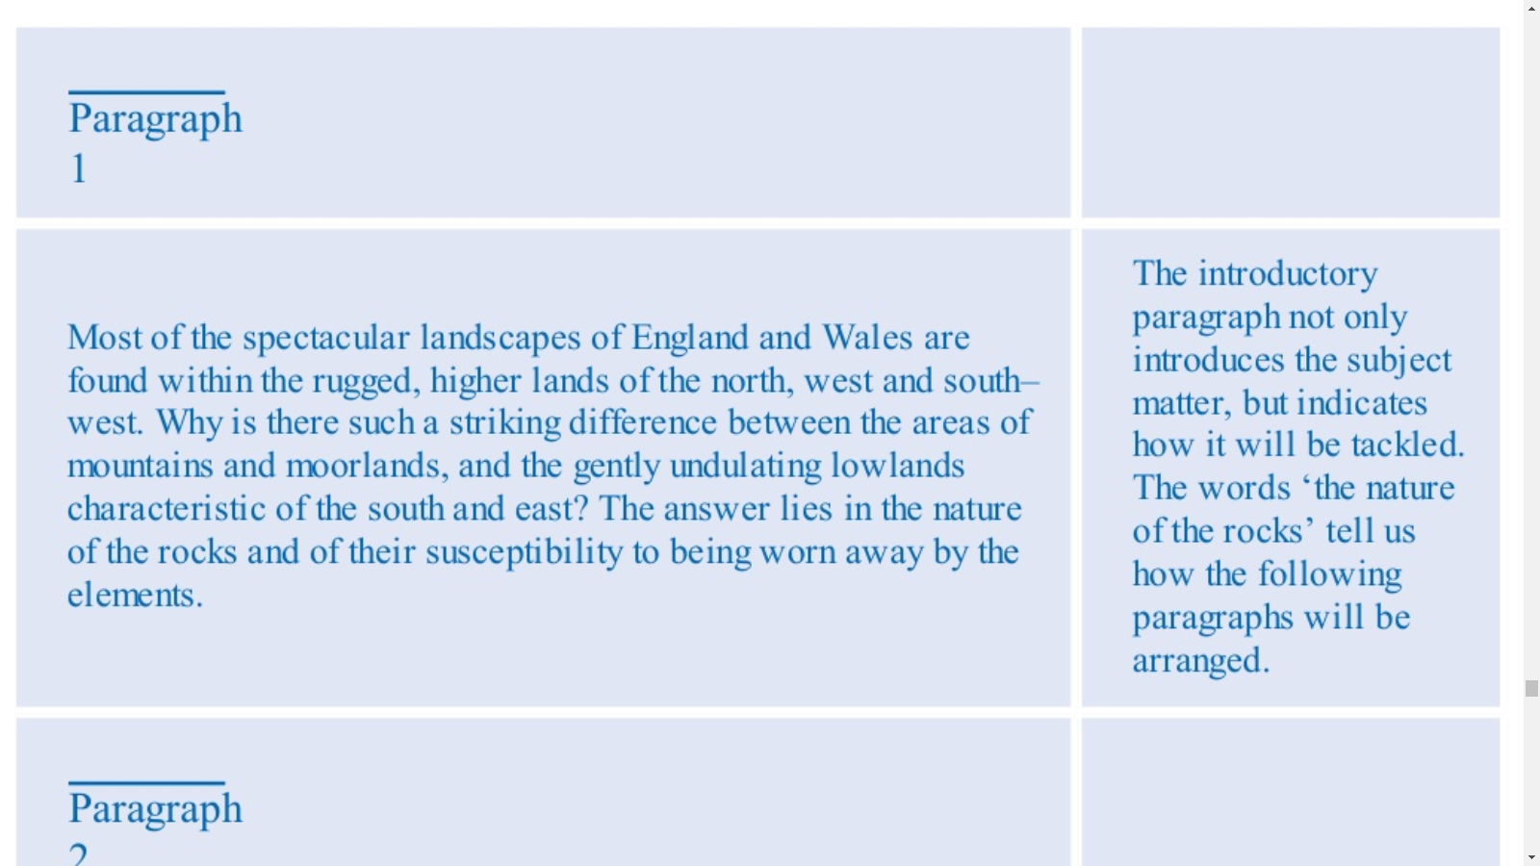

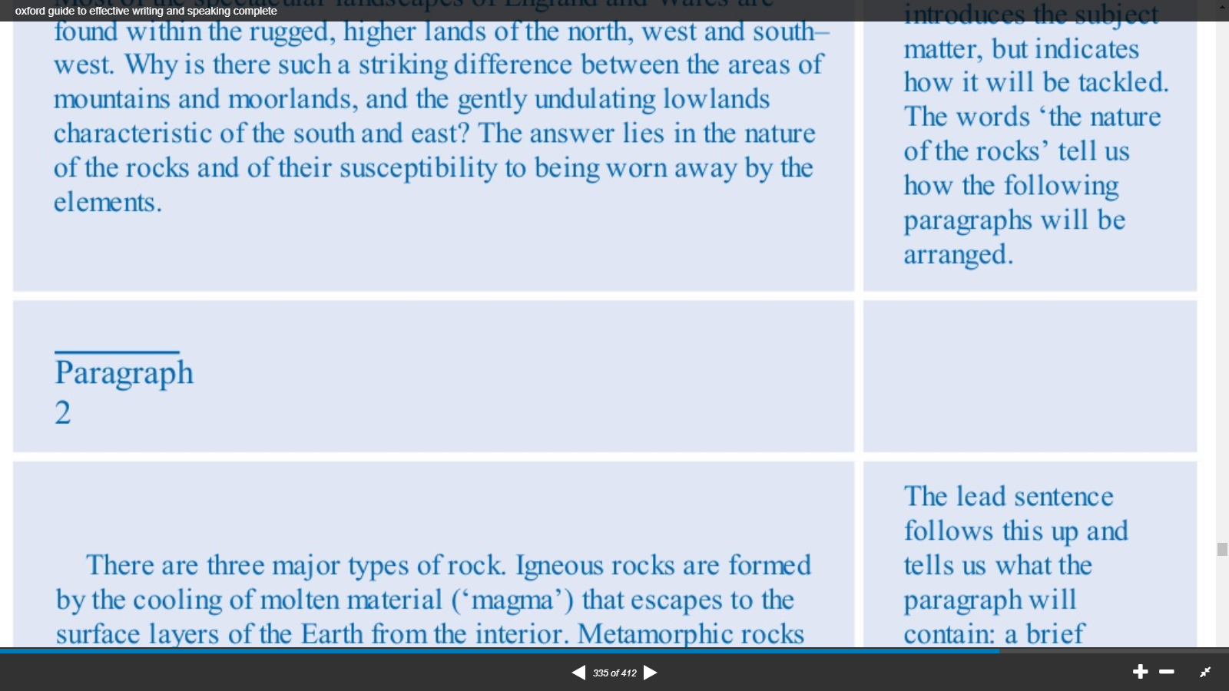

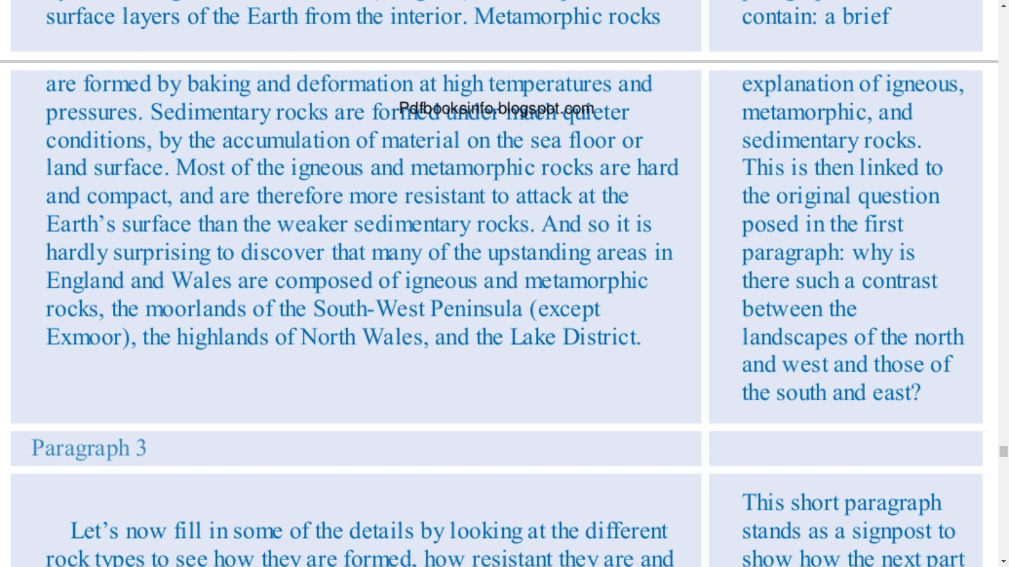

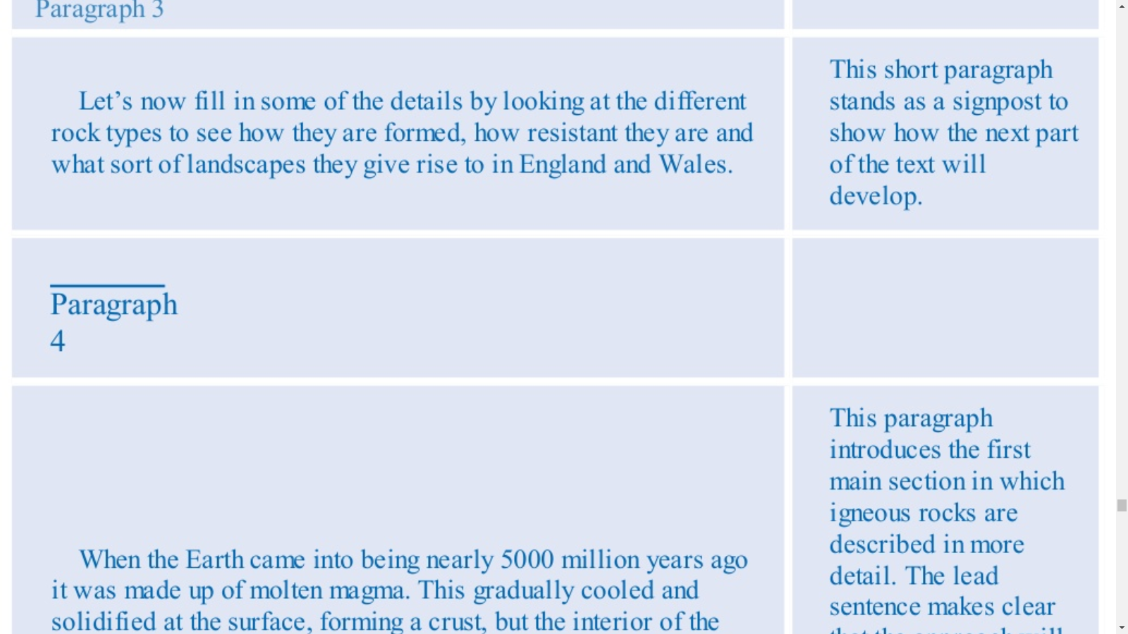

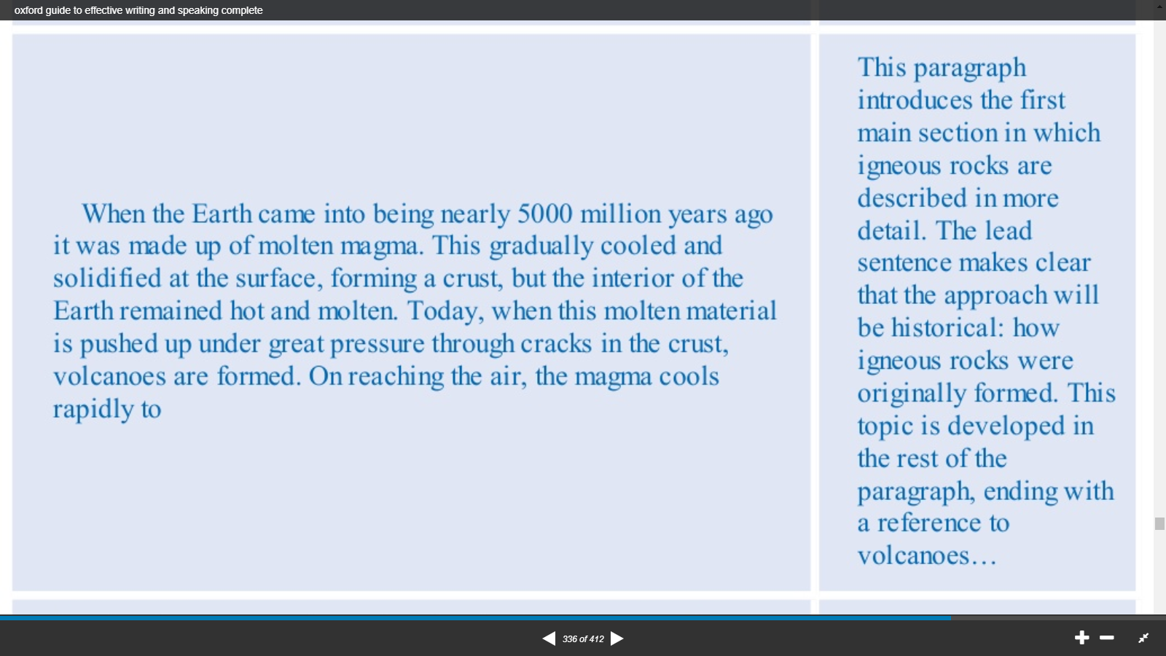

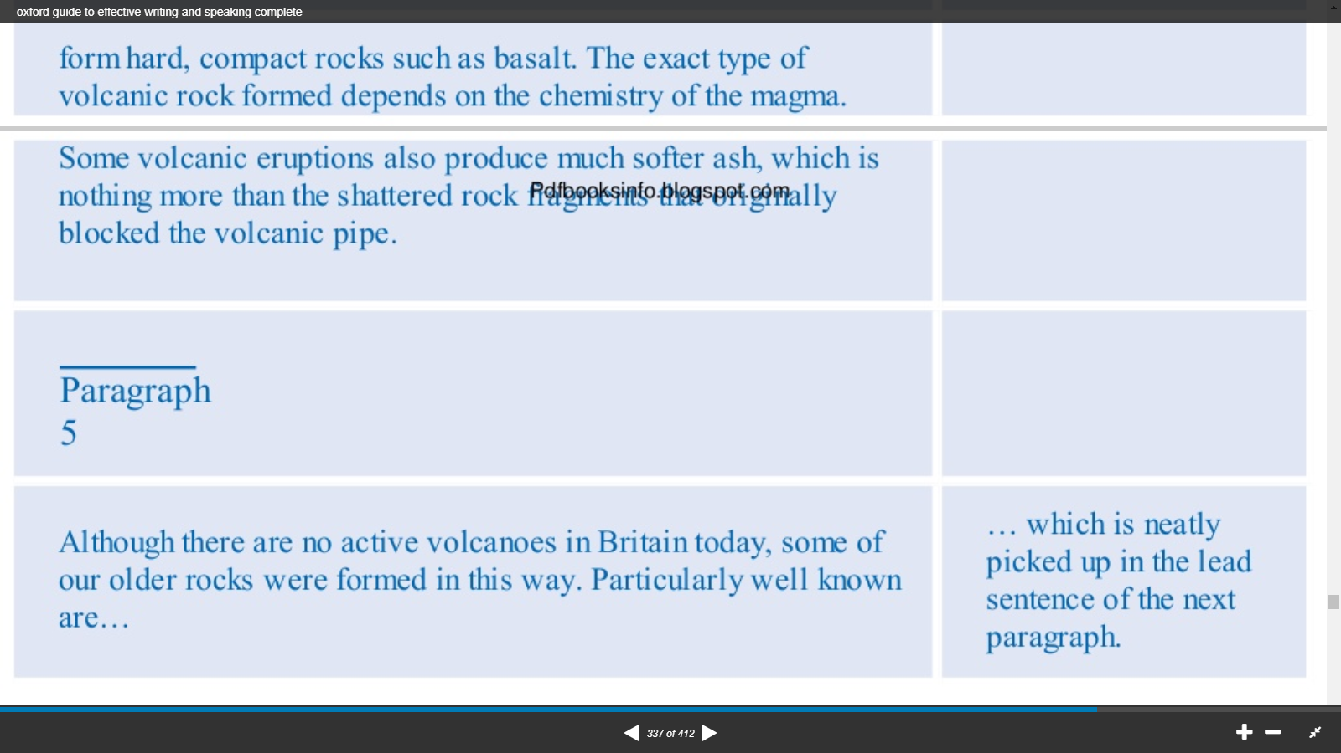

* **Hooks**

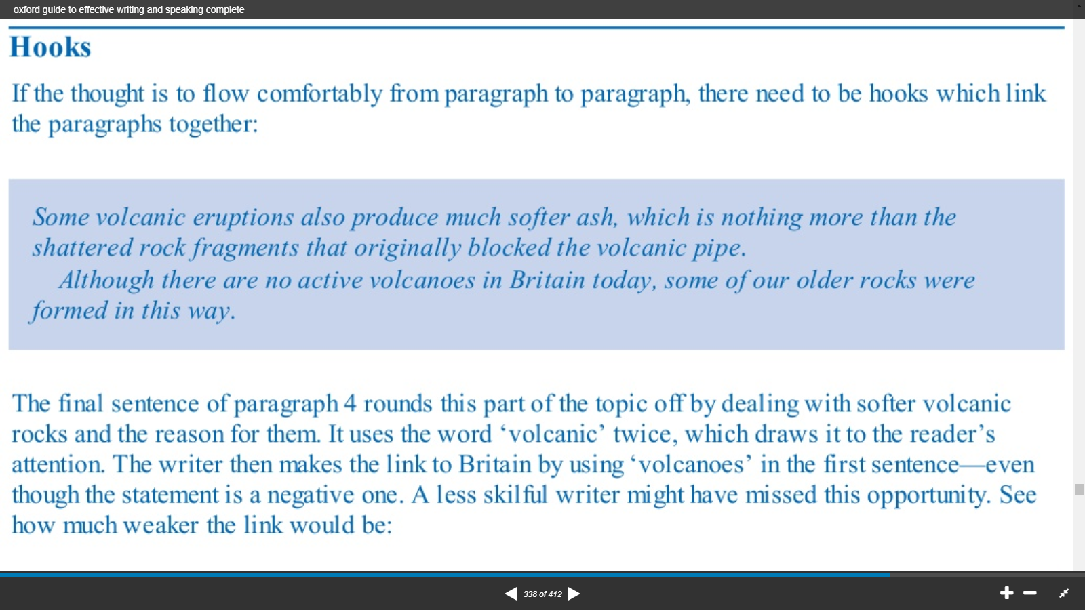

* **The Conclusion of the piece of writing**

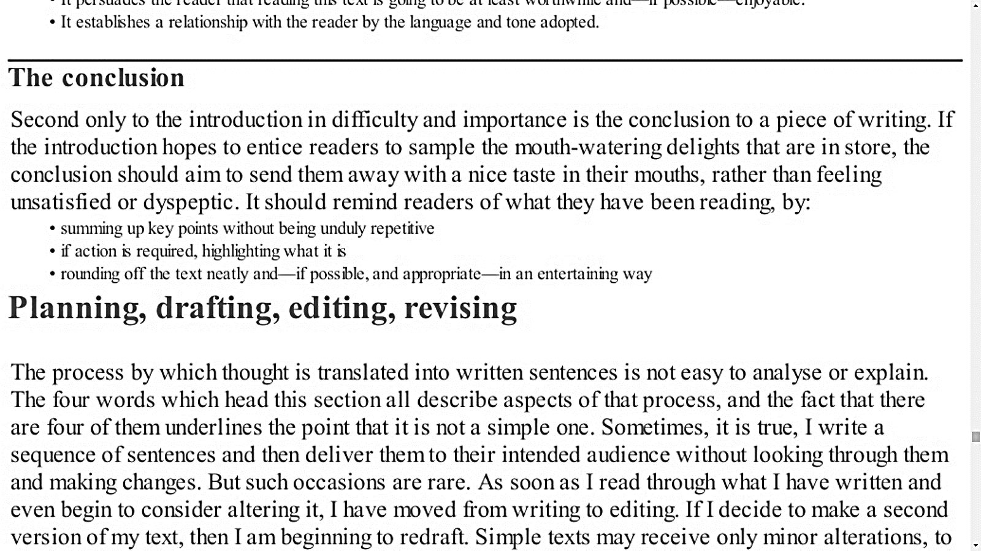

1. **How to organize thoughts within a paragraph**

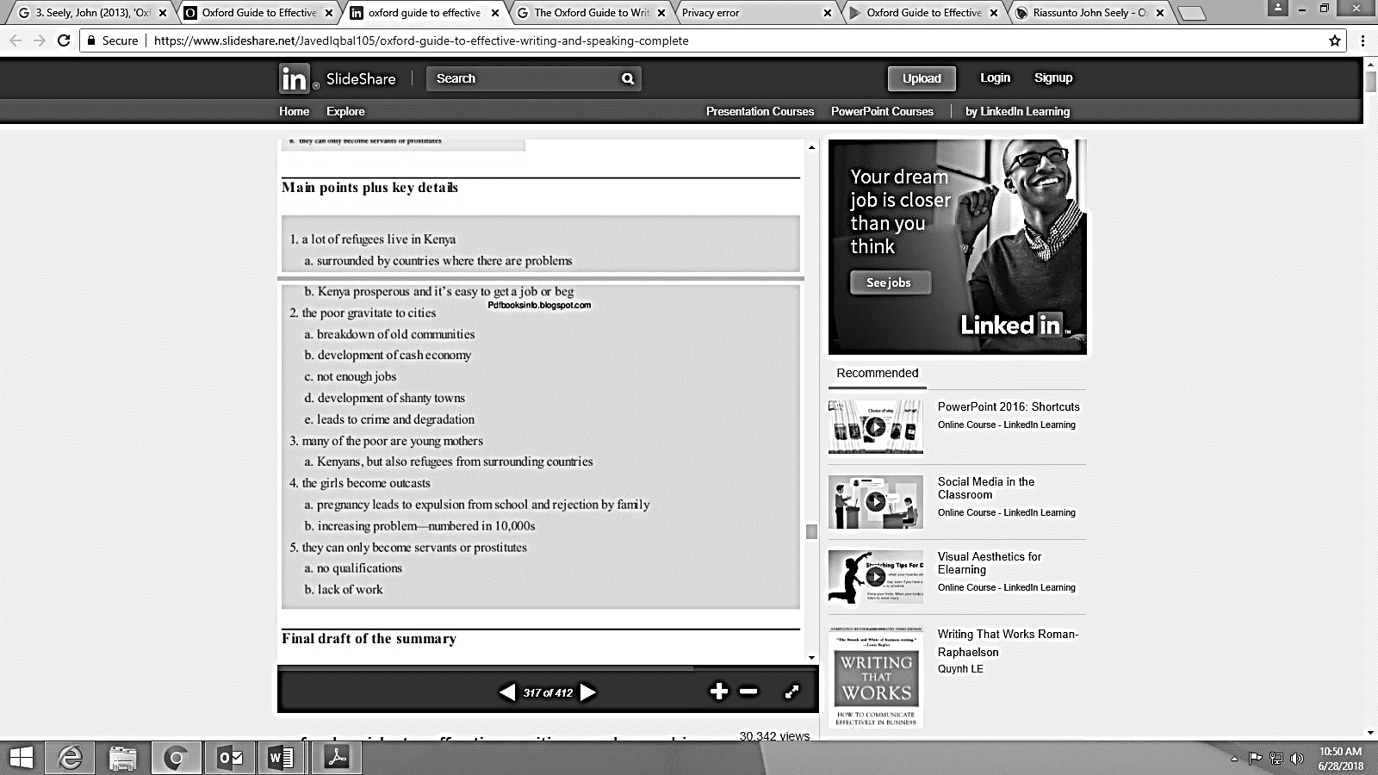

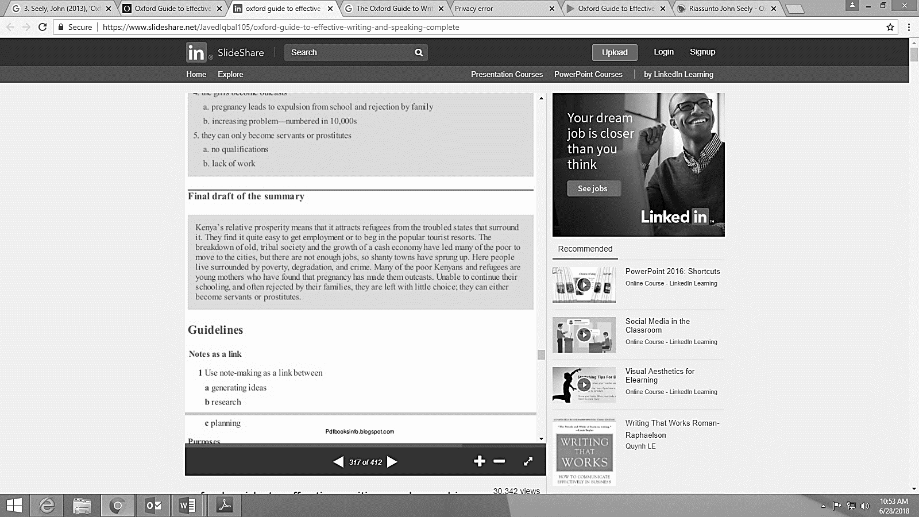

* **The Topic Sentence:**

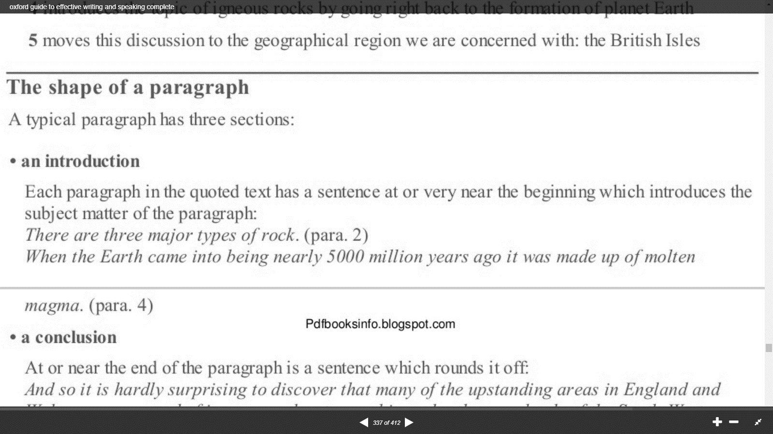

1. **Editing and Revising**

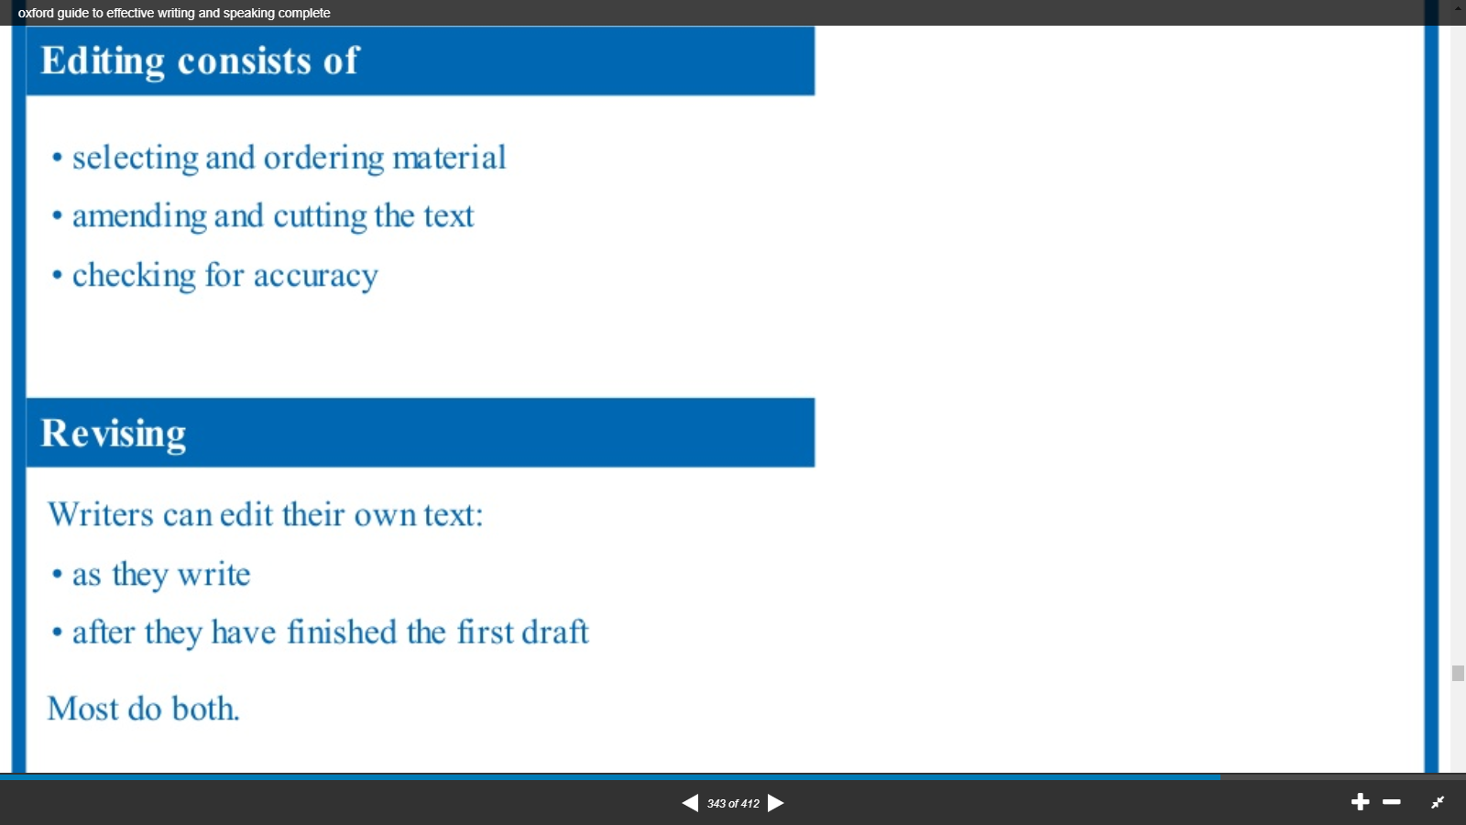

|  |
| --- |
|  |

**Unit 3:** **Identifying Common Errors in Writing (5 hours)**

**1. Subject Verb Agreement:**

In order for the sentence to be a sentence, and the clause to be a clause, the first verb in the sentence and clause must agree in number with the subject. By agree we mean that the number of the verb must match with the number of the subject. For example a singular subject must be paired with the corresponding singular form of the verb, and a plural subject must be paired with the corresponding plural form of the verb:

* The boy **plays** excellent guitar.
* The boys from Harmony **play** excellent guitar.

**RULE #1** In simple present tense, a singular subject takes a plural verb and a plural subject takes a singular verb.

* That apple **looks** fresh.
* Those apples **look** fresh.

**RULE #2** Now, this may cause a grammatical error at times, especially when the subject phrase is long or rather complicated. This particular error is called “Error in agreement with lost subjects” or “The principle of proximity” or “the nearest noun agreement error”. What actually happens is that the subject phrase is so long or complicated that the verb mistakenly agrees with a word that is not the actual subject. For example:

X The cost of all the repairs we needed to make **were** more than we could afford.

√ The **cost** of all the repairs we needed to make **was** more than we could afford.

X The resounding and rhythmic beat of the drums **make** my heart go faster.

√ The resounding and rhythmic **beat** of the drums **makes** my heart go faster.

X The last stage of the thousand meter’s climb **were** tough.

√ The last **stage** of the thousand meter’s climb **was** tough.

X A group of Yachts with brightly coloured banners flying in the wind **were** entering the harbour.

√ A **group** of Yachts with brightly coloured banners flying in the wind **was** entering the harbour.

**Rule # 3 Agreement with compound subjects:** A compound subject is made up of

Two or more nouns or pronouns that are connected by a coordinating conjunction.

* When two nouns or pronouns are connected by **and**, the resulting compound subject takes a plural verb.
* Sanjay and Rakesh **have** passed the test.
* A compound subject that refers to one idea, subject or thing, or to something considered as one unit, takes a singular verb.
* The famous poet, mathematician, and philosopher, Bill Roper, **has** come.
* My neighbour and good friend Sally **has** lived here for years.
* His pride and joy **was** his antique collection.
* His son and heir **is** an accountant in Burbank.
* A compound subject made up of Plural nouns or pronouns that are connected by OR or NOR takes a plural verb.
* Criminals or law breakers are often victims of circumstances.
* A compound subject made up of a singular noun or pronoun that are connected by OR or NOR takes a singular verb.
* A Criminal or a law breaker **is** often a victim of circumstances.
* When a compound subject is made up of singular and plural nouns connected by correlative conjunctions either… or’, ‘neither…nor’ or not only… but also’, the verb agrees with the number of the noun that is closes to the verb.
* Neither the school nor the students **were** interested in the competition.
* Neither the students nor the school **was** interested in the competition.
* Either she or her friends **are** responsible for this mischief.
* Either her friends or she **is** responsible for this mischief.
* Not only my parents but also I **am** regretting the change of the school.
* Not only I but also my parents **are** regretting the change of the school.

**RULE#4** A collective noun takes a singular verb when the noun is regarded as a single unit even though it is made up of separate units.

* The Board of directors **is** united in its opposition to the introduction of a new leave policy.
* The board of directors **are** divided on the issue, sticking to **their** views.

**RULE#5** Indefinite pronouns such as *much, anything, nothing, everything, something, either* and *neither* takes a singular verb.

* Much **was** left unsaid between the two friends.
* Either of the two options **is** good.

**RULE#6** When the subject of a sentence contains the phrase ‘a pair of’, it must be followed by a plural noun and a singular verb. This is because the word pair is singular, though it means two:

* A pair of spectacles **was** found in the classroom.
* Where **is** my new pair of jeans?

**RULE#7** Certain words such as *all, more, most, none, enough, plenty* can either be singular or plural depending on the noun they qualify.

* Most of my work **is** over
* Most of the people **are** not really bothered about others.
* None of my arguments **were/was** accepted as valid. (both was, were are acceptable)

**RULE#8** When the subject of the sentence is contains the phrase *many a*, it must be followed by a singular noun and a singular verb.

* Many a man **has** regretted words spoken in anger.
* In this city, many a road **leads** nowhere.

**RULE#9** Words and phrases that express an amount of money, distance or intervals of time take singular verbs.

* Do you think **fifty miles is** a short distance?
* A **thousand rupees a day is** a good amount of money for this work.
* I am surprised that even **two hours was** not enough for you.

**RULE#10** Title of books magazine etc. take a singular verb even if the title suggests something plural.

* The three Idiots **was** quite a successful film.
* Twenty Thousand Leagues under the Sea **is** written by Jules Verne.

**RULE#11** When the modifier Each or Every is used to modify compound subject, the verb is singular.

* Each senator and representative on the committee **has** one vote.
* Each boy and girl **takes** a turn at drawing games.
* It seems that every town, country and village **has** an Oak Street.

**RULE#12** Agreement with Existential construction using There is/are/was/were: In case of sentences having **There** placed before the noun, the number of the verb is decided by the number of the noun succeeding **there**.

* There **is a fly** in my soup.
* There **are insects** in my soup.

**RULE#13** Words/phrases joined using **along with, as well as,** or **with** take a singular or a plural verb depending on the number of subject.

* The fishing boat with *eight men* **has** gone missing.
* Three planes along with *essential supplies, doctors and volunteers* **have** been sent to the affected area.
* Summer as well as winter **is** extreme here.

**RULE#14** When the subject of a sentence begins with one of, it must be followed by a plural noun and a singular verb.

* One of the students is not wearing proper uniform.
* One of the passengers is complaining of chest pain.

**Exercise: Subject - Verb Agreement:**

1. The number of residents who have been residing in Vasant Kunj are quite small.
2. Two hundred rupees are too much for me to keep in my wallet.
3. A lot of work have to be completed before we go.
4. A lot of people has left the party.
5. The school were forced to close for the day because of the CNG strike.
6. The essence of the matter are therefore this.
7. The news of hijacking are disturbing.
8. Avinasha nd Anurag of St. Mary’s are two of a type.
9. The student Council have to elect the new head girl.
10. Only two boys are noisy and troublesome, the rest is quiet.
11. Some of the pocket money are used.
12. The most famous of such cases were that of the sting operation carried out by the FBI.
13. Neither the judge nor I are ready to announce who the winner is.
14. Poverty as well as low literacy rates have split people into those who have and those who don’t.
15. The private sector is quite possibly the one hope that the disabled has of being accepted.
16. The ability to connect people to information and services are changing global work ethos.
17. Everyone were coughing and squeezing his eyes shut against the burning sensation.
18. Not all of these concerns is baseless, some sound genuine enough.
19. In personal care products, companies like Revlon has actually managed to increase their market share.
20. Two lakh rupees are a lot of money.
21. Army personnel was patrolling the streets in full strength to enforce the curfew.
22. Officially, our shop are only meant to take passport size photos.

**2. Topic- Noun- Pronoun Agreement**

A pronoun is a word that stands for a noun; it saves repeating the noun. The noun that a pronoun stands for is called the antecedent of the pronoun. Pronoun agreement means that a pronoun and its antecedent should match up in a logical way. The two most common areas of needed agreement are number and gender.

* Number agreement requires both the antecedent and the pronoun to be singular or both to be plural.
* Gender agreement requires both the antecedent and the pronoun to be female or both to be male, or a genderless pronoun to be used appropriately to refer to either males or females.

Examples:

1. Early typewriters were cumbersome. Some required a foot pedal to return the carriage.( both typewriters and some are plural and genderless)

2. In 1867 Christopher Sholes built the first typewriter that was considered practical. He later signed a contact with gunsmiths E. Remington and Sons to manufacture his machine. (Christopher Sholes, he and his are all singular and male.)

3. I learned these facts from my grandfather and sister; they collect typewriters. ( The noun grandfather and sister are used together as a plural subject; they is plural. The genderless they can refer to either male or female)

**Some more rules for pronoun agreement:**

# In case of a compound subject including one pronoun, the pronoun always come second.

X I and Rina are going to school.

√ Rina and I are going to school.

# A pronoun in objective case cannot act as subject in a sentence. Neither a pronoun in subjective case can act as an object in the sentence.

X Ravi and Me are planning a party.

√Ravi and I are planning a party.

X This gift is for you and I.

√ This gift is for you and me.

# Reflexive pronouns cannot act as subjects in a sentence.

X Rohit and myself are confident of our success.

√Rohit and I are confident of our success.

# Indefinite Pronouns (all, any, many, more, some, none, each, every) are often involved in agreement errors involving number. Some indefinite pronoun are always plural, some are always singular, and some can be either depending on whether the antecedent is singular or plural. Some indefinite pronouns such as everyone, everything, somebody and anyone-are especially likely to be involved in agreement errors because they seem to be plural but are actually singular.

X Everybody needs to bring their grammar books tomorrow.

√ Everybody needs to bring his/her grammar book tomorrow.

√All the students need to bring their grammar books tomorrow.

# Use who when you need a pronoun of subjective case and whom when you need a pronoun in objective case in the sentence.

X You are speaking to Who?

√You are speaking to whom?

X Whom all are ready?

√Who all are ready?

**Exercise: Pronoun Errors:**

1. Avinash didn’t know who he should take to the party.
2. Everybody ran away to their respective houses on hearing about the arrival of dacoits.
3. The army had to suffer terrible privations in their march.
4. The baby fell from bed and hurt his leg.
5. Each must do their work, do not copy from your neighbor.
6. This is the girl from summer fields School who painting won the first prize at the interschool art competition.
7. I have been informed by Vibhor, Richa and he about the Saturday evening dance.
8. All the students except I are going for the nature walk.
9. People that are too sharp cut their own fingers.
10. One must not be overconfident of his own success.
11. I and Rohit took the initiative.
12. This chocolate box is for you and I.
13. They always talk whom never perform.
14. Ayush and us are going to join the same school.
15. When they have enough money, Karan and her will probably buy a Lancer.
16. The bus leaves Daphne and She at the corner.
17. Do you really believe that Ripul Khanna has blamed us for the punishment, especially, you and I?
18. Among we boys, he is the most intelligent.
19. My mother approves of me acting in movies.
20. The matron insisted on she taking up a break from the hectic studies.
21. Annie and Robert are not dating one another anymore.
22. It was her, Jackie who stayed with Helen for ten years, teaching and encouraging her student.
23. His brilliant passing skills make himself one of the best in the game today.
24. Power enables one to do as he likes.
25. Radha visited Rajeev and I.
26. The fleet will take their position.
27. The female lion is called lioness as it has no mane.
28. Nobody in their right senses would have uttered such foolish remarks
29. The meeting was delayed because of he coming late.
30. The committee decided the matter without leaving its seats.
31. Ravi and Myself are best of friends.
32. The entire emigration process was taken care of by Shambhu and herself.

3. **Topic- Modification**

1**. Misplaced Modifiers:** Sentences containing misplaced modifiers are not ungrammatical. The problem is that misplaced modifiers make sentences say something the writers do not intend to say. A misplaced modifier is a modifier placed in a position where it modifies something that the writer does not intend it to modify. The following example using the modifier *almost* conveys this problem clearly:

- Senator Blathor **almost** spoke for two hours.

Now it is highly unlikely that the sentence means exactly what it says, that the Senator was scheduled to speak for two hours, but mercifully something happened that prevented him from speaking. However it is much more likely that the writer meant to say:

* Senator Blather spoke for **almost** two hours.

In other words, Senator Blather did indeed speak, and the speech lasted for nearly two hours. Most of the misplaced modifiers fall into two main categories:

* Misplaced adverb qualifiers
* Misplaced prepositional phrases

1. **Misplaced Adverb Qualifiers:** Suppose the writer wants to comment on how much cake Bob ate, and he writes this:

* Bob **nearly** ate the whole cake

Unfortunately what the writer actually said is that Bob did not ate any cake at all, although he contemplated eating the whole cake. The problem is with the placement of the adverb *nearly.* It should instead be written like this:

* Bob ate **nearly** the whole cake.

*Nearly, almost, only* and *Just* are some of the adverbs which may cause this particular modification error when used carelessly. When using these adverbs, we need to be aware that they are easily misplaced. We need to check the possibility that they really modify something following the verb-Usually, but not always a noun phrase.

Examples:

# 1. Alice *almost* spent Rs.3000 on a new sound system.

Now did Alice actually spend the amount to buy a new sound system? If she did not, then the adverb *almos*t is correctly placed. However, if she did get her new sound system, then what the writer actually meant was this:

# 1. Alice spent *almost* Rs. 3000 on a new sound system.

#2. We *just* located two vendors for that product.

If the writer meant that they just now located two vendors, then the modifier just is correctly placed. But if the writer meant that they were able to find only two vendors, then this is what the writer should have written:

#2. We located *just* two vendors for the product.

#3. The committee only meets on Wednesdays.

In the above example, the differences are more subtle. The Placement of only in front of the verb meets implies that the committee takes no action at its Wednesday meets. Presumably, the committee takes action at some other time. However suppose the writer really meant to say that the committee has just a single weekly meeting-on Wednesdays. In that case, the adverb needs to follow the verb:

#3. The committee meets only on Wednesdays.

1. **Misplaced Prepositional Phrases:** Prepositional phrases can play two different roles: adjectives and adverbs. One problem with prepositional phrases at the end of the sentence is that the reader interprets the prepositional phrase as one part of speech, while the writer intended the other. Here is one example:

**#1.** The runners stood ignoring the crowd *in their lanes.*

It seems as though the writer is using the prepositional phrase as an adjective modifying *crowd.* The sentence seems to say that the crowd aws in the runners’lanes, a highly unlikely situation. What the writer meant was for the prepositional phrase to be used as an adverb telling us where the runners stood. Here is what the the writer should have written:

#1. The runner stood *in their lanes* ignoring the crowd.

A second problem with the prepositional phrases is that when there is more than pone clause, adverb prepositional phrases can be placed so that they modify the wrong verb. Here is an example of such an adverb prepositional phrase:

#2. He went to a hospital where he underwent emergency surgery *in a limousine*.

On first reading, we interpret the adverb prepositional phrase *in a limousine* as modifying the nearest verb underwent.

X he underwent a surgery *in a limousine.*

√ He went to hospital *in a limousine.*

What the writer meant of course, is for the prepositional phrase to modify the first verb, went :

#2. He went *in a limousine* to a hospital where he underwent emergency surgery.

The best way to monitor for misplaced prepositional phrases is to always make sure the prepositional phrase is directly attached to the word that it should modify. Pay special attention to the prepositional phrases at the ends of sentences. They are the ones most likely to be misplaced.

**2. Squinting Modifiers**: Squinting modifiers are words that are placed at a boundary of two clauses or phrases with the unfortunate result that the reader cannot tell which clause or phrase the adverb should go with. These modifiers are called squinting because they seem to look in two different directions at the same time. Following are the examples of squinting modifiers:

#1.The mayor promised *after her reelection* she would not raise her taxes.

Here, the modifier is the adverb prepositional phrase *after her reelection*. The adverb phrase squints because we can interpret it in two different ways:

* *After her reelection* modifies the preceding verb promised, We can paraphrase the interpretation as:

After the mayor was reelected, she promised that she would not raise taxes.

That is, the mayor has already been elected.

* After the reelection modifies the following verb would raise. We can paraphrase this interpretation as follows:

The mayor promised that after she was reelected, she would not raise taxes.

That is, the mayor is making a promise about what she would do if and when she were reelected.

#2. Students who practice writing *often* will benefit.

The modifier is the adverb *often*. The adverb squints because we can interpret it in two different ways:

* *Often* modifies the preceding verb writing. We can paraphrase this interpretation as follows.

Those students who *often* practice writing are the ones who will benefit.

* *Often* modifies the following verb will benefit. We can paraphrase this interpretation as follows:

Students will *often* benefit when they practice writing.

Sentences containing squinting modifiers are not ungrammatical per se. The problem is that the squinting modifier creates an unintended and undesired ambiguity. Once the writer realizes the confusion, the ambiguity is easily resolved one way or another. The problem, of course, is that the writer sees only the intended meaning, not the unintended one.

There is no simple solution or test for squinting adverbs. Nonetheless, it is helpful for writers to be aware of the condition in which squinting adverbs can occur. Squinting adverbs occur at te boundary between two clauses or phrases. Once writers are aware that this boundary is asquinting adverb danger zone, they can take the extra second to consciously check to see if adverbs at the boundaries can be interpreted in more than one way.

**3. Dangling Modifiers:**

A dangling modifier is said to dangle because it looks like it might fall off the sentence it is attached to. Dangling modifiers are adverbial phrases of various sorts; **participial** and **infinitive phrases** being the most common.

Examples of dangling modifier:

* X *Regretfully declining the desert menu*, the waiter brought us our bill. (Who declined the dessert menu? It sounds like the waiter did.)
* X *Worried about being late*, a taxi seemed like a good idea. (Was the taxi really worried about being late?)
* X *After getting a new job*, my commuting costs have doubled. (Did my commuting costs get a new job?)
* X *To recover from the surgery*, the doctor recommended bed rest. (How’s the doctor feeling now?)

The problem is that the modifier lacks a basic rule of grammar that we call “missing subject”. This principle simply requires that the subject to the adverbial phrase has to be present somewhere in the sentence. It’s ok for the subject not to be immediately placed next to the adverbial phrase as long as it is present somewhere in the rest of the sentence.

√ *Turning the key in the lock*, Holmes quietly slipped into the room.

In this sentence, the subject of the verb turning has been dropped. But in this example, we can find out who did the turning by looking at the subject in the main part of the sentence. It was Holmes: Holmes turned the key in the lock. In other parts, we can legitimately drop the subject Holmes from the modifier because we can get it back from the main sentence.

We can find out if the modifier is dangling or not by a simple two-step process that tests to see if the subject in the modifier has been legitimately dropped:

1.Move a copy of the subject of the main sentence into the subject position of the modifier:

[Holmes] Turning the key in the lock, Holmes quietly slipped into the room.

2. Change the verb in the modifier to past form, so that it agrees with the restored subject.

Holmes turned the key in the lock.

Does this new sentence make sense? If the answer is no, then it is a dangling modifier. If the answer is yes, as in the above example, then the modifier is not dangling.

Let’s apply this two- step process to the first four examples and if needed correct the modification errors.

1. *Regretfully declining the desert menu*, the waiter brought us our bill.

* The waiter, *regretfully declining the desert menu*, the waiter brought us our bill.
* The waiter declined the desert menu.

The waiter regretfully declined the desert menu .This doesn’t make sense because it were the customers who declined the desert menu. Therefore the main sentence has to be rewritten.

* *Reluctantly declining the desert menu*, we asked the waiter for our bill.

1. *Worried about being late*, a taxi seemed like a good idea.

* A taxi*, Worried about being late*, a taxi seemed like a good idea.
* A taxi worried about being late.

This doesn’t make sense. This doesn’t make sense because it were the customers who declined the desert menu. Therefore the main sentence has to be rewritten.

* Worried about being late, we called for a taxi.
* As we were worried about being late, a taxi seemed like a good idea.

1. *After getting a new job*, my commuting costs have doubled.

* My commuting costs , *after getting a new job*, my commuting costs have doubled
* My commuting costs got a new job.

This doesn’t make sense. This doesn’t make sense because it were the customers who declined the desert menu. Therefore the main sentence has to be rewritten.

* After I got a new job, my commuting costs have doubled.
* My commuting costs have doubled after my getting a new job.

*4. To recover from the surgery*, the doctor recommended bed rest.

- The doctor, *to recover from the surgery*, the doctor recommended bed rest.

-The doctor recovered from the surgery.

This doesn’t make sense. This doesn’t make sense because it were the customers who declined the desert menu. Therefore the main sentence has to be rewritten.

* To recover from the surgery, the patient was advised bed rest by the doctor.

**Modification Exercise: Correct the errors in the given sentences:**

1. Having read your letter, my cat will stay indoors until the ducklings fly off.
2. After reading your notes, your case is not supported.
3. Meticulous and Punctual, David’s work ethic is admirable.
4. Having followed a strict high-protein diet, her weight dropped off rapidly.
5. Packing my kit into three huge holdalls, my little Jack Russell could tell a long trip was coming.
6. With a ferocious appetite for extra-curriculum activities, Sergeant Baker's work ethic is remarkable.
7. Upon entering the doctor's office, a skeleton caught my eye.
8. Andrew told us after the holiday that he intends to stop drinking.
9. Running quickly improves your health.
10. We will not sell paraffin to anyone in glass bottles.
11. She saw a moose on the way to the store.
12. He shot a terrorist with an AK-47
13. He bought a dog for his sister called Colin.
14. One morning I shot an elephant in my pajamas.
15. Did you see the bird with the telescope?
16. The pie you baked recently went missing.
17. Those who miss lessons fail the exam frequently.
18. The chef told his students finally the pudding had risen.
19. Janice loves her Barbie only because it was her first doll.
20. Running often is hard.
21. Adopted by the Vermas, high society was entered by Angela.
22. Standing a line, the teacher took the children to McDonalds.
23. After finishing his speech, the audience was invited to ask questions.
24. Scarcely had I reachedthe station, then the train left.
25. Watching the Trilogy back to back on DVD through the evening, the dinner got burnt.
26. Returning from the meeting a few loose papers without signatures caught my attention.
27. The woman bought a dress at the store with green stripes.
28. Looking towards the south a funnel shaped cloud stirred up the dust.
29. Roy couldn’t eat the sandwich the diner with a broken hand.
30. Mary and John nearly watched two hundred movies last year.
31. Vimal almost makes a10 crores a year and still we are living in a rented apartment.

**Topic: Prepositions**

Introduction:

Prepositions are words normally placed before nouns or pronouns .Prepositions can also be followed by verbs but, except after **but** and **except**, the verb must be in the gerund form:

* *He is talking of emigrating.*
* *They succeeded in escaping.*

The student has two main problems with prepositions. He has to know (a) whether in any construction a preposition is required or not, and (b) which preposition to use when one is required.

The first problem can be especially troublesome to a European student, who may find that a certain construction in his own language requires a preposition, whereas a similar one in English does not, and vice versa: e.g. in most European languages purpose is expressed by a preposition + infinitive; in English it is expressed by the infinitive only:

*I came here to study.*

The student should note also that many words used mainly as prepositions can also be used as conjunctions and adverbs. Where this is the case it will be pointed out in the following paragraphs.

**Alternative position of prepositions**

*A) Prepositions normally precede nouns or pronouns. In two constructions, however, it is possible in informal English to move the preposition to the end of the sentence:*

In questions beginning with a preposition **+ whom/which/what/whose/where**:

*-To whom were you talking?* (formal)

*-Who were you talking to?* (informal)

*-In which drawer does he keep it?* (formal)

*-Which drawer does he keep it in?* (informal)

It used to be thought ungrammatical to end a sentence with a preposition, but it is now accepted as a colloquial form. Similarly in relative clauses, a preposition placed before whom/which (can be moved to the end of the clause. The relative pronoun is then often omitted:

*-the people with whom I was travelling* (formal)

*-the people I was travelling with* (informal)

*-the company from which I hire my TV set* (formal)

-*the company I hire my TV set from* (informal)

B) But in phrasal verbs the preposition/adverb remains after its verb, so the formal type of construction is not possible, *the children I was looking after* could not be rewritten with **after + whom** and *Which bridge did they blow up?* Could not be rewritten with **up + which**.

Omission of *to* and *for* before indirect objects:

A sentence such as I gave the book to Tom could also be expressed :

*-I gave Tom the book*, i.e. the indirect object can be placed first and the preposition to omitted.

We can use this construction with the following verbs: *bring, give, hand, lease* (in a will), *lend, offer, pass* (= hand), *pay, play* (an instrument/piece of music), *promise, sell, send, show, sing, take, tell* (= narrate, inform):

* *I showed the map to Bill = I showed Bill the map.*
* *They sent £5 to Mr Smith = They sent Mr Smith £5.*

*Similarly* I'll find a job for Ann *could be expressed* I'll find Ann a job *(putting the indirect object first and omitting* ***for****). This construction is possible after* book, build, buy, cook*, (*bake, boil, fry *etc.).* fetch, find, get, keep, knit, leave, make, order, reserve*:*

*-I'll get a drink for you = I'II get you a drink.*

*-I bought a book for James = I bought James a book.*

Normally either construction can be used. But:

*The construction without preposition is preferred when the direct object is a phrase or a clause:*

* *Tell her the whole story.*
* *Show me what you’ve got in your hand.*

*The construction with preposition is preferred:*

*(*a) When the indirect object is a phrase or a clause:

* *We kept seats for everyone on our list/for everyone who had paid.*
* *I had to show my pass to the man at the door.*

(b) When the direct object is **it** or **them**. Sentences such as *They kept it for Mary, She made them for Bill, We sent it to George* cannot be expressed by a verb + noun + pronoun construction.

If the indirect object is also a pronoun (*I sent it to him*) it is sometimes possible to reverse the pronouns and omit to (*I sent him if*), but this cannot be done with for constructions and is better avoided.

This restriction does not apply to other pronoun objects:

* *He gave Bill some. He didn't give me any.*
* *He bought Mary one. I'll show you something.*

C. *promise, show, tell* can be used with indirect objects only, without to:

*-promise us, show him, tell him*

*read, write* can be used similarly, but require to:

* *read to me ,write to them*

*play, sing* can be used with to or for:

* *play to us, play for us, sing to us, sing for us*

**Use and omission of to with verbs of communication**

Verbs of command, request, invitation and advice, e.g. *advise, ask, beg, command, encourage, implore, invite, order, recommend, remind, request, tell, urge, warn*, can be followed directly by the person addressed (without to) + infinitive:

* *They advised him to wait.*
* *I urged her to try again.*

The person addressed (without to) can be used after *advise, remind, tell, warn* with other constructions also:

* *He reminded them that there were no trains after midnight.*
* *They warned him that the ice was thin/warned him about the ice*

But note that *recommend* (= advise) when used with other constructions needs to before the person addressed:

* *He recommended me to buy it* but *He recommended it to me.*
* *He recommended me (for the post)* would mean *'He said I was suitable'.*

When **ask** is used with other constructions the person addressed is often optional. The preposition to is never used here:

* *He asked (me) a question.*
* *He asked (me) if I wanted to apply.*
* *She asked (her employer) for a day off.*

*call* (= shout), *complain, describe, explain, grumble, murmur, mutter*, *say, shout, speak, suggest, talk, whisper* need **to** before the person addressed, though it is not essential to mention this person:

* *Peter complained (to her) about the food.*
* *She said nothing (to her parents).*
* *He spoke English (to them).*

shout at can be used when the subject is angry with the other person:

* *He shouted at me to get out of his way.*

compare with He shouted to me which means he raised his voice because I was at a distance.

**Time and date: at, on, by, before, in**

A. **at, on**

**-at** a time:

*-at dawn ;at six; at midnight ;at 4.30 .*

* **at** an age:
* *at sixteen/at the age of sixteen*
* *She got married at seventeen.*
* **on** a day/date:
* *on Monday; on 4 June; on Christmas day*

**Exceptions:**

* *at night*
* *at Christmas*, *at Easter* (the period, not the day only)

on the morning/afternoon/evening/night of a certain date:

* *We arrived on the morning of the sixth.*
* It is also, of course, possible to say:

*this/next Monday etc., any Monday, one Monday*

B. **by, before**

**- by** a time/date/period = at that time or before/not later than that date. It often implies 'before that time/date':

*- The train starts at 6.10, so you had better be at the station by 6.00.*

**- by** + a time expression is often used with a perfect tense, particularly the future perfect (see 216):

*- By the end a/July I'll have read all those books.*

**before** can be preposition, conjunction or adverb:

* *Before signing this . .* . (preposition)
* *Before you sign this . . .* (conjunction)
* *I've seen him somewhere before.* (adverb)

C. **on time, in time, in good time**

* **on time** = at the time arranged, not before, not after:
* The 8.15 train started on time. (It started at 8.15.)

**in time/in time for** + noun = not late; in good time (for) = with a comfortable margin:

* *Passengers should be in time for their train.*
* *I arrived at the concert hall in good time (for the concert).* (Perhaps the concert began at 7:30 and I arrived at 7:15.)

D. **on arrival, on arriving, on reaching, on getting to**

**- on arrival/on arriving, he** . . . = when he arrives/arrived, he ...

**- on** can also be used similarly with the gerund of certain other verbs (chiefly verbs of information):

*- On checking, she found that some of the party didn't know the way.*

*- On hearing/Hearing that the plane had been diverted, they left the airport.*

The **on** in the last sentence could be omitted.

E. at **the beginning/end, in the beginning/end, at first/at last**

* **at the beginning (of)/at the end (of)** = literally at the beginning/end:

*-At the beginning of a book there is often a table of contents.*

*- At the end there may be an index.*

**- in the beginning/at first** = in the early stages. It implies that later on there was a change:

*- In the beginning/At first we used hand tools. Later we had machines.*

**- in the end/at last** = eventually/after some time:

- *At first he opposed the marriage, but in the end he gave his consent.*

**Time: from, since, for, during**

* **from**, since and for
* **from** is normally used with **to** or **till/until**:

*Most people work from nine to five*

* **from** can also be used of place:

*Where do you come from?*

* **since** is used for time, never for place, and means 'from that time to the time referred to'. It is often used with a present perfect or past perfect tense

*He has been here since Monday,* (from Monday till now)

*He wondered where Ann was. He had wit seen her since their quarrel.*

* **since** can also be an adverb (see 37, 185-8):

*He left school in 1983. I haven't seen him since.*

* **since** can also be a conjunction of time:

*He has worked for us ever since he left school.*

*It is two years since I last saw Tom = last saw Tom two years ago/I haven't seen Tom for two years.*

* **for** is used of a period of time: **for six years, for two months**,
* **for ever**:

*Bake it/or two hours.*

*He traveled in the desert for six months.*

For + a period of time can be used with a present perfect tense or past perfect tense for an action which extends up to the time of speaking:

*He has worked here for a year.* (He began working here a year ago and still works here.)

* **for** used in this way is replaceable by **since** with the point in time when the action began:

*He has worked here since this time last year.*

* **during** and **for**
* **during** is used with known periods of time, i.e. periods known by name, such as Christmas, Easter or periods which have been already refilled:

*during the Middle Ages during 1941*

*during the summer (of that year)*

*during his childhood*

*during my holidays*

The action can either last the whole period or occur at some time within period:

*It rained all Monday but stopped raining during the night.* (at some point of time)

*He was ill for a week, and during that week he ate nothing.*

* **for** (indicating purpose) may be used before known periods:

*I went there/I hired a car/I rented a house for my holidays/for the summer.*

* **for** has various other uses: ;

*He asked for £5. I Raid £1 for it.*

* *I bought one for Tom.* (See 88.)
* **for** can also be a conjunction and introduce a clause).

Time: **to, till/until, after, afterwards** (adverb)

* **to** and **till/until**
* **to** can be used of time and place; **till/until** of time only.
* We can use **from** ... **to** or **from** . . . **till/until**:

*They worked from five to ten/from five till ten. (at five to ten would mean 'at 9:55'.)*

* But if we have no from we use till/until, not to:

*Let's start now and work till dark. (to would not be possible here.)*

* **till/until** is often used with a negative verb to emphasize lateness:

*We didn't get home till 2 a.m.*

*He usually pays me cm Friday but last week he didn't pay me till the following Monday.*

* **till/until** is very often used as a conjunction of time:

*We 'II stay here fill it stops raining.*

*Go on till you come to the level crossing.*

* But note that if 'you come to' is omitted, the till must be replaced by to:

*Go on to the level crossing.*

*B* ***after*** *and* ***afterwards*** *(adverb)*

* **after** (preposition) must be followed by a noun, pronoun or gerund:

*Don't bathe immediately after a meal/after eating.*

*Don't have a meal and bathe immediately after it.*

* If we do not wish to use a noun/pronoun or gerund, we cannot use **after**, but must use **afterwards** (= **after that**) or **then**:

*Don't have a meal and bathe immediately afterwards.*

*They bathed and afterwards played games/played games afterwards* or

*They bathed and then played games.*

* **afterwards** can be used at either end of the clause and can be modified by **soon, immediately, not long** etc.:

*Soon afterwards we got a letter.*

*We got a letter not long afterwards.*

* **after** can also be used as a conjunction:

*After he had tuned the piano it sounded quite different.*

A Travel and movement: **from, to, at, in, by, on, into, onto, off, out, out of**

* We travel **from** our starting place to our destination:

*They flew/drove/cycled/walked from Paris to Rome.*

*When are you coming back to England?*

We also send/post letters etc. to people and places. (But see note on home below.)

* **arrive at/in, get to, reach** (without preposition)
* We **arrive** in a town or country, **at** or **in** a village, at any other destination:

*They arrived in Spain/in Madrid.*

*I arrived at the hotel/at the airport/at the bridge/at the crossroads.*

* get to can be used with any destination, and so can reach:

*He got to the station just in time for his train.*

*I want to get to Berlin be fore dark.*

*They reached the top of the mountain before sunrise.*

* **get in** (**in** = adverb) can mean 'arrive at a destination'. It is chiefly used of trains:

*What time does the train gel in?* (reach the terminus/our station)

* Note also get there/back (there, back are adverbs).
* **home**
* We can use a verb of motion etc. + home without a preposition:

*I took us an hour to get home.*

*They went home by bus.*

* But if **home** is immediately preceded by a word or phrase a preposition is necessary:

*She returned to her parents' home.*

* We can **be/live/stay/work** etc. **at home, at + . . . + home** or **in + . . . + home**. But in cannot be followed directly by home:

*You can do this sort of work at home or at/in your own home.*

* Transport: **by, on, get in/into/on/onto/off/out of**
* We can travel by car (but **in** the/my/Tom's car), **by** bus/train/plane/helicopter/hovercraft etc. and **by** sea/air. We can also travel **by** a certain route, or **by** a certain place (though via is more usual):

*We went by the M4. We went via Reading.*

* We can walk or go **on** foot. We can cycle or go **on** a bicycle or **by** bicycle. We can ride or go **on** horseback.
* We get **into** a public or private vehicle, or get **in** (adverb).
* We get **on/onto** a public vehicle, or get **on** (adverb).
* But we go **on board** a boat (= embark).
* We get **on/onto** a horse/camel/bicycle.
* We get **out of** a public or private vehicle, or get **out** (adverb).
* We get **off** a public vehicle, a horse, bicycle, etc., or get **off** (adverb).
* **get in/into/out/out of** can also be used of buildings, institutions and countries instead of **go/come/return** etc. when there is some difficulty in entering or leaving, in and out here are used as adverbs.

*I've lost my keys! How are we going to get into the flat/to get in?* (adverb)

*The house is on fire! We had better get out!* (adverb)

*It's difficult to get into a university nowadays.*

*F Giving directions:* ***at, into, to*** *etc. (prepositions),* ***along, on*** *(prepositions and adverbs) and* ***till*** *(conjunction):*

*Go along the Strand till you see the Savoy on your right.*

*The bus stop is just round the comer.*

*Turn right/left at the Post Office/at the second traffic lights.*

*Go on (adverb) past the post office.*

*Turn right/left into Fleet Street.*

*Take the first/second etc. turning on/to the right or on/to your right.*

*Go on (adverb) to the end of the road. (till could not be used here.)*

*You will find the bank on your left halfway down the street.*

*When you come out of the station you will find the bank opposite you/in front of you.*

*Get out (of the bus) at the tube station and walk on (adverb) till you come to a pub.*

*Get off (the bus! and walk back (adverb) till you come to some traffic lights.*

* **at, in; in, into; on, onto**
* **at** and **in**
* **at**
* We can be **at** home, **at** work, **at** the office, **at** school, **at** university, **at** an address, **at** a certain point e.g. **at** the bridge, **at** the crossroads, **at** the bus-stop.

**in**

* We can be **in** a country, a town, a village, a square, a street, a room, a forest, a wood, a field, a desert or any place which has boundaries or is enclosed.
* But a small area such as a square, a street, a room, a field might be used with at when we mean 'at this point' rather than 'inside'.
* We can be in or at a building, in means inside only; at could mean inside or in the grounds or just outside. If someone is 'at the station' he could be in the street outside, or in the ticket office/waiting room/restaurant or on the platform.
* We can be **in** or **at** the sea, a river, lake, swimming pool etc.
* **in** here means actually in the water:

*The children are swimming in the river.*

* **at** the sea/river/lake etc. means 'near/beside the sea'. But **at** sea means 'on a ship'.

- **in** and **into**

**- in** as shown above normally indicates position.

**- into** indicates movement, entrance:

*They climbed into the lorry. I poured the beer info a tankard.*

*Thieves broke info my house/My house was broken into.*

* With the verb **put**, however, either **in** or **into** can be used:

*He put his hands in/into his pockets.*

* **in** can also be an adverb:

*Come in* = Enter. *Get in* (into the car).

- **on** and **onto**

**- on** can be used for both position and movement:

*He was sitting on his case. Snow fell on the hills.*

*His name is on the door. He went on board ship.*

* **onto** can be used (chiefly of people and animals) when there is movement involving a change of level:

*People climbed onto their roofs. We lifted him onto the table.*

*The cat jumped onto the mantelpiece.*

* **on** can also be an adverb:

*Go on. Come on.*

**above, over, under, below, beneath** etc.

* **above** and **over**
* **above** (preposition and adverb) and over (preposition) can both mean 'higher than' and sometimes either can be used:

*The helicopter hovered above/over us.*

*Flags waved above/over our heads.*

* But over can also mean 'covering', 'on the other side of’, 'across' and ‘from one side to the other':

*We put a rug over him.*

*He lives over the mountains.*

*There is a bridge over the river.*

* **all over** + noun/pronoun can mean 'in every part of:

*He has friends all over the world.*

* **above** can have none of these meanings.
* **over** can mean 'more than' or 'higher than'.
* **above** can mean 'higher than' only.
* Both can mean 'higher in rank'. But He is over me would normally mean ‘He is my immediate superior', 'He supervises my work', above would not necessarily have this meaning.
* We have a bridge over a river, *above the bridge* means úpstream’.
* **over** can be used with meals/food/drink:

*They had a chat over a cup of tea.* (while drinking tea)

* in the combination **take** + a time expression + **over** + noun/pronoun,
* **over** can mean 'to do/finish' etc.:

*He doesn't fake long over lunch/to eat his lunch.*

*He took ages over the job*. (He took ages to finish it.)

* **above** can also be an adjective or adverb meaning 'earlier' (in a book, article etc.):

*the above address* (the previously mentioned address)

* **below** and **under**
* **below** (preposition and adverb) and under (preposition) can both mean 'lower than' and sometimes either can be used. But **under** can indicate contact:

*She put the letter under her pillow.*

*The ice crackled under his feet.*

* With **below** there is usually a space between the two surfaces:

*They live below us.* (We live on the fourth floor and they live on the third.)

Similarly: *We live above them.*

* **below** and **under** can mean 'junior in rank'. But *He is under me* implies that I am his immediate superior, **below** does not necessarily have this meaning.
* (Both **over** and **under** can be used as adverbs, but with a change of meaning,)

- **beneath** can sometimes be used instead of **under**, but it is safer to keep it for abstract meanings:

*He would think it beneath him to tell a lie.* (unworthy of him)

*She married beneath her.* (into a lower social class)

* **beside, between, behind, in front of, opposite**

Imagine a theatre with rows of seats: A, B, C etc.. Row A being nearest the stage.

Stage

Row A Tom Ann Bill

Row B Mary Bob Jane

This means that:

*Tom is beside Ann; Mary is beside Bob etc.*

*Ann is between Tom and Bill; Bob is between Mary and Jane.*

*Mary is behind Tom; Tom is in front of Mary.*

* But if Tom and Mary are having a meal and Tom is sitting at one side of the table and Mary at the other, we do not use **in front of**, but say:

*Tom is sitting opposite Mary or Tom is facing Mary.*

* But *He stood in front of me* could mean either *'He stood with his back to me*' or *'He faced me'*.
* People living on one side of a street will talk of the houses on the other side as *the houses opposite* (us) rather than *the houses in front of us*. With other things, however, these restrictions do not apply:

*She put the plate on the table in front of him.*

*She sat with a book in front of her.*

*Where's the bank? - There it is, just in front of you!*

*There's a car-park in front of/at the back of the hotel.*

*E Don't confuse* ***beside*** *with* ***besides****.*

* **beside** = at the side of:

*We camped beside a lake.*

* **besides** (preposition) = in addition to/as well as:

*I do all the cooking and besides that I help Tom.*

*Besides doing the cooking I help Tom.*

* **besides** (adverb) means (a) 'in addition to that/as well as that':

I do the cooking and help Tom besides

and (b) 'in any case/anyway':

*We can't afford oysters. Besides, Tom doesn't like them.*

* **between** and **among**
* **between** normally relates a person/thing to two other people/things,
* but it can be used of more when we have a definite number in mind;

*Luxembourg lies between Belgium, Germany and France.*

* **among** relates a person/thing to more than two others; normally we have no definite number in mind:

*He was happy to be among friends again.*

*a village among She hills*

* **with** could also be used instead of **among** in the last sentence above.

Also, of course, with a singular object:

*He was with a friend.*

Examples of other uses:

*He cut it with a knife.*

*Don't touch it with bare hands.*

*The mountains were covered with snow.*

*I have no money with me/on me.*

*He fought/quarreled with everyone.*

In descriptions:

*the girl with red hair*

*the boy with his hands in his pockets*

*the man with his back to the camera/with his feet on his desk*

* **but** and **except** (prepositions)

These have the same meaning and are interchangeable.

* **but** is more usual when the preposition + object is placed immediately rafter nobody/none/nothing/nowhere etc;

*Nobody but Tom knew the way.*

*Nothing but the best is sold in our shops.*

* **except** is more usual when the preposition phrase comes later in the sentence:

Nobody knew the way except Tom

* **but** is more emphatic than **except** after *anybody/anything/anywhere* etc.:

You can park anywhere but/except here. (You can't park here.)

* **but** and **except** take the bare infinitive (see 98).

**Prepositions used with adjectives and participles**

Certain adjectives and past participles used as adjectives can be followed by a preposition + noun/gerund.

Usually particular adjectives and participles require particular prepositions. Some of these are given below; others can be found by consulting a good dictionary, which after any adjective will give the prepositions that can be used with it.

* **about, at, for, in, of, on, to, with** used with certain adjectives and participles:

*absorbed in involved in*

*according to keen on*

*accustomed to*

*liable for/to*

*afraid of*

*nervous of*

*anxious for/about*

*owing to*

*ashamed of*

*pleased with*

*aware of*

*prepared for*

*bad at/for*

*proud of*

*capable of*

*ready for*

*confident of*

*responsible for/to*

*due to/for*

*scared of*

*exposed to*

*sorry for/about*

*fit for*

*successful in*

*fond of*

*suspicions of*

*frightened of/at*

*terrified of*

*good at/for*

*tired of*

*interested in*

*used to*

* She is afraid/frightened/scared of the dark.
* According to Tom it's 2.30. (Tom says it's 2:30.)
* He is bad/good at chess, (a bad/good player)
* Running is bad/good for you. (unhealthy/healthy)
* They are very keen on golf.
* Drivers exceeding the speed limit are liable to a fine.
* The management is not responsible for articles left in customers' cars.
* I'm sorry for your husband. (I pity him.)
* I'm sorry for forgetting the tickets.
* I'm sorry about the tickets.

**Verbs and prepositions**

A large number of verb + preposition combinations are dealt with in chapter 38. But there are a great many other verbs which can be followed by prepositions and some of these are listed below. More can be found in any good dictionary.

*accuse of*

*insist on*

*apologize to / for*

*live on (food/money)*

*apply to /for*

*long for*

*ask for/about*

*object to*

*attend to*

*occur to*

*beg for*

*persist in*

*believe in*

*prefer to*

*beware of*

*prepare for*

*blame for*

*punish for*

*charge with (an offence)*

*quarrel with /about*

*compare with*

*refer to*

*comply with*

*rely on*

*conform to*

*remind of*

*consist of*

*resort to*

*deal in*

*succeed in*

*depend on*

*suspect of*

*dream of*

*think of/about*

*fight with/ for*

*wait for*

*fine for*

*warn of/about*

*hope/or wish for*

* *He was absorbed in his book.*
* *Do you believe in ghosts?*
* *They were charged with receiving stolen goods.*
* *You haven't complied with the regulations.*
* *For a week she lived on bananas and milk.*
* *It never occurred to me to insure the house.*
* *They persisted in defying the Saw.*
* *When arguments failed he resorted to threats.*
* Notice also **feel like** + noun/pronoun = feel inclined to have something:

Do you feel like a drink/a meal/a rest?

**feel like** + gerund = feet inclined to do something:

*I don't feel like walking there.*

Passive verbs can of course be followed by **by** + agent; but they can also be followed by other prepositions:

*The referee was booed by the crowd.*

*The referee was booed for his decision/for awarding a penalty.*

* *He left without paying his bill.*
* *I apologize/or not writing before.*
* *She insisted on paying/or herself.*
* *Before signing the contract, read the small print.*
* A few noun + preposition + gerund combinations may also be noted:

*There's no point in taking your car if you can't park.*

*What's the point of taking your car if you can't park?*

*Is there any chance/likelihood of his changing his mind?*

*Have you any objection to changing your working hours?*

*I am in favour of giving everyone a day off.*

**Gerunds after prepositions**: Verbs placed immediately after prepositions mut be in the gerund form.

The only exceptions to the gerund rule are except and but (preposition), which take the bare infinitive:

*I could do nothing except agree.*

*He did nothing but complain.*

However, if but is used as a conjunction, it can be followed directly by either full infinitive or gerund:

*Being idle sometimes is agreeable, but being idle all the time might become monotonous.*

*To be idle sometimes is agreeable, but to be idle all the time etc.*

Prepositions/adverbs

Many words can be used as either prepositions or adverbs:

*He got off the bus at the comer. (preposition)*

*He got off at the comer. (adverb)*

The most important of these are **above, about, across, along, before, behind, below, besides, by, down, in, near, off, on, over, past, round, since, through, under, up**:

*They were here before six. (preposition)*

*He has done this sort of work before. (adverb)*

*Peter is behind us. (preposition)*

*He's a long way behind. (adverb)*

*She climbed over the wall. (preposition)*

*You 'II have to climb over too. (adverb)*

*When the meeting was over the delegates went home. (adverb; here over = finished)*

*The shop is just round the comer. (preposition)*

*Come round (to my house) any evening. (adverb)*

*He ran up the stairs. (preposition)*

*He went up in the lift. (adverb)*

Many of these words are used to form phrasal verbs

*The plane took off. (left the ground)*

*He came round. (recovered consciousness)*

**Exercise: Fill in the blanks with appropriate prepositions. Choose your answers from the options given in the brackets.**

1. This material is different ………………… that. (from / to / with)

2. You should explain this ………………… them. (to / at / with)

3. He has been absent ………………… Monday. (since /for / from)

4. I haven’t been to the theatre ………………… a long time. (since / for /from)

5. He goes ……………….. school by car. (to / at / on)

6. This is a comfortable house to live ……………… (on / at / in)

7. They are called …………………. different names. (by / with / for)

8. We should not spend money ………………. luxuries. (for / on / with)

9. I gave him a chair to sit ………………. (on / at / in)

10. The new term begins …………………. June 1st. (on / in / from)

11. He poured the tea ………………….. the mug. (into / on / in)

12. He said that he was very pleased …………………. my work. (with / on / at)

**Topic: Articles**

1. **a/an** (the indefinite article)

The form **a** is used before a word beginning with a consonant, or a vowel with a consonant sound:

*a man;* a lad; a *university; a European* ;*a one-way street*

The form **an** is used before words beginning with a vowel (**a, e, i, o, u**) or words beginning with a mute **h**:

*an apple ;an island; an uncle ;an egg ;an onion ;an hour*

or individual letters spoken with a vowel sound:

*an L-plate; an MP ;an SOS; an ‘x’*

**a/an** is the same for all genders:

*a man; a woman ;an acto;r an actress ;a table*

2 .Use of **a/an**

**a/an** is used:

A. Before a singular noun which is countable (i.e. of which there is more than one) when it is mentioned for the first time and represents no particular person or thing:

* *I need a visa.*
* *They live in a flat.*
* *He bought an ice-cream.*

B. Before a singular countable noun which is used as an example of a class of things:

*- A car must be insured*

*- All cars/Any car must be insured.*

*- A child needs love*

*- All children need/Any child needs love.*

C. With a noun complement. This includes names of professions:

*- It was an earthquake.*

*- She’ll be a dancer.*

*- He is an actor.*

D. In certain expressions of quantity:

*-a lot of a couple ; a great many a dozen (*but *one dozen* is also possible); *a great deal of*

E. With certain numbers:

*a hundred; a thousand*

Before **half** when **half** follows a whole number;

*1* ½ *kilos = one and a half kilos* or *a kilo and a half*

But ½ *kg = half a kilo* (no **a** before *half),* though *a + half +* noun is sometimes possible:

*a half-holiday a half-portion a half-share*

With *1/3, ¼, 1/5 etc.* **a** is usual: *a third, a quarter* etc., but **one** is also possible.

F. In expressions of price, speed, ratio, etc.:

*- 5p a kilo £1 a metre sixty kilometres an hour*

*- 10 p a dozen four times a day*

(Here **a/an = per)**

G . In exclamations before singular, countable nouns:

*Such a long queue! What a pretty girl!* But

*Such long queues! What pretty girls!*

H. **a** can be placed before Mr/Mrs/Miss + surname:

*a Mr Smith a Mrs Smith a Miss Smith a Mr Smith*

3. Omission of **a/an**

**a/an** is omitted;

A. Before plural nouns.

**a/an** has no plural form. So the plural of *a dog* is *dogs,* and of *an egg* is *eggs.*

B. Before uncountable nouns (see 13).

C. Before names of meals, except when these are preceded by an adjective:

*We have breakfast at eight.*

*He gave us a good breakfast.*

The article is also used when it is a special meal given to celebrate something or in someone's honour:

*I was invited to dinner* (at their house, in the ordinary way) but

*I was invited to a dinner given to welcome the new ambassador.*

4. . **a/an** and **one**

**A a/an** and **one** (adjective)

1 When counting or measuring time, distance, weight etc. we can use either **a/an** or **one** for the singular:

*£1 = a/one pound £1,000,000 = a/one million pounds (See chapter 36.)*

But note that in *The rent is £100 a week* the **a** before *week* is not replaceable by **one**

In other types of statement **a/an** and **one** are **not** normally interchangeable, because **one** + noun normally means 'one only/not more than one' and **a/an** does not mean this:

*A shotgun is no good.* (It is the wrong sort of thing.)

*One shotgun is no good.* (I need two or three.)

2. Special uses of **one**

(a) **one** (adjective/pronoun) used with **another/others:**

*One (boy) wanted to read, another /others wanted to watch TV****.***

*One day he wanted his lunch early, another day he wanted it late.*

(b) **one** can be used before *day/week/month/year/summer/winter* etc. or before the name of the day or month to denote a particular time when something happened:

*One night there was a terrible storm.*

*One winter the snow fell early.*

*One day a telegram arrived.*

(c) **one day** can also be used to mean 'at some future date':

*One day you'll be sorry you treated him so badly.*

*(Some day* would also be possible.)

**B a/an** and **one** (pronoun)

**one** is the .pronoun equivalent of **a/an:**

*Did you get a ticket? ~ Yes, I managed to get one.*

The plural of **one** used in this way is **some:**

*Did you get tickets? ~ Yes, I managed to get some.*

3. **a little/a few** and **little/few**

**A. a little/little** (adjectives) are used before uncountable nouns:

*a little salt/little salt*

**a few/few** (adjectives) are used before plural nouns:

*a few people/few people*

All four forms can also be used as pronouns, either alone or with of:

*Sugar? ~ A little, please.*

*Only a few of these are any good.*

**B. a little/a few (adjectives and pronous)**

**a little** is a small amount, or what the speaker considers a small amount, **a few** is a small number, or what the speaker considers a small number.

**only** placed before **a little/a few** emphasises that the number or amount really is small in the speaker's opinion:

*Only a few of our customers have accounts.*

But **quite** placed before **a few** increases the number considerably:

*I have quite a few books on art.* (quite a lot of books)

**C. little** and **few** (adjectives and pronouns)

**little** and **few** denote scarcity or lack and have almost the force of a negative:

*There was little time for consultation.*

Little is known about the side-effects of this drug.

*Few towns have such splendid trees.*

This use of **little** and **few** is mainly confined to written English (probably because in conversation **little** and **few** might easily be mistaken for **a little/a few).** In conversation, therefore, **little** and **few** are normally replaced by **hardly any.** A negative verb + **much/many** is also possible:

*We saw little = We saw hardly anything/We didn't see much.*

*Tourists come here but few stay overnight =*

*Tourists come here but hardly any stay overnight.*

But **little** and **few** can be used more freely when they are qualified by *so, very, too. extremely, comparatively, relatively etc.* **fewer** (comparative) can also be used more freely.

*I'm unwilling to try a drug I know so little about.*

*They have too many technicians, we have too few.*

*There are fewer butterflies every year.*

**D. a little/little** (adverbs)

**1. a little** can be used:

(a) with verbs: *It rained a little during the night.*

*They grumbled a little about having to wait.*

(b) with 'unfavourable' adjectives and adverbs:

*a little anxious a little unwillingly*

*a little annoyed a little impatiently*

(c) with comparative adjectives or adverbs:

*The paper should be a little thicker.*

*Can't you walk a little faster?*

**rather** could replace **a little** in (b) and can also be used before comparatives (see 42), though **a little** is more usual. In colloquial English **a bit** could be used instead of **a little** in all the above examples.

**2. little** is used chiefly with **better** or **more** in fairly formal style:

*His second suggestion was little* (= not much) *better than his first.*

*He was little* (= not much) *more than a child when his father died.*

It can also, in formal English, be placed before certain verbs, for example *expect, know. suspect, think:*

*He little expected to find himself in prison.*

*He little thought that one day . . .*

Note also the adjectives *little-known* and *little-used*:

*a little-known painter a little-used footpath*

***6. the*** *(the definite article)*

A. Form

***the*** *is the same for singular and plural and for all genders:*

*the boy the girl the day*

*the boys the girls the days*

B .Use

The definite article is used:

1 When the object or group of objects is unique or considered to be unique:

*the earth the sea the sky the equator the stars*

2. Before a noun which has become definite as a result of being mentioned a second time:

*His car stuck a tree; you can still see the mark on the tree.*

3 Before a noun made definite by the addition of a phrase or clause:

*the girl in blue the man with the banner*

*the boy that I met the place where I met him*

4 Before a noun which by reason of locality can represent only one particular thing:

*Ann is in the garden*, (the garden of this house)

*Please pass the wine,* (the wine on the table)

Similarly: *the postman* (the one who comes to us), *the car* (our car), *the newspaper* (the one we read).

5 Before superlatives and *first, second* etc. used as adjectives or pronouns, and only:

*the first (week) the best day the only way*

C. **the** + singular noun can represent a class of animals or things:

*The whale is in danger of becoming extinct.*

*The deep-freeze has made life easier for housewives.*

But man, used to represent the human race, has no article:

*If oil supplies run out, man may have to fall back on the horse.*

**the** can be used before a member of a certain group of people:

*The small shopkeeper is finding life increasingly difficult.*

**the** + singular noun as used above takes a singular verb. The pronoun is **he, she** or **it:**

*The first-class traveller pays more so he expects some comfort.*

D. **the** + adjective represents a class of persons:

*the old* = old people in general

E. **the** is used before certain proper names of seas, rivers, groups of islands, chains of mountains, plural names of countries, deserts, regions:

*the Atlantic the Netherlands*

*the Thames the Sahara*

*the Azores the Crimea*

*the Alps the Riviera*

and before certain other names:

*the City the Mall the Sudan*

*the Hague the Strand the Yemen*

**the** is also used before names consisting of noun **+ of +** noun:

*the Bay of Biscay the Gulf of Mexico*

*the Cape of Good Hope the United States of America*

**the** is used before names consisting of adjective + noun (provided the adjective is not *east, west* etc.):

*the Arabian Gulf the New Forest the High Street*

**the** is used before the adjectives *east/west* etc. + noun in certain names:

the East/West End the East/West Indies

*the North/South Pole*

but is normally omitted:

*South Africa North America West Germany*

**the,** however, is used before *east/west* etc. when these are nouns:

*the north of Spain the West* (geographical)

*the Middle East the West* (political)

Compare *Go north* (adverb: in a northerly direction) with *He lives in the north* (noun: an area in the north).

F. **the** is used before other proper names consisting of adjective + noun or noun **+** of **+** noun:

*the National Gallery the Tower of London*

It is also used before names of choirs, orchestras, pop groups etc.:

*the Bach Choir the Philadelphia Orchestra the Beatles*

and before names of newspapers *(The Times)* and ships *(the Great Britain).*

*G****.* the** with names of people has a very limited use**. the** + plural surname can be used to mean ‘the … family’.

*the Smiths = Mr and Mrs Smith (and children)*

**the** + singular name + clause/phrase can be used to distinguish one person from another of the same name:

*We have two Mr Smiths. Which do you want? ~ I want the Mr Smith who signed this letter.*

**the** is used before titles containing **of** *(the Duke of York)* but it is not used before other titles or ranks *(Lord Olivier, Captain Cook),* though if someone is referred to by title/rank alone **the** is used:

*The earl expected . . . The captain ordered . . .*

Letters written to two or more unmarried sisters jointly may be addressed *The Misses +* surname: *The Misses Smith.*

7. Omission of **the**

A . The definite article is not used:

1 Before names of places except as shown above, or before names of people.

2 Before abstract nouns except when they are used in a particular sense;

*Men fear death* but *The death a/the Prime Minister left his party without a leader.*

3 After a noun in the possessive case, or a possessive adjective:

*the boy's uncle = the uncle of the boy It is my (blue) book = The (blue) book is mine.*

4 Before names of meals (but see 3 C):

*The Scots have porridge/or breakfast but The wedding breakfast was held in her/other's house.*

5 Before names of games: *He plays golf.*

6 Before parts of the body and articles of clothing, as these normally prefer a possessive adjective:

*Raise your right hand. fie took off his coat.*

But notice that sentences of the type:

*She seized the child's collar.*

*I patted his shoulder.*

*The brick hit John's face.*

could be expressed:

*She seized the child by the collar.*

*I patted him on the shoulder.*

*The brick hit John in the face.*

Similarly in the passive:

*He was hit on the head. He was cut in the hand.*

B Note that in some European languages the definite article is used before indefinite plural nouns but that in English **the** is never used in this way:

*Women are expected to like babies,* (i.e. women in general)

*Big hotels all over the world are very much the same.*

If we put **the** before *women* in the first example, it would mean that we were referring to a particular group of women.

C *nature,* where it means the spirit creating and motivating the world of plants and animals etc., is used without **the:**

*If you interfere with nature you will suffer for it.*

**Exercise:**

**1. Directions: Fill in the blank with the appropriate article, *a*, *an*, or *the*, or leave the space blank if no article is needed**.

1. I want ____ apple from that basket.

2. ____ church on the corner is progressive.

3. Miss Lin speaks ____ Chinese.

4. I borrowed ____ pencil from your pile of pencils and pens.

5. One of the students said, "____ professor is late today."

6 Eli likes to play ____ volleyball.

7. I bought ____ umbrella to go out in the rain.

8. My daughter is learning to play ____ violin at her school.

9. Please give me ____ cake that is on the counter.

10. I lived on ____ Main Street when I first came to town.

11. Albany is the capital of ____ New York State.

12. My husband's family speaks ____ Polish.

13. ____ apple a day keeps the doctor away.

14. ____ ink in my pen is red.

15. Our neighbors have ____ cat and ____ dog

**2. Choose a little / little / a few / few:**

1. I have _______ water left. There’s enough to share.

2. I have _______ good friends. I’m not lonely.

3. He has _______ education. He can’t read or write, and he can hardly count.

4. There are _______ people she really trusts. It’s a bit sad.

5. We’ve got _______ time at the weekend. Would you like to meet?

6. Julie gave us _______ apples from her garden. Shall we share them?

7. She has _______ self-confidence. She has a lot of trouble talking to new people.

8. There are _______ women politicians in the UK. Many people think there should be more.

9. It’s a great pity, but the hospital has _______ medicine. They can’t help many people.

10. I’ve got _______ cakes to give away. Would you like one?

11. There’s _______ milk left in the fridge. It should be enough for our coffee.

12. _______ children from this school go on to university, unfortunately.

13. Do you need information on English grammar? I have _______ books on the topic if you would like to borrow them.

14. She’s lucky. She has _______ problems.

15. London has _______ sunshine in the winter. That’s why so many British people go on holiday to sunny places!

16. There’s _______ spaghetti left in the cupboard. Shall we eat it tonight?

17. There are _______ programmes on television that I want to watch. I prefer to download a film or read a book.

18. He has _______ free time. He hardly ever even manages to call his mother!

19. Unfortunately, I have _______ problems at the moment.

20. Are you thirsty? There’s _______ juice left in this bottle, if you’d like it.

**Topic: Redundancies – words, phrases and usage; Clichés – words, phrases and usage**

Effective writing is an essential skill for any profession, be it technical or business. The purpose of rewriting any professional document is to communicate specific ideas, and everything about the document should contribute to that goal. Thus we need to be aware of elements of effective writing. Choosing the right words and phrases, constructing grammatically as well as logically correct sentences, and well-developed and coherent paragraphs-all would contribute to enhancing the quality of writing.

1. Right words and Phrases: Using the right words in the right context is one of the essential elements of effective writing. The guidelines for the same are:

1. Prefer simple, familiar words to obscure, unfamiliar words
2. Prefer concrete and specific words to abstract and general words
3. Use acronyms carefully
4. Avoid clichés
5. Avoid excessive use of jargon
6. Avoid foreign words and phrases
7. Avoid redundancy and circumlocution
8. Avoid discriminatory writing

We will focus on how to avoid use of redundant words and phrases and how to avoid cliché words and phrases for effective writing.

**Redundancy:** We need to avoid the use of unnecessary words or resort to needless repletion of an idea. This makes the writing redundant. Redundancy is the part of a message that can be eliminated without loss of much information. Re-emphasizing the same point through the same point through the usage of extra words does not confer any extra worth to the idea.

Once necessary words are pruned, the idea stands out clearly and effectively. Some examples of redundancy are- The superfluous words like *basic* fundamentals; return *back; adequately* enough*;* resume *again; the month of* May*;* Few *in number; detailed* perusal*; true* fact ;*new* innovations; *future* prospects; etc.

Example 1

Original: Unemployment decline, which has continued over the past few years, indicates that the recession has bottomed and the upturn in the economy is a fact.

Revised: The strong reversal of unemployment trends indicates an improvement in the economy.

Example 2

Original: It is not believed that the proposed design will meet all the required specifications based on the previous test experiences obtained in the laboratory.

Revised: Lab tests indicate that the proposed design will not meet all the requirements.

**Clichés:** Clichés are overused words and phrases that have lost their appeal. Nobody likes to hear stale, once fashionable phrases that add little or no meaning to what we say. Some well- known clichés include *food for thought, teeming millions; last but not the least, fishing in troubled water;, and to burn the midnight oil*. An indiscriminate use of clichés makes technical communication unimpressive and stale. However there may be instances where cliché conveys the idea so effectively that it becomes extremely difficult to improve upon it or think of a substitute. Hence it is completely the writer’s judgement on how often to use clichés and when to avoid them.

Example 1:

Original: The report discusses threadbare the problem of air pollution in India.

Revised: The report discusses the problem of air pollution in India in detail.

Example 2:

Original: The engineers left no stone unturned to construct the bridge in time.

Revised: The engineers worked very hard to construct the bridge in time.

**Exercises:**

**1. Rewrite these sentences to eliminate confusing, long words or phrases (Redundancies):**

1. Bill received excessive remuneration for his promulgated work according to his professional colleagues.
2. What form of personal conveyance shall we solicit between airport and the hotel?
3. The best operative unit for this interaction is the computer assisted storage system.
4. Extel, the computer company, has an inordinate influence on your purchasing agent.
5. The company terminated their contract with the city as a consequence of their ineffectual payment procedures.
6. The audience was demonstrating engrossment with the audio-visually mediated presentation.
7. We received approbation from the executive committee.
8. Last year’s profits were exorbitant in that division.
9. Our assets cannot be utilized to the maximum due to the unavailability of trained human resources.
10. This antiquated procedure would be liquidated with the new word processing system.
11. Record sales were set by the top division, from $ 48.2 million to $ 51.4 million: the home appliance division decreased from $ 67.2 million to $ 58.4: the big shock was in the electronic division, which saw a drop from $17.2 million to $14.9 million: but all in all top management was generally pleased.
12. Management attributed the decline to several significant business environment economic factor conditions including higher borrowing interest rates.
13. At this point in time pursuant to your request we find it difficult to meet your stated requests as made in your letter.
14. The task force has been given the special responsibilities to accomplish the goals as stated in the letter sent yesterday by the executive vice president to the task force chairperson who was assigned the position.
15. On the grounds that this action could be completely finished in a period of one year, it was not seen as a totally practical action to take.
16. The past history of the new innovations indicates that the product- innovation department could be terminated and ended.
17. We received your recent enquiry of last week regarding our new products we just came out with.
18. For the reason that all the information was not completely available, no immediate decision could be made then.

**2. Rewrite the following sentences to eliminate trite/Cliché expressions and improve clarity:**

1. Enclosed please find a check in the amount of $40.
2. Please be advised that your order will be shipped within a short period of time.
3. I enclose herewith an order to which you will please give your earliest attention and forward, with as little delay as possible, as per shipping instructions attached.
4. Your letter dated July 25 has been duly received and noted.
5. Referring to your letter of the fifth, we wish to state that there has been an error in your statement.
6. With reference to your letter of the tenth, permit me to state that there will be no interference with the affairs of your department.

**Unit 4 – Nature and Style of Sensible Writing**

**Session 13 and 14 - Describing – Technical description of objects, processes and instruction writing**

Technical description is a key part of any descriptive technical document because it defines objects and/or processes. Basically, a technical description divides a complex item or topic into more manageable components. It defines, describes and illustrates the various elements contained within the whole – whether an object, process or concept. The general guideline for writing technical descriptions is to generate iterations of naming, defining, describing and illustrating.

Audience analysis

The writing needs to meet the needs, interests and backgrounds of the intended readers. Audiences must be analyzed in terms of characteristics such as:

* Background – Knowledge, Experience, Training
* Needs and Interests
* Wide variability in an audience
* Other demographic characteristics (example: age groups)

The type of audience can also be identified. The common division of audience into categories (especially for technical writing) is as follows:

* Experts – These are the people who know the theory and the product. They designed it and they tested it. More often, the communication challenge faced by the expert is communicating to the technician and the executive.
* Technicians – These are the people who build operate, maintain and repair the products that the experts design and theorize about.
* Executives – These are the people who make economic, administrative, legal, governmental, and political decisions on the products that the experts and technicians work on.
* Non-specialists – These people have the least technical knowledge. They may want to use new product to accomplish their tasks, or they may be curious about a particular technical matter and want to learn about it.

Once the audience has been analyzed, one needs to ensure that one connects with the readers and tailors the information as per the needs and interests of the readers. Some of these methods for non-specialist audience are:

* Change the level of information.
* Change the organization of the information.
* Check to see whether key information is missing.
* Omit unnecessary information.
* Add examples.
* Strengthen transitions.
* Write stronger introduction
* Work on sentence clarity and economy
* Use more or different graphics

Guidelines for writing good descriptions:

* Organization:
  + Overview – Begin with a brief overview that reveals the object’s:
    - Overall framework, arrangement or shape
    - Purpose or function
  + Parts – Divide the object into parts and describe each part:
    - In sufficient detail so that reader is able to use, make, or draw it
    - In a way that reveals its role and its relation to other parts
  + Order – Organize the part descriptions in one of the following orders:
    - Spatial order (top to bottom, outside to inside)
    - Priority order (most to least important)
    - Chronological order (order of [dis]assembly)
* Content
  + Specifics
    - Include relevant specific features (such as size, shape, color, material and technical names)
    - Omit irrelevant background, confusing details and needless words
  + Comparison – Compare features or parts with other things already familiar
  + Contrast – Contrast properties with the properties of others to reveal their significance
* Structure
  + Format – Clarify the text with
    - Heads – Identify topics with clear, nested section headings
    - Lists – Itemize related features with indenting and marks
    - Figures – Integrate figures and text with labels and references
  + Verbal cues – Guide the reader through the instructions with:
    - Parallelism – Use parallel words and phrases for parallel ideas
    - Proleptics – Use verbal links (also, but, however, etc.) to signal how the description fits together

Writing technical descriptions:

The main steps involved in writing technical descriptions include:

* Naming - naming the objects and processes being described
* Definition - assigning meaning to objects
* Description - highlighting certain aspects of the object
* Illustrations - description using graphic elements rather than words. Graphics are very useful as aids to transmitting meaning, especially when language is a barrier to understanding. However, in technical writing it must be understood that the illustration does not replace the words, rather it enhances the meaning of the words.

Description (Object):

* A picture in words
* Object description—how does it look like?
* Process description—how does it work? Why does it work this way?
* Description of the object should include:
  + a definition of the object to be described
    - by class and differentiation
    - form and function
    - etymology
  + the classification – apparatus/ instrument/ machine/ tool/ mechanism/ engine.
* Example
  + A hydrometer is an instrument used for measuring the specific gravity of liquids.
  + A steam engine is a machine which converts heat energy into mechanical energy.
* Format of the content can be structured as –Definition, Diagram, Working, Description. (Other sections possible are Applications/ Use/ Advantages/ Disadvantages /Types).

Description (Process):

* Explaining a process is for a reader who wants to understand the working.
* The format of the content can be structured as:
  + Definition
  + Apparatus/ Equipment/ Material required
  + Diagram
  + One complete cycle of operation
  + Caution & Warning (Caution –Information given when there is a chance of damage to equipment. Warning—Information given when there is chance of serious injury to the person.)

Description (Object) in detail:

Description is the process of making an object, idea, or process known to someone who is unfamiliar with it. A description will use words and illustrations to outline the shape, the material, the purpose or function, and the relationship of one object, idea or process to other objects, ideas or processes. A description attempts to make the unknown familiar; therefore, it occasionally uses the light of the familiar to illuminate the unfamiliar. In this respect, it is common for descriptions to use analogies, metaphors, or similes to get an idea across. Description also relies on strategies of organization such as division and classification, comparison and contrast. Division and classification is the process of breaking down complex systems into more manageable components and then grouping components together based on some over-riding determinant such as spatial relationship, functional or genetic similarity, chronological relationship, or host of other bases upon which a classification can take place. Compare and contrast method depends on a fixed set of criteria such as cost, practicality, efficiency or options available in order to analyze the choices available to the user. Compare and contrast analysis is result-oriented and sometimes persuasive, rather than being strictly informative.

**Example: Technical description of an electric iron**

**Definition**

An electric iron is a household appliance used to press the wrinkles out of and creases into clothes. When the iron is switched on, it can be moved over an item of clothing on an ironing board. The combination of heat and pressure removes wrinkles.

**Diagram**

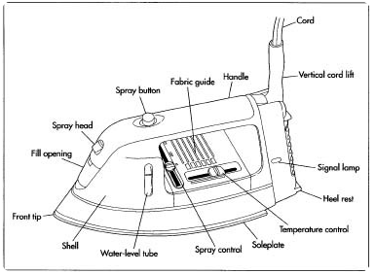

**Working**

When a current is passed through the heating element which is placed between the sole plate and pressure plate, the element gets heated up and transfers its heat to the sole plate through conduction and in-turn the sole plate also gets heated up. Now to remove the wrinkles in clothing, one should apply heat and pressure. Heat is formed due to the coil and when the garment is pressed with the electric iron, the wrinkles are removed. For maintaining the optimum temperature, a thermostat is used along with pilot lamp which serves as an indicator. (Precaution and Warning may also be discussed here.)

**Description – Parts of an Electric Iron**

**Sole Plate**

The sole plate is the thick, triangular-shaped slab of iron that forms the base over which the electric iron is built up. The bottom surface and edges are heavily chromium plated, to prevent it from rusting. The base plate should hold the iron pressure plate and cover plate in position. For this purpose we can see two or sometimes three studs in the base plate. These studs aid in holding the position of cover plate and pressure plate.

**Pressure Plate**

This plate is generally called the top plate as it follows the shape of sole plate. The pressure plate has some holes through which the studs form the base plate passes through. We should tighten the nuts on the studs in such a way that the pressure plate and sole plate are pressed tight against each other. In some iron the pressure plate is heavy and made of cast iron while in some other cases, it is a thin sheet of steel, about ¼ cm thick.

In automatic type of electric iron, the pressure plate has a rectangular or circular hole for locating the thermostat.

**The Heating Element**

The heating element is present between the sole plate and pressure plate. It is pressed hard between the two plates. The heating element consists of nichrome wire wound around a sheet of mica. The two ends of the nichrome wire are connected to the contact strips. The contact strips are connected to the terminals of the iron. There are two reasons for which mica is chosen in the heating material. Mica is a very good insulating material. Besides that mica can also withstand very high temperatures. The entire assembly of mica sheet, nichrome wire and contact strips are riveted together resulting in a mechanically sound and robust construction. There is an asbestos sheet, which separates and thermally insulates the top plate from the heating element.

**The Cover Plate**

The cover plate is made of thin sheet of iron. It is placed on top of the base plate and it covers all the internal parts of the iron. The handle and connector are only attached to the cover plate.

**Handle**

The handle can be made either with wood or with plastic. The handle is attached to the cover plate with the aid of screws. Studs can also be used for this purpose.

**Pilot Lamp**

The pilot lamp is housed in the cover plate of the electric iron. One end of the pilot lamp is connected to supply, while the other end is connected to the heating element. A shunt resistance is provided across the pilot lamp which assists in providing a voltage drop. The shunt is designed to provide a voltage drop of 2-5 volts.

**Thermostat**

When it comes to an automatic electric iron, the thermostat is the most important item. It uses a bimetallic strip to operate the switch which is connected in series with the resistance (or) heating element.

The bimetallic strip is a simple element which converts a temperature change into mechanical displacement. A bimetallic strip consists of two different metals bonded together. The two metals should have a different coefficient of expansion. If such a strip is heated, it starts to curve towards the metal having the lower co-efficient of expansion. On cooling, it straightens and comes back to the normal position.

Now we might wonder why such an element is used in iron. What is the purpose of this element in an electric iron?

The bimetallic strip is attached to a contact spring through small pins. The contact point between the strip and contact points remains closed. When the temperature rises significantly, the unusual expansion causes the strip to curve and the contact between strip and contact spring opens. Thus the supply to heating element is temporarily stopped (until the temperature goes down to normal). A special device called the cam is placed is placed near the contact spring, with which we specify the amount of curving of bimetallic strip required to separate the contact.

Thus using bimetallic strip the temperature is kept constant within certain limits.

**Capacitor**

The thermostat helps in maintaining the temperature within limits. But frequent making and breaking of circuit damages the contact points and it may also result in interference with radio reception. To avoid this, a capacitor of certain range is connected across the two contact points.

Description (Process) in detail:

Once the components of the object, idea, or process have been described and illustrated, there is one more form of description that allows the reader to visualize the complete function: the cycle of operation. This is a functional or relational description and shows how all the parts described work together to produce the desired result. This section takes the form of a narrative and gives the reader an overall view of the object, idea or process. Usually, process descriptions are written as if the process is taking place right now – and so in present tense. They usually begin and end at the same point – that is, one complete cycle of operation is described. A technical description follows this basic three step form:

* A definition, followed by a list of the major components to be discussed, and an illustration
* A section for each of the major components listed, which defines the components in terms of their function and then describes the components in terms of their material, dimensions, texture, relationship to other components, method of attachment, and lists all sub-components (which will also follow the basic define, describe and illustrate format).
* A description of one complete cycle of operation (process description).

Writing instructions:

Instructions, in general, are simple steps explaining how to do a particular task. They shape a reader’s attitude towards a process, a product, or the writer of the instructions. They generally contain: an announcement of the subject or topic; a declaration of what can be achieved by following the instructions; a description of the intended readers; information about the scope of the instructions; details about the organization of the instructions and how to use the instructions effectively.

Some of the most common instructions are process descriptions, which relate to:

* Trouble shooting an issue
* Constructing or creating a piece of product or machinery
* Performing a crucial function
* Conceptualizing or representing how to improve productivity within the organization structure

Product instructions should give people the information they need, when and where they need it. Effective product instructions have the following characteristics:

* Logical sequence of actions, discriminations, and judgement leading to successful outcome
* Concise, comprehensive and direct language, and therefore appropriate for users
* Emphasize and identify hazards
* Formatted in accordance with the way people use them
* Accurate and suited to the environment in which they are used

The primary purpose for product instructions is to convey essential information to users, especially when it is not available or cannot be communicated through the design of the product itself.

Structure of instructions:

* Introduction – Plan the introduction to the instructions carefully and make sure that the introduction:
  + Indicates the specific task or procedure to be explained as well as the scope of coverage
  + Indicates what the audience needs in terms of knowledge and background to understand the instructions
  + Gives the general idea of the procedure and what it accomplishes
  + Indicates the conditions when the instructions should be used
  + Gives an overview of the contents of the instructions
* Technical background or theory – At the beginning of certain kinds of instructions, some discussion of the background related to the procedure is required. For example, for certain instructions on how to use a camera, some theory might be required. This background is critical – otherwise the steps in the procedure would make no sense
* Equipment and supplies – Most instructions include a list of the things you need to gather before you start the procedure. This includes *equipment*, the tools you use in the procedure and *supplies*, the things that are consumed in the procedure. A two-column list can be used to add some specifications to some or all of the items.
* Discussion of the steps – When you get to the actual writing of the steps, there are several things to keep in mind: the structure and format of those steps, supplementary information that might be needed, and the point of view and general writing style. There are some variations and other considerations in the way we format instructions:
  + Fixed-order steps are steps that must be performed in the order presented. These are numbered lists (usually, vertical numbered lists).
  + Variable order steps are steps that can be performed practically in any order. You can do these kind of steps practically in any order. With this type, the bulleted list is the appropriate format.
  + Alternative steps are those in which two or more ways to accomplish the same thing are presented. Use bulleted lists with OR inserted between the alternatives, or the lead-in indicating that alternatives are about to be presented.
  + Nested steps. In some cases, individual steps within a procedure can be rather complex and need to be broken down into substeps. In this case, you indent further and sequence the substeps as a, b, c and so on.
  + ‘Stepless’ instructions, There exist instructions that cannot use numbered vertical list and that do not have straightforward instructions. Some situations can be so generalized or so variable that steps cannot be stated. For example, the installation instruction in the computer can be ‘stepless’.
* Supplementary discussion – Sometimes the audience needs additional explanatory information such as how something should look before and after a step, what mechanical principle is behind a step, etc. However, you should ensure that the actual step does not get buried in a mass of information. One method to do this is to split the instruction from the supplement into separate paragraphs.
* Content formatting
  + Headings – While writing instructions, make good use of headings. Headings are the titles and sub titles within the actual text and they alert readers to upcoming topics and sub topics. They also keep the writers organized and focused on the topic. Normally a heading may be given for any background section, one for the equipment and supplies section, a general heading for the actual instructions and sub headings for the individual tasks or phases within that section.
  + Lists – Certain types of lists make for easier reading and they create more white space and spread out the text so that it is easy on the eye. Instructions typically make frequent use of lists, particularly numbered vertical lists for sequential steps.
  + Special notices – While writing instructions, the readers must be alerted about situations where they may damage their equipment, waste supplies, cause the entire procedure to fail or injure themselves or others.
  + Numbering – Instructions use plenty of numbers, abbreviations and symbols. Number or label the steps clearly. Often a major step is numbered 1, and the sub-steps are numbered 1.1 and 1.2 . The sub-sub-steps are numbered 1.1.1 and 1.1.2, etc.
  + Number of tasks
    - An important consideration is the number of tasks comprising the procedure for which instructions need to be written. We can use the term procedure to refer to the whole set of activities the instructions are intended to discuss. A task is a semi-independent group of actions within the procedure: for example, setting the clock in a microwave oven is one task in the overall procedure of operating a microwave.
    - Merely listing tasks may not be sufficient. Often, there may be many tasks that must be grouped so that readers can find individual ones more easily. For example: unpacking and setup tasks, installing and customizing tasks, routine maintenance tasks, etc.
    - Some instructions only have a single task, but several steps within that single task. A good approach is to group similar and related steps into phases, and start re-numbering the steps at each new phase. A phase then is a group of similar steps within a single task.
  + Illustrations – Illustrations are crucial to instructions and should be used whenever the situation calls for them. They help the readers visualize what they are supposed to do. Photographs, diagrams, and schematics can be used as illustrations.
* Writing style – Instructions use a lot imperative (command, or direct-address) kind of writing; they use a lot of ‘you’. This kind of writing is appropriate to gain the reader’s full attention. Passive voice must be specifically avoided in writing instructions. Keep in mind the audience’s background knowledge, capacity to grasp and their ability to act upon the instructions. Use plain, direct and clear language.

A few guidelines that would aid in writing instructions are:

* Include four elements as needed: an introduction, a list of equipment and materials, a description of the steps involved in the process, and a conclusion.
* Explain in the beginning why the process is important and how it is related to a larger purpose.
* Divide the process into short, simple steps presented in the order of occurrence.
* Present the steps in a numbered list, or present them in paragraph format, making plentiful use of words indicating time or sequence, such as ‘first’ and ‘then’.
* If the process involves more than ten steps, divide them into groups or stages identified with headings.
* When appropriate, indicate how readers may tell whether a step has been performed correctly and how on step may influence another. Supply warnings that performing a step incorrectly could result in damage or injury, but limit the number of warnings so that readers do not underestimate their importance.
* Include diagrams of important devices and refer to them in the appropriate steps.
* Summarize the importance of the process and the expected results in the conclusion.
* Present the steps of your directions in a numbered or bulleted list.
* Restrict each step, sub-step or sub-sub-step to an individual piece of information.
* Make liberal use of headings and sub-headings.
* List alternative steps readers may take and place them where readers can find them easily.
* Include a trouble shooting guide at the end of the instructions. This should list potential problems and their solutions. Usually trouble shooting guides use a table format with the problem in the left column and the solutions to the right.

As you reread and revise your instructions, watch out for problems such as the following:

* Make sure you provide real instructions – explanations of how to build, operate or repair something
* Write a good introduction – in it, indicate the exact procedure to be explained and provide an overview of contents
* Make sure that you use the various types of lists wherever appropriate. In particular, use numbered vertical lists for sequential steps
* Use headings to mark off all the main sections and subheadings for subsections. (Remember that no heading ‘Introduction’ is needed between the title and the first paragraph. Remember not to use first-level headings in this assignment, start with the second level)
* Use special notices as appropriate
* Make sure you use proper format for all headings, lists, special notices, and graphics
* Use graphics to illustrate any key actions or objects
* Provide additional supplementary explanation of the steps as necessary
* Remember to create a section listing equipment and supplies, if necessary
* Include strong sections of definition, description, or both, as necessary, using the guidelines provided on content, organization and format
* Share the draft with the people of similar aptitude and knowledge for whom the instructions are made

**Example: Technical instructions for soldering (sample content)**

Soldering is a process in which two or more metal items are joined together by melting and then flowing a filler metal into the joint—the filler metal having a relatively low melting point. Soldering is used to form a permanent connection between electronic components. The metal to be soldered is heated with a soldering iron and then the solder is melted into the connection.

Equipment and materials required for soldering:

1. A soldering iron is used to heat the connections to be soldered.
2. Rosin core solder – Solder has a lower melting point than the metals that are being connected. The solder melts when it is heated by the soldering iron, but the metals being joined will not melt. The rosin core acts as a flux. It prevents oxidation of the metals that are being connected, and enhances the ability of the solder to “wet” the surfaces that are being joined.
3. Stand on which to hold the hot soldering iron
4. Sponge – the damp sponge is used to clean the tip of the iron
5. Solder braid – this is used to remove solder
6. Prototype board – this is used to assemble the circuit
7. Steel wool or fine sandpaper – this is used to clean connections prior to soldering
8. Crocodile clips – these can be used as heat sinks, if needed

1. Preparing the Soldering Iron: Tinning the Tip

1.1 Place the soldering iron in its stand and plug it in.

1.2 Wait for the soldering iron to heat up.

1.3 Moisten the sponge.

1.4 Wipe the tip of the iron on the damp sponge. This will clean the tip.

1.5 Melt a little solder on the tip of the iron. This is called *tinning* and it will help the heat flow from the iron’s tip to the joint. The tip of the soldering iron should be a shiny silver colour. If it is black and pitted, replace it with a new one.

2. Soldering

2.1 Solder needs a clean surface on which to adhere.

2.1.1 Buff the copper foil of a PC board with steel wool before soldering.

2.1.2 Remove any oil, paint, wax, etc. with a solvent, steel wool, or fine sandpaper.

2.2 To solder, heat the connection with the tip of the soldering iron for a few seconds, then apply the solder.

2.2.1 Heat the connection, not the solder.

2.2.2 Hold the soldering iron like a pen, near the base of the handle.

2.2.3 Both parts that are being soldered have to be hot to form a good connection.

2.3 Keep the soldering tip on the connection as the solder is applied.

2.3.1 Solder will flow into and around well-heated connections.

2.3.2 Use just enough solder to form a strong connection.

2.4 Remove the tip from the connection as soon as the solder has flowed where you want it to. Remove the solder, then the iron. Don’t move the connection while the solder is cooling.

2.5 Inspect the joint closely. It should look shiny.

2.6 Wipe the tip of the iron on a damp sponge to clean it. The tip should now be shiny.

2.7 Unplug the soldering iron when it is not in use.

Note that precautions and warning can also be included within the instructions or even after them.

# Session 15 - Defining and Classifying

The main steps involved in writing technical descriptions include:

* Naming
* Definition
* Description
* Illustration

A technical description begins with a definition of the object or process to be described and a general breakdown of the components that will be detailed. The introductory paragraph provides the reader with general information of the content that follows. Usually, the definition is followed by a list of the components and a brief note on the detailed description of each.

A definition fixes an object, concept or process within some system of knowing. Definitions appear in one of three forms:

* Formal: A formal definition will contain a term (that which is to be defined), a category to which the term belongs, and a set of differentia (a set of terms that separate the term from those elements within the category in which the term is located.
* Informal: An informal definition appears in brackets in a sentence to help clarify a concept.
* Extended: An extended definition is a form of description and could be lengthy.

The formal definition is the most common form of definitions. As a rule, a definition cannot use the term itself in the category or the differentia. Two common mistakes are to:

* Define term using the same term
* Define term using terms that also need definition

In technical writing, definition is the process by which one assigns a precise meaning to a term.

Term = Classification + Differentiation

Classification: a general category in which the term fits

Differentiation: Narrowing the meaning of the term to just one possibility within the class.

For example: A bug is a condition in a program which causes the program to behave in a way that deviates from its specification by producing erroneous behavior or violating some other constraint.

A key part of the definition of technical writing is the receiver of the information—the audience. Technical writing is the delivery of technical information to readers in a manner that is adapted to their needs, level of understanding, and background. For technical definitions, who the audience is matters. For instance, depending on the audience, the definition could be:

* In water softening, zeolite is an exchange resin that releases sodium ions while gaining calcium and magnesium ions. OR
* In water softening, zeolite is a special material that releases sodium into the water while absorbing calcium and magnesium from the water.

Organization of content in technical writing:

Choose the organizational method based on the audience, the document being written and the information going into it. The three most common methods are: Chronological, Deductive and Inductive

* Chronological: A chronological scheme organizes information based on the time of occurrence. Chronological organization is usually used in describing processes or giving instructions.
* Deductive: Deductive organization is also known as division. Start with the larger ideas and break them down into smaller parts. Move from general to specific.
* Inductive: Inductive organization is also known as classification. Start with the smaller ideas and build the larger ideas out of these smaller ones. Move from specific to general.

Description is the process of making an object, idea or process known to someone who is unfamiliar with it (it is very much like a definition in that respect). Description divides a complex idea or topic into more manageable components. It defines, describes, and illustrates the various elements contained within the whole. Description also relies upon strategies of division and classification, comparison and contrast. The process of division and classification helps to manage an overwhelming amount of detail inherent in complex information and simply breaks down large amounts of information into manageable segments. In many cases, the division process continues through many levels of detail. The process of classification groups similar items on the basis of function or location or material in order to put them into some category relevant to the descriptive task. The general guideline for writing effective descriptions is to generate iterations of naming, defining, describing and illustrating.

Division and classification is the process of breaking down complex systems into more manageable components and then grouping components together based on some over-riding determinant such as spatial relationship, functional or genetic similarity, chronological relationship, or host of other bases upon which a classification can take place. Thus classification helps to break a general idea into specific categories. The result is usually informative or analytical in nature rather than comparative. (Comparison and contrast is result oriented, rather than being strictly informative.)

Students can be asked to write definitions of terms like: voltmeter, electric iron, calculator, thermometer, etc.

They could also be asked to write definitions of processes like: soldering, filing, welding, etc.

Through the structure of the definitions, classification and differentiation could also be discussed effectively.

# Session 16 - Providing examples or evidence – building an effective argument

The three-step process can easily be adapted to build an effective argument.

**Step 1. Planning an effective argument**

Analyzing the situation – In addition to having a clear purpose, the best written messages are closely connected to audience members’ desires and interests. Consider the needs and motivation as well as the concerns and objections. With these two insights, you can work to find common ground with your reader while emphasizing positive points and minimizing negative ones. Adapting the audience has been discussed further in the latter part of this session.

Gathering information – Evaluate the sources carefully, especially for its reliability and ensure that the claims are supported with evidence.

Selecting the right medium – Building an effective argument is important in every communication medium, from instant messages and podcasts to advertisements. The medium chosen should fulfil the objective of the argument

Organizing the information – While building an argument, one should pay attention to all four aspects of organizing information: defining the main idea, limiting the scope, choosing the direct or indirect approach and grouping points in a meaningful way. The indirect approach can be used as it gives the writer the opportunity to explain his or her reasons and build interest before asking for a decision or action. However, consider using the direct approach when the reader is ready to hear the proposal.

**Step 2. Writing an effective argument**

Adapting to your audience:

Providing the right information in the right format is essential. You may also need to adjust your writing for specific situations and to adapt to your audience in a way that provides a compelling answer to the “what’s in this for me?” question. The three techniques for adapting to your audience are:

* Being sensitive to your audience’s needs
  + Use the “You” attitude
  + Maintain standards of etiquette
  + Emphasize the positive
  + Use bias-free language (no gender, racial, ethnic, age or disability bias)
* Building strong relationships with your audience
  + Establish your credibility

Establishing credibility is vital to the success of the communication effort. People are more likely to react positively to the message when they have confidence in the writer. To enhance credibility, emphasize factors such as honesty, integrity, awareness of audience needs, and by supporting your points with apt evidence and not empty terms such as – amazing, incredible, extraordinary etc. In addition you can improve your credibility with these techniques:

* + - Using simple language
    - Supporting your message with facts
    - Identifying your sources
    - Establishing common ground
    - Being objective
    - Displaying your willingness to keep the audience’s best interest in mind
  + Project your company’s image
* Controlling your style and tone
  + Use a conversational tone

The tone of the business message can range from informal to conversational to formal. Most business messages aim for a conversational style that sounds business-like but is warm.

* + - Understand the difference between texting and writing
    - Avoid pompous language
    - Be careful with humor and intimacy
  + Use plain language
  + Select the active or passive voice appropriately

Composing the message:

The first draft may not be perfect. As you create and refine your message, your writing can be viewed at three levels – strong words, effective sentences and coherent paragraphs.

Strong words – Successful writers take care to find the most effective words and phrases to use. Correctness is the first consideration when choosing words. Effectiveness is the second consideration.

* Understanding denotation and connotation
* Balancing abstraction and concreteness
* Using words that are powerful and familiar – avoid clichés, be extremely careful with trendy buzz words and use jargon only when your audience is completely familiar with it
* Avoid redundancy and circumlocution
* Use acronyms carefully

Creating effective sentences – Arranging the chosen words carefully in effective sentences is the next step in creating powerful messages. Faulty construction of sentences gives rise to ambiguity. Ambiguity arises mainly due to misplaced modifiers in sentences. The position of a modifier in a sentence is important. Whether it is a word, a phrase or a clause, it should be placed as close as possible to the word it modifies.

Start by selecting the optimum type of sentence to communicate each point you want to make:

* Choosing from the four types of sentences (simple, compound, complex and compound complex) – Simplicity in writing can be achieved mainly by writing short sentences. If too many ideas are stuffed into a sentence through words, the meaning is lost and the reader is left confused. Therefore, one should attempt to limit the amount of information in each sentence. Long sentences are well suited for certain purposes such as summarizing, combining ideas and listing.
* Using sentence style to emphasize key thoughts – you can emphasize ideas in a sentence by devoting more words to them, putting them at the beginning or end of the sentence, making them the subject of the sentence

Crafting unified coherent paragraphs – Most paragraphs consist of a topic sentence that reveals the subject of the paragraph, related sentences that support and expand the topic, transitions that help readers move between sentences and between paragraphs. By carefully arranging the elements of each paragraph, you help the readers grasp the main idea of the document and understand how the specific pieces of support material back up that idea.

Five ways to develop paragraphs:

* Illustration
* Comparison or contrast
* Cause and effect
* Classification
* Problem and solution

**Step 3. Completing the argument**

When you evaluate the content, try to judge your argument objectively and try not to overestimate your credibility. Make sure your design elements complement rather than detract from your argument. In addition, meticulous proof reading will help identify mechanical or spelling errors that would weaken the argument. Finally, make sure your distribution methods fit the audience’s expectations and preferences.

If the objective of the argument is persuasion, then within the context of the three step process, effective persuasion involves four essential strategies:

* Framing your arguments

Most persuasive arguments use the indirect approach. A number of indirect models have been developed by experts in persuasive communication. One of the best known is the AIDA model which organizes the messages into four phases – Attention, Interest, Desire, Action. The AIDA model is tailor made for the indirect approach. However, it can also be used for the direct approach in which you use the main idea as an attention-getter, build interest with the argument, create desire with the evidence, and re-emphasize the main idea in the action phase with the specific action you want the reader to take.

* Balancing emotional and logical appeal

To find the optimum balance, consider four factors:

* + The action you hope to motivate
  + Your reader’s expectations
  + The degree of resistance you need to overcome
  + How far you feel empowered to go in order to establish your point of view in the argument

A logical appeal calls on reasoning and evidence. When appealing to an audience’s logic, you can use three types of reasoning – analogy, induction, deduction.

* Reinforcing your position

After you have worked out the basic elements of your argument, step back and look for ways to bolster the strength of your position. Choose your words carefully and use abstractions to enhance emotional content. Using vivid abstractions with basic facts and figures can bring the argument to life though one must be able to use them carefully and wisely.

* Anticipating objections

Even powerful arguments can encounter resistance from the reader. One should keep two things in mind:

1. You don’t always have to explicitly discuss a potential objection.

2. If you expect a hostile audience, one biased against your plan from the beginning, present all sides of the story. As you cover each option, present the pros and cons.

# Session 17 - Writing introduction and conclusion

Effective writing is an essential skill for any profession and the goal of writing, whether it is technical or business, is clarity and understanding. Writing is a skill that can be learnt and practiced. But to improve writing skills, we need to be aware of the elements of effective writing. Choosing the right words and phrases, constructing grammatically as well as logically correct sentences, and well developed and coherent paragraphs – all would contribute to enhancing the quality of writing.

In order to convey the exact meaning of what you wish to communicate, you must put the content in the right order. The introduction and the conclusion are more important than the rest of the elements. The introduction calls attention to the contents, whereas the conclusion re-emphasizes the purpose of the message.

Whatever kind of writing you do, there are four stages you usually have to go through before you begin:

* statement of intent
* generating ideas
* research
* planning the order/sequence

For simple pieces of writing this process may just take place in your head. For longer projects, on the other hand, it will almost always need to be written down.

Statement of intent:

The statement of intent is a short document you write for your own use setting out the essential features of your writing project. Even if you think you have a very clear idea of what you are going to write, it is still useful to take time to clarify your objectives. How you go about this depends on how the project originated:

* as an externally imposed brief, for example:
  + a report requested by your line manager
  + an article commissioned for a newsletter
  + an essay set as part of a college course
* as a personal project

Externally imposed brief:

An externally imposed brief may be as simple as a short conversation or email. Sometimes the brief will be rather more detailed. Even when a brief is very detailed, you should still interrogate it in order to produce a more precise and usable version.

Personal project:

In the case of a personal project it is still more important to write a brief before you do anything else. If not, you may well find yourself floundering as you work through your first draft.

A statement of intent should contain answers to all the following questions:

What? – A definition of the subject matter. To answer this question, you should isolate the most important features only. The more detailed points can be picked up later. One way of starting this process is to highlight key words in the brief.

Who? – The target audience for your writing. The brief gives a fairly clear idea of who will read this piece of writing. If you are writing for a small group of colleagues whom you meet every day, and who share a common language and experience, you are likely to write in a different way than if you are addressing a group of people who are not necessarily experts and whom you may only know on a more formal basis.

Why? – Your purpose(s) in writing. Pinning down the purpose of a piece of writing is often the most difficult part of the brief. The commonest general purposes for any kind of writing can be summed up in this list:

* to inform
* to persuade
* to make a record
* to entertain
* to interact
* to find out
* to regulate

When? – There is often a deadline for writing tasks and you need to schedule all aspects of a writing project with this in mind. The writing schedule developed by you should include dates for:

* Completion of first draft
* Circulation for comments
* Editing and redrafting
* Final delivery

How? - The format of your writing. The final element in a brief describes the format(s) in which your writing will be presented. It is important to pin these down, because different formats require different structures. For example if the writer has been asked to ‘prepare a report’, you would work with the understanding that it would consist of the following parts:

* Executive summary
* Body
* Introduction
* Main text, possibly divided into sections or chapters
* Conclusion(s)
* Appendices

The introduction and conclusion are essential in this structure as exemplified below:

* Introduction: This should contain the following information:
  + The origins of the report - The background and events leading to the need for the report.
  + Its terms of reference - The scope (and limitations) of the report and its purpose.
  + How it was conducted and by whom. This can also include acknowledgements of help received.
  + Other introductory information - It is important to think of the readers of the report and to include at this point any other background information they will need in order to understand the material in the body of the report.
* Conclusions: Each section of the report should lead to a number of conclusions. At the end of the section these are spelled out and the reasoning behind them explained. If there is a separate Conclusions section these conclusions are pulled out and presented as an ordered sequence. Sometimes a report that is divided into major sections will have a short Summary at the end of each section. It is often a good idea to repeat the conclusions you reached again in a separate section, referring back to relevant sections of the report as necessary.

In order to write an effective introduction and conclusion in any kind of writing, the following guidelines can be adhered to:

* You need to decide first how many main sections there should be, apart from an introduction and a conclusion. There should be enough to encompass all the ideas you have generated, but few enough for the pattern of the essay to be clear to the reader.
* You should decide how best to order these sections so that your material can be presented in a logical and interesting way.
* You can then arrange your material, fitting all your ideas into the relevant sections. The guiding principle is the paragraph. Effective use of paragraphing is at the heart of good writing:
  + as a means of structuring a whole text
  + as a way of shaping the argument as you write
  + as a technique for ensuring that the argument flows through the text and so is easy to read
* So the writer should use paragraphing when planning; when writing; when revising
* You can plan the structure of each paragraph such that it has an introduction (a sentence at or very near the beginning which introduces the subject matter of the paragraph), a conclusion (at or near the end of the paragraph is a sentence which rounds it off) and the body of the paragraph (an orderly and convincing arrangement of sentences from the introduction to the conclusion). The body of the paragraph should lead smoothly from the introduction to the conclusion.
* Now decide how you will introduce your essay and conclude it. The introduction needs to indicate the approach you propose to take, but should avoid giving the game away right at the start. If you tell the reader everything that you are going to say in the course of the first paragraph, there is little incentive to read on. Similarly the conclusion should refer to the main points you have made without being repetitive; but if possible you should save up a telling, interesting, or amusing point for the conclusion, so that the reader’s interest is held until the very last sentence.

A successful text is one where the reader is taken along by the flow of the writing, doesn’t get lost or confused, and comes away with the feeling that the ideas it contains could not have been expressed in any other way. So it is important to develop a pattern in which ideas are developed logically and necessary information is introduced at exactly the right point. Where it is necessary to use ideas or information that have not been referred to for some time, the reader needs a gentle reminder of what these are. If the flow of ideas needs to take a sudden new turn, this may need preparation or explanation. At every point the reader’s needs, expectations, and possible difficulties must be considered.

Guidelines for writing an introduction

The introduction is often the most difficult section to write. It sets the tone of what is to come and fixes the reader’s expectations. However important the first sentence or two may be, the introduction to a text will normally consist of one or more paragraphs and may be a complete chapter or even section of a book. It has to perform these functions:

* It gives the reader an indication of what the subject matter will be.
* It persuades the reader that reading this text is going to be at least worthwhile and—if possible—enjoyable.
* It establishes a relationship with the reader by the language and tone adopted.

For example, business letters have an introduction which sets out briefly the subject matter and purpose of the letter. Here, you outline what the letter is about and the introduction to a letter has to fulfil these requirements:

* It must state clearly what the letter is about. This enables the recipient to make an initial decision about what to do with it: deal with it now? put it in a heap of mail to be dealt with at an appointed time? pass it on to someone else? One way of doing this is to give the letter a heading immediately after the salutation.
* It should indicate why the writer is writing it. A heading gives a general idea of the subject matter. The introduction should go on to spell out the writer’s purpose. Essentially, that is all the introduction has to do. When you have read it, you should have a clear idea of what the letter is going to be about and enough information to be able to decide how to tackle the rest of it.

Guidelines for writing a conclusion

Second only to the introduction in difficulty and importance is the conclusion to a piece of writing. If the introduction hopes to entice readers to read the text that is in store, the conclusion should aim to send them away with a good feeling – a sense of satisfaction. It should remind readers of what they have been reading, by:

* summing up key points without being unduly repetitive
* if action is required, highlighting what it is
* rounding off the text neatly and—if possible, and appropriate—in an entertaining way

For example, business letters have a conclusion in which you re-emphasize your purpose, possibly spelling out what you would like to be done about it. A conclusion could also be intended to leave the reader feeling positive towards the writer and not ask for an action.

To summarize, when you plan your writing:

1 The notes you have made as you define the task, brainstorm, and research form the basis of your planning.

2 Begin by deciding the main points you wish to make in your text.

3 You can then develop each of these with more detailed subsidiary points to flesh out your plan.

4 Alternatively you may prefer to develop the list of main points by a process of drafting and redrafting.

5 Whichever route you follow, you should ensure that your writing follows a pattern that is clear to the reader.

6 It is particularly important to have an effective introduction and conclusion.

7 Use paragraphing as a planning tool. Remember, as you make your plan, that each point in it represents either one paragraph or a small group of linked paragraphs.

8 As you write, form your thought into paragraphs.

9 Begin each paragraph with one or two sentences that introduce the topic of the paragraph.

10 The beginning of the paragraph should also have some kind of ‘hook’ to the previous paragraph.

11 Make sure that the paragraph ends with one or two sentences that round it off and lead on to the next paragraph.

12 The body of the paragraph should lead smoothly from the introduction to the conclusion.

13 The introduction and the conclusion thus form the scaffolding of the written content comprised of sections structured and connected through effective paragraphs.

After completing your written draft, check whether the following criteria ae fulfilled, and if not, revise the draft further:

* The introductory paragraph catches the reader’s attention and provides a general idea about the topic and the line of argument
* The content of the main argument is divided into several well-structured paragraphs
* Each paragraph discusses only one main idea
* There is smooth transition among the sentences in each paragraph and among the paragraphs in the essay
* The conclusion is focused and emphasizes the highlights of your view

**Unit 5. Writing Practices**

* **Ways to improve comprehension skills:**

• Read a variety of materials. Do not limit yourself to textbooks.

• Read large portions and not only tit-bits.

• Circle unknown or unfamiliar words as you read. Look up these words. Learn the meanings and revise the same until the words and meanings become a part of your system.

* **Reasons of poor comprehension:**

lack of interest; lack of concentration; failure to understand a word, a sentence, or relationships among sentences; failure to understand how information fits together.

* **Techniques that can be employed for effective comprehension:**
* Skimming and Scanning

First skim through for the following information:

• for which audience the text was written (general public, professionals, laymen . . .); • what type of text it is (report, informal letter, formal letter, article, advertisement . . .);• what the purpose of the author is (to describe, to inform, to explain, to instruct, to persuade); and• the general contents of the text.

Give a scanning (thorough reading, sometimes for looking up specific information) after this.

* Non-verbal Signals

The meaning of a text is not only conveyed by means of words. All texts also contain non-verbal signs like:

* certain style features, such as different fonts, bold print, underlining, or italics.
* photographs, chats, diagrams, maps, etc.
* Predicting

From titles, captions, way of paragraph division (topic sentences, length of paragraphs)

In many well-written texts the reader can get a good idea by reading just the

the topic sentences of each paragraph.

* Being conscious of the author’s viewpoint

You make inferences about the position of the author. Is the author neutral or does he/she have an opinion? The author often shows his or her opinion by using certain words, tones, etc.

* Guessing meanings of unknown words

Clues from your knowledge of etymology

* Determine the word class, i.e., a verb, a noun, an adjective, an adverb, etc.
* Determine its function in the sentence, i.e., how it is related to other words in the sentence.
* Analyse the contextual clues, i.e., the context in which we find this word positive or negative; what the context tells us about the word.
* Is there any relation between this word and a word that is familiar to you?
* Note-making and summarizing
* SQ3R Reading Technique
* Survey
* Question
* Read and while doing so, also ‘Recall’ important/ connected points
* Review the write-up to check whether your understanding and recalling are correct. If you find that your understanding isn’t adequate, re-read.
* Consciousness of ‘Discourse Coherence’
* A coherently structured discourse is a collection of sentences, and in turn paragraphs, that are ***ordered such that they make good sense*** in some ***relation to each other.***
* Incoherence can arise from too much or too little information as well as from ***incorrectly ordered sentences or thoughts.***
* We severally start using our own interpretations while reading/ listening. ***Therefore, it must be ensured that there is no scope for ambiguity***.
* To clearly express the relationship between various segments of a discourse, you can use the following ***‘transition words’*** (also called ‘connectors’ or ***‘signal words’***):

but, yet, so, as, and, since, while, similarly/likewise/in the same way, on the other hand/on the contrary/contrariwise/whereas/while/however/yet/although/

nevertheless/nonetheless/whereas/unlike/despite/in spite of/even so, therefore/as a result/as a consequence/consequently/thereby/thus, because/due to/on account of/ inasmuch as, though/although/even though, in addition/moreover/furthermore, either…or, neither…nor, of course, in fact/clearly/evidently/obviously/actually/indeed/surely/certainly, so that/so as to/in order to, in other words/that is/to put it differently/to repeat/namely, for instance/for example, hence/in conclusion/to sum up/at last/finally

* Use signal words that suit your purposes, taking care to avoid their overuse.
* **Sequencing of Sentences**

Some tips that can be handy:

• Read all the sentences and try to identify the topic sentence.

• Place it in the beginning of the text/paragraph.

• Look for discourse markers such as signal words, pronouns, repetitions,

synonyms, etc.

* *Use your common sense and logic* in the arrangement of coherence in sentences!

**Worksheet**

Given below are eight passages, each followed by certain questions to check your

comprehension of the contents and the author’s viewpoint. We have provided the answers

also in these sample passages. After going through these solved pas-sages, you can try the

exercises given at the end of this chapter.

**Sample Passage 1**

Do birds know how to come back home after a long fl ight? Bird scientists, known as

ornithologists, say that birds know exactly where they are and where their nests are. Even the

young ones can fl y hundreds of nautical miles without losing their way. How do they do it?

God has given them a tremendous sense of direction; possibly they have a compass of sorts in

their brain. Every year, we can see birds from north India fl y to the south. In India we have

several bird sanctuaries where birds from both parts of the globe come, spend a few months

and return when the climatic conditions in their homeland are more favourable. When it

is winter in the northern hemisphere, it is summer in the southern hemisphere. The birds

which cannot stand the cold climate fl y to the warmer regions. They are called migratory

birds. They can fl y non-stop up to twenty hours or so in one stretch and cover a few hundred

miles in one stop. The migratory birds always fl y in groups.

**Questions**

1. Who is an ornithologist?

2. Why do we call some birds migratory birds?

3. Are the seasons the same in both hemispheres?

**Sample Passage 2**

Petroleum products such as gasoline, kerosene, home heating oil, residual fuel oil, and

lubricating oils come from one source—crude oil found below the earth’s surface, as well as

under large bodies of water, from a few hundred feet below the surface to as deep as 25,000

Reading Techniques | **85**

feet into the earth’s interior. Sometimes crude oil is secured by drilling a hole into the earth,

but more dry holes are drilled than those producing oil. Either pressure at the source or

pumping forces crude oil to the surface.

Crude oil wells fl ow at varying rates, from about ten to thousands of barrels per hour.

Petroleum products are always measured in forty-two-gallon barrels.

Petroleum products vary greatly in physical appearance: thin, thick, transparent, or

opaque, but regardless, their chemical composition is made up of only two elements: carbon

and hydrogen, which form compounds called hydrocarbons. Other chemical elements found

in union with the hydrocarbons are few and are classifi ed as impurities. Trace elements are

also found, but in such minute quantities that they are disregarded. The combination of

carbon and hydrogen forms many thousands of compounds which are possible because of

the various positions and unions of these two atoms in the hydrocarbon molecule.

The various petroleum products are refi ned by heating crude oil and then condensing the

vapours. These products are the so-called light oils, such as gasoline, kerosene, and distillate

oil. The residue remaining after the light oils are distilled is known as heavy or residual fuel

oil and is used mostly for burning under boilers. Additional complicated refi ning processes

rearrange the chemical structure of the hydrocarbons to produce other products, some of

which are used to upgrade and increase the octane rating of various types of gasoline.

**Questions**

1. How is crude oil brought to the surface?

2. What are the principal components of all petroleum products?

3. What is heavy oil?

4. All of the following are listed as light oils EXCEPT

(a) Distillate oil (b) Gasoline (c) Lubricating oil (d) Kerosene

5. The word ‘upgrade’ in the last but one line is closest in meaning to

(a) improve (b) counteract (c) charge (d) unite

***Answers***

1. Crude oil is brought to the surface by pressure and pumping.

2. The principal components of all petroleum products are hydrogen and carbon.

3. Heavy oil is the residue remaining after the light oils are distilled.

4. c

5. a

**Sample Passage 3**

If you are not in the grip of avarice, you will choose a trade or profession that appeals to you

as the means of self-expression and social service, even if you cannot earn much money by

it. Your daily duty is not merely money-making drudgery; it is your contribution to social

progress and the path of personal development. How sad must be the lot of the man or

woman who must do uncongenial work simply for the sake of more money? I know a younger

professor who loved literature passionately and taught it admirably; but his salary was small,

and he became a lawyer in order to secure a larger income. I tell you that man was guilty of

**86** | Technical Communication

a crime, and he will not be happy as a lawyer, though he may be a little more comfortable,

a little better fed and dressed and lodged. A musician who is born a violinist can never be

personally happy or socially useful as a prosperous merchant or stock-broker, as he will miss

the violin all the time. Avarice puts round men in square jobs and square men in rounds

jobs. At present many persons in all classes, rich and poor, are unhappy and restless because

their daily work is not interesting. It does not provide an outlet for the creative impulse and

the insistent urge of personality. Therefore, don’t ask in youth, ‘How can I earn the biggest

salary?’ Ask rather, ‘How can I be truly happy and do most good to society?’ Then you may

have less money, but you will have more of life and joy.

**Questions**

1. When can a man choose a profession through which he can express himself and serve

others?

2. Why does the author consider the lawyer known to him guilty of a crime?

3. Why are most of the people unhappy at present?

4. When will a violinist be unhappy?

5. Who are the misplaced persons according to the writer?

6. What is the advice of the writer to the youth?

***Answers***

1. If one has to choose a profession to serve others, or to express his personality as a human

being, he must have no undue attraction towards money even if the profession can

provide it.

2. The lawyer was guilty as he left his real profession of a lecturer in which he had real

interest—a passion for teaching—simply to earn a little more for material comforts. He

sold his happiness for a few pieces of gold.

3. One should take up a profession in which he has real involvement, in which he can

create something, where he can express his personality. Most people do not choose such

a profession. They choose one which gives them more money. Thus they are better off

but never happy.

4. The violinist will always be unhappy if he becomes a busy businessman because his real

interest is in violin. His love is for violin. He will miss it. If one loses his love he can never

be happy.

5. The persons who take up a job in which they are not primarily interested are misplaced

persons. They put themselves in such situations to earn more at the cost of their

personality and real interests.

6. Young people should fi nd ways to earn money, but should also devote themselves to the

cause of society. This will give them real happiness and make them more active too.

**Sample Passage 4**

The term co-operation loses its meaning when ‘co-operative’ becomes ‘competitive’ and just

a fi rm of retail shopkeepers, entering into rivalry with either similar co-operatives or private

shops. In the issue of licences, permits, supplies, grants, loans, etc. Government follows a

Reading Techniques | **87**

general policy of preferring co-operatives to private organizations. Since Government itself is

run on party lines, this has led to rival co-operatives, one favoured by the party in power and

the other trying to checkmate it. To remedy this, one way would be to insist on having only

one multi-purpose co-operative in one unit, to eliminate all private dealers in distribution,

and to make membership in the co-operative society compulsory for every householder.

My feeling is that co-operatives, whether in selling, purchasing, or distributing should

be restricted to carry on their operations for and among their members only. They must

not become commission agents or middlemen between non-members on the one hand and

Government or the world on the other. Their purchases must be for the needs of their

members only, and not for sale to the public. Their sales to the public must be confi ned to

their own productions. Permits, grants, loans, and other help should be given to them for

proper distribution among their members only.

**Questions**

1. When does a co-operative lose its proper function?

2. What solution has been suggested by the writer to remove rivalry among cooperatives?

3. Why should membership be made compulsory for all householders?

4. Co-operatives should sell only those things to the public

(a) which they purchase from the market

(b) which are meant for consumers

(c) which they produce themselves

5. The word ‘operation’ in the passage means

(a) a surgical procedure (b) work

(c) management

6. The co-operatives should purchase things

(a) for the requirements of their own members

(b) to secure more permits from the government

(c) to make supplies to the government

***Answers***

1. A co-operative ceases to function as a co-operative when it starts competing with retail

shopkeepers or with other co-operative societies either in sales or production.

2. According to the writer, rivalry can be removed by having only one co-operative society in

one area performing all those functions which are done by different types of societies.

3. Membership of multipurpose co-operative societies should be compulsory for all

householders to do away with all private dealers.

4. c

5. b

6. a

**Sample Passage 5**

When I go into a stranger’s library I wander round the bookshelves to learn what sort of

person the stranger is, and when he comes in I feel that I know the key to his mind and the

**88** | Technical Communication

range of his interests. A house without books is a characterless house, no matter how rich

the Persian rugs. These only tell you whether he has a lot of money, but the books tell you

whether he has got a mind as well. It is not a question of money that we do not buy books.

I repeat that the books are the cheapest as well as the best part of the equipment of a few

dollars. Nearly all the best literature in the world is at your command at two dollars a volume.

For 100 dollars you can get a library of fi fty books. Even if you do not read them yourself,

they are a priceless investment for your children. What delight is there like the revelation of

books—the sudden impact of a master-spirit, the sense of a window fl ung wide open to the

universe? It is the adventures of the mind, the joy of which does not pass away, that give the

adventure of life itself beauty and fragrance.

**Questions**

1. Why does the adventure of mind not pass away?

2. Why does the writer wander round the bookshelves when he goes to a stranger’s

house?

3. What delight does a good book provide?

4. What can books tell you about a stranger?

(a) That he is a rich man

(b) That he believes in priceless investment

(c) That he has good mental faculties

5. When one reads a good book, one is delighted because

(a) one fi nds the windows of the library opened

(b) one feels the infl uence of a great writer

(c) one knows much about the universe

6. The words ‘master-spirit’ in the passage mean

(a) a prominent writer

(b) the spiritual effect of a master

(c) one who has a control over the spirit of a man

***Answers***

1. The adventures of the mind permeate one’s own life, fi lling it with happiness that never

goes away.

2. The writer wanders round the bookshelves to learn about the mind of the owner.

3. A good book delights us as it reveals the mind of a great man.

4. c

5. b

6. b

**Sample Passage 6**

Our society is built with money for mortar; money is present in every joint of circumstance. It

might be named the social atmosphere, since in society, it is by that alone that men continue

to live, and only through that can they reach or affect one another. Money gives us food,

shelter, and privacy; it permits us to be clean in person, opens for us the doors of the theatre,

Reading Techniques | **89**

gains us books for study or pleasure, enables us to help the distresses of others, and puts

us above necessity so that we can choose the best of life. If we have scruples, it gives us an

opportunity to be honest; if we have any bright designs, here is what will smooth the way to

their accomplishment. Penury is the worst slavery and will soon lead to death. But money

is only a means, it pre-supposes a man to use it. The rich man can go where he pleases,

but perhaps pleases himself nowhere. He can buy a library or visit the whole world but has

neither patience to read nor intelligence to see. The table may be loaded and the appetite

wanting; the purse may be loaded and the heart empty. He may have gained the world and

lost himself, with all his wealth around him in a great house. Without an appetite, without an

aspiration, void of appreciation, bankrupt of desire and hope, there in his great house, let him

sit and look at his fi nger. It is perhaps more fortunate to have a taste for collecting shells than

to be born a millionaire. Although neither is to despised, it is always a better policy to learn

an interest than to make a thousand pounds, for the money will soon be spent or perhaps you

may feel no joy in spending it, but interest remains imperishable and ever new.

**Questions**

1. Why does the writer give preference to collecting shells than to be born a very rich

man?

2. What is the source of mutual relations in the world?

3. How does money give us the opportunity to choose the best of life?

4. Why does the writer consider poverty as the worst slavery?

5. Why is it not possible for a rich man to enjoy his riches?

6. Explain the idea of the word ‘appetite’ in the passage.

7. Do you agree with the statement that ‘money is only a means’? What is the ‘end’ of life

hidden in the passage?

***Answers***

1. Collecting shells is a permanent interest. One may have any other such interest. Money

may not remain with us permanently. One may not derive real pleasure through it.

Thus it is better to learn an interest than to be a rich man.

2. Money is the source of mutual relations in the world. We can reach others and create an

effect on them through money.

3. Money frees us from tension about the necessities of life. Freed from this worry, we get

time and opportunity to help others, and to acquire knowledge. So we can choose the

best of life, to follow our dreams, to be honest, and to create conveniences for others.

4. Poverty does not allow a man freedom. A poor man always depends upon others. Thus

it is the worst slavery.

5. A man cannot enjoy the best of food if he has no appetite. Money is only a means to an

end. A rich man cannot enjoy his riches if he is simply interested in accumulating wealth

and has no other desires or interests to pursue.

6. ‘Appetite’, in the passage, means desire or interest in enjoying and deriving emotional

pleasure from something.

7. Money is indeed a means of accomplishing the aims of one’s life. A man who only

makes money for its own sake could be intellectually and emotionally bankrupt. The

goal of life is to develop all of one’s faculties to the fullest and be of service to others.

**90** | Technical Communication

**Sample Passage 7**

The march of scientifi c mechanization over industry, throughout the world, is unabated,

so is the misery of the poor. Equally unchecked is the thriving of a few among the upper

rungs of industrial hierarchy and the bureaucratic and political echelons. One feels proud

of the scientifi c innovations in the manufacturing process where manpower is speedily being

replaced by capital potential. The researches in the fi eld are so swift that the labour factor is

gradually being eliminated. Automation has withdrawn hazards from man but has offered

him unemployment. In the progressing countries, where there is no check on population,

scientifi c industrialization has become an eyesore on the job front. It has resulted in long

queues at the employment exchanges.

Scientifi c industrial development has proved manna for the progressive countries of

Western Europe, Canada, the USA, and Japan. They reap certain advantages over the

backward nations. It has provided a luxurious life even to the common man there. Scientifi c

researches result in mass production of commodities. Thus the West has a huge surplus of

fi nished goods to fl ood the world market and to reap profi ts. The resultant economic growth

in these countries enables them to proceed with further scientifi c researches to make the

industries more capital oriented. Thus they always have an advantage over the backward

countries.

Notwithstanding the backwardness or poverty, scientifi c industrialization is responsible

for an increase in the Gross National Product in progressing countries like India too. But

it creates two-fold problems. The advantages of this increase in Gross National Product

are reaped by the rich, for it is they who have invested money. The growth of capital too is

their prerogative. The profi ts and interest go to the coffers of the industrialists. The fruits

of progress and mechanization do not go to the poor. It is only a class, a group that benefi ts

from scientifi c development, not all.

**Questions**

1. Who are benefi ted by scientifi c mechanization?

2. Who is affected by scientifi c development and how?

3. What are the advantages reaped by progressive countries?

4. What is the effect of economic growth in progressive countries?

5. What is scientifi c industrialization responsible for in backward countries too?

6. Who profi ts by increase in GNP in backward countries?

7. Why do the profi ts of scientifi c development not go to the poor?

***Answers***

1. Scientifi c mechanization has been advantageous to the rich, the bureaucrats, and the

political leaders.

2. Scientifi c development has affected workers the most. Automation has withdrawn men

from work. Thus it has resulted in large scale unemployment. It has affected people in

backward countries the most, where population is increasing.

3. Scientifi c research in progressive countries has contributed to greatly improving the

standard of living even among common people. The progressive countries manufacture

Reading Techniques | **91**

goods on a large scale, leading to increased incomes and more luxurious lifestyle for their

people. They also have huge surplus goods to sell in the foreign market.

4. Economic growth allows the progressive countries to spend on further research which

backward countries cannot afford. Thus they always have an advantage over developing

countries.

5. Scientifi c development increases the Gross National Product even in backward countries,

i.e., the total volume of production is increased.

6. As the GNP increases through more investment by the rich on mechanized production,

they reap the profi ts. The benefi ts of scientifi c development in industry has resulted in

greater mechanization. Since the poor do not own industries, these benefi ts do not reach

them. On the contrary increased automation means fewer jobs; so the poor lose out on

employment too.

**Sample Passage 8**

It has always been clear that a properly designed media programme uses press, posters,

printed leafl ets, and so on in proportions suitable to the nature of the product itself. In

such a programme, television occupies a relatively important place if the product is sold in

small quantities at a low price to the vast mass of the people. It is regarded as a quick-acting

medium, peculiarly suited to promoting ‘impulse purchases’.

Larger items, such as cars and refrigerators, may be more profi tably advertised in the

press or other media which are examined in greater detail and more at leisure than television

‘commercials’ can possibly be. Nevertheless, in most mass advertising campaigns, the media

are used in combination with each other, in proportions which tend to be more and more

carefully, and even scientifi cally, determined.

It is signifi cant, in this connection, that the poster medium, and outdoor advertising

generally are now staging something of a recovery, after sustaining what at fi rst looked like

a severe blow at the time of introduction of commercial television into the United Kingdom

in 1955.

Media planning is only one of the branches of the British advertising business, where more

exact methods of measurement and the close study of statistical data have made considerable

headway in recent years. The marketing and research departments of advertisers themselves,

and of the agents who act as middlemen between advertisers and media owners in the case

of more than 50 per cent of British advertising business, are constantly expanding. These

departments have for some time included a number of university graduates, usually with

particular qualifi cations in statistics, and the movement of university-trained men into the

advertising business is growing, as is the study of advertising problems in the universities

themselves, particularly in the departments of economics, psychology, and sociology.

**Questions**

1. A properly designed media programme uses

(a) television if the commodity is produced on a large scale

(b) different sources of media according to the type of the product

(c) a media which depends on the impulse

2. The producers advertise larger items

**92** | Technical Communication

(a) on television ‘commercials’ to appeal to the people

(b) in the press so that the customer may see details leisurely

(c) to make profi t through poster advertisement

3. The poster medium and outdoor advertisement

(a) started in the United Kingdom in 1955

(b) are again becoming popular these days

(c) nowadays depend upon commercial television

4. British advertising business

(a) is one of the branches of media planning

(b) has a close study of roads and ways in recent years

(c) closely studies methods of advertisement

5. The marketing and research departments of advertisers

(a) have employed a number of university graduates

(b) have appointed 50 percent middlemen

(c) have started departments of economics, psychology, and sociology

**Answers**

1. b 2. b 3. b 4. c 5. a

**Skills Check 1**

Directions: Quickly (30–45 seconds) run through the passage and the questions given below.

You may use the guidelines given in the preceding discussion. After predicting the content,

encircle the most appropriate answer for each question.

**Sample Passage 9**

There can be nothing simpler than an elementary particle—it is an indivisible shard of

matter, without internal structure and without detectable shape or size. One might expect

commensurate simplicity in the theories that describe such particles and the forces through

which they interact; at the least, one might expect the structure of the world to be explained

with a minimum number of articles and forces. Judged by this criterion of parsimony, a

description of nature that has evolved in the past several years can be accounted a reasonable

success. Matter is built out of just two classes of elementary particles—the leptons, such as

the electron, and the quarks, which are the constituents of the proton, the neutron, and

many related particles. Four basic forces act between the elementary particles. Gravitation

and electromagnetism have long been familiar in the macroscopic world; the weak force

and the strong force are observed only in sub-nuclear events. In principle, this complement

of particles and forces could account for the entire observed hierarchy of material structure,

from the nuclei of atoms to stars and galaxies. An understanding of nature at this level of

detail is a remarkable achievement; nevertheless, it is possible to imagine what a still simpler

theory might be like. The existence of two disparate classes of elementary particles is not

fully satisfying; ideally one class would suffi ce. Similarly, the existence of four forces seems a

needless complication; one force might explain all the interactions of elementary particles.

An ambitious new theory now promises at least a partial unifi cation along these lines. The

theory does not embrace gravitation, which is by far the feeblest of the forces and may be

Reading Techniques | **93**

fundamentally different from the others. If gravitation is excluded, however, the theory unifi es

all elementary particles and forces. The fi rst step in the construction of the unifi ed theory

was the demonstration that the weak, the strong, and the electromagnetic forces could all be

described by theories of the same general kind. The three forces remained distinct, but they

could be seen to operate through the same mechanism. In the course of this development,

a deep connection was discovered between the weak force and electromagnetism, a

connection that hinted at a will grander synthesis. The new theory is the leading candidate

for accomplishing the synthesis. It incorporates the leptons and the quarks into a single

family and provides a means of transforming one kind of particle into the other. At the same

time, the weak, the strong, and the electromagnetic forces are understood as aspects of a

single underlying force. With only one class of particles and one force (plus gravitation), the

unifi ed theory is a model of frugality.

(Source: Kaplan GRE, 2000, New York: Simon and Schuster, pp. 221–222)

**Questions**

1. Which of the following is not a difference between the two theories described by the

author?

(a) The second theory is simpler than the fi rst.

(b) The fi rst theory encompasses gravitation while the second does not.

(c) The second theory includes only one class of elementary particles.

(d) The fi rst theory accounts for only a part of the hierarchy of material structure.

(e) The second theory unifi es the forces that the fi rst theory regards as distinct.

2. The primary purpose of the passage is to

(a) correct a misconception in a currently accepted theory of the nature of matter.

(b) describe efforts to arrive at a simplifi ed theory of elementary particles and forces.

(c) predict the success of a new effort to unify gravitation with other basic forces.

(d) explain why scientists prefer simpler explanations over more complex ones.

(e) summarize what is known about the basic components of matter.

**Analysis**

Through a quick survey of the passage, you might have understood that simplicity is the

criterion that the author sets up. The passage deals with the aim of science to derive a theory

that describes particles and their forces as simply as possible. So, you might have predicted

that the author would discuss the simpler theories. With this prediction, you may be able to

arrive at the answers for the two questions given above.

***Answers***

1. (d), 2. (b)

**Sample Passage10**

The food we eat seems to have profound effects on our health. Although science has made

enormous steps in making food more fi t to eat, it has, at the same time, made many foodstuffs

unfi t to eat. Some research has shown that perhaps eighty per cent of all human illnesses are

related to diet and forty per cent of cancer is related to the diet as well, especially cancer of

**94** | Technical Communication

the colon. People of different cultures are more prone to contact certain illnesses because of

the characteristic foods they consume.

That food is related to illness is not a new discovery. In 1945, government researchers

realized that nitrates and nitrites (commonly used to preserve colour in meats) as well as

other food additives caused cancer. Yet, these carcinogenic additives remain in our food, and

it becomes more diffi cult all the time to know which ingredients on the packaging labels of

processed food are helpful or harmful.

The additives that we eat are not all so direct. Farmers often give penicillin to cattle

and poultry, and because of this, penicillin has been found in the milk of treated cows.

Sometimes, similar drugs are administered to animals not for medicinal purposes, but for

fi nancial reasons. The farmers are simply trying to fatten the animals in order to obtain a

higher price on the market. In spite of the Food and Drug Administration, the practices

continue.

A healthy diet is directly related to good health. Often, we are unaware of detrimental

substances we ingest. Sometimes, well-meaning farmers or others who do not realize the

consequences add these substances to food without our knowledge.

**Questions**

1. What is the best title for this passage?

(i) Harmful and Harmless Substances in Food

(ii) Improving Health Through a Natural Diet

(iii) The Food You Eat Can Affect Your Health

(iv) Avoiding Injurious Substances in Food

2. Which one of the following statements is true?

(i) Drugs are always given to animals for medical reasons.

(ii) Some of the additives in your food are added to the food itself and some are given

to the living animals.

(iii) Researchers have known about the potential hazards of food additives for more

than forty-fi ve years.

(iv) Food may cause 40 per cent of the cancer in the world.

**Analysis**

By skimming the given passage, you might have identifi ed that the overall purpose and the

central idea are contained in the fi rst paragraph. While the overall purpose is to elaborate on

‘the food we eat has profound effects on our health’, the central idea of the passage is ‘certain

illnesses are contracted by people because of the characteristic food they eat’. The author

intends to illustrate the main idea of the passage by providing examples.

***Answers***

1. (iii), 2. (i)

**Sample Passage 11**

Mycorrhizal fungi infect more plants than do any other fungi and are necessary for many

plants to thrive but they have escaped widespread investigation until recently for two

Reading Techniques | **95**

reasons. First, the symbiotic association is so well balanced that the roots of host plants show

no damage even when densely infected. Second, the fungi cannot as yet be cultivated in

the absence of a living root. Despite these diffi culties, there has been important new work

that suggests that this symbiotic association can be harnessed to achieve more economical

use of costly super phosphate fertilizer and to permit better exploitation of cheaper, less

soluble rock phosphate. Mycorrhizal benefi ts are not limited to improved phosphate uptake

in host plants. In legumes, Mycorrhizal inculcation has increased nitrogen fertilizer alone.

Certain symbiotic associations also increase the host plant’s resistance to harmful root fungi.

Whether this resistance results from exclusion of harmful fungi through competition for

sites, from metabolic change involving antibiotic production or from increased vigour is

undetermined.

(Source: GRE Big Book, p. 210, ETS, NJ)

**Questions**

Which of the following most accurately describes the passage?

(i) A description of a replicable experiment

(ii) A summary report of new fi ndings

(iii) A recommendation for abandoning a diffi cult area of research

(iv) A refutation of an earlier hypothesis

(v) A confi rmation of earlier research

**Analysis**

As the passage does not have any title and it contains only one paragraph, you might have

grasped the main idea by concentrating on the beginning and the ending of the passage to

identify the topic sentence. The main idea is ‘Mycorrhizal fungi have expressed widespread

investigation’ and the passage proceeds to talk about the new research. You need to be

careful in identifying the main idea as at times you may be beguiled by the repetition of some

words as in this case ‘Micorrhizal fungi’. Though the passage is about these fungi, it mainly

focuses on the new research in this area.

***Answer***

(ii)

*Directions: Scan the passage given below in about 45 seconds in order to answer the following question:*

**Question**: How many times does the word ‘colour’ in its various forms (coloured, colours,

etc.) appear in the passage?

**Sample Passage 12**

About ten men in every hundred suffer from colour blindness in some way; women are

luckier—only about one in two hundred is affected in this matter.

There are different forms of colour blindness. In some cases, a man may not be able to

see deep red. He may see red, orange, and yellow as shades of green. Sometimes, a person

cannot tell the difference between blue and green. In rare cases, an unlucky man may see

every thing in shades of green—a strange world indeed!

**96** | Technical Communication

In certain occupations, colour blindness can be dangerous, and candidates are tested

most carefully. For example, when fi ghting in a jungle at night, soldiers use coloured lights

and fl ares to signal each other. A green light may mean ‘advance’ and a red light may mean

‘danger’, ‘keep back’. You can see what will happen if somebody thinks that red is green.

Colour blindness in human beings is a strange thing to explain. In a single eye, there are

millions of very small things called cones. These help us to see things in bright light and tell

the difference between colours. There are also millions of ‘rods’ and they are used for seeing

when it is nearly dark. They show us shapes but not colours.

Birds and animals that hunt at night have eyes containing few or no cones at all; so, they

cannot see colours. As far as we know, bats and adult owls cannot see colours at all—only

light and dark shapes. Similarly, cats and dogs cannot see colours as well as we can. On the

other hand, lizards have no rods in their eyes but they can see colours very well.

The eyes of some insects are very strange. They have neither cones nor rods but consist

of thousands of little ‘eyes’ all joined together. Insects can see ultraviolet rays, which are

invisible to us, and some of them can see X-rays. The wings of an ordinary moth may seem

grey and dull to us, but to insects, they may appear beautiful, showing colours that we cannot

see. Indeed, scientists know that there are other colours around us that insects can see but

we cannot.

One scientist experimented with some ants, which normally keep their eggs in the dark.

When he put their eggs in the sunlight, the ants quickly dragged them into a dark place.

The eggs were then put in different coloured rays of light. When the scientist shone an

ultraviolet ray on the eggs, the ants quickly dragged them into a red light, thinking that it

was darkness.

***Answer***

It is important to remember the key words while scanning the passage and look for them in

the passage. In the given passage, the word ‘colour’ appears 14 times in the forms such as

colour, colours, and coloured.

**Sentence Sequence**

Rearrange the following sentences in a logical and sequential way so as to make a coherent

paragraph:

(i) The dual purpose bicycle has a permanent attachment and modifi ed broad stand cum

carrier.

(ii) There are two types of pedal power devices in existence today.

(iii) This modifi ed bicycle is called a dual-purpose bicycle.

(iv) It can also be used to power a drill, a woodworking lathe, and a circular saw.

(v) The second type of pedal power device is a modifi ed bicycle, which can be used both as

a vehicle for transportation as well as power production.

(vi) Some examples are paddy threshers, winnowers, groundnut shell removers, small waterpumps,

and grinders.

(vii) This rotary motion can be used to operate machines such as threshers, winnowers,

pumps, woodworking lathes, and metal lathes.

(viii) The fi rst type is a stationary one, in which bicycle parts such as the frame, crank, chain,

and free wheel are used to produce a rotating notion.

***Answer***

The correct order of sentences is: (ii), (viii), (vii), (vi), (iv), (v), (iii), (i). See below:

There are two types of pedal power devices in existence today. The fi rst type is a

stationary one, in which bicycle parts such as the frame, crank, chain, and free wheel are

used to produce a rotating notion. This rotary motion can be used to operate machines such

as threshers, winnowers, pumps, woodworking lathes, and metal lathes. Some examples are

paddy threshers, winnowers, groundnut shell removers, small water-pumps, and grinders.

It can also be used to power a drill, a woodworking lathe, and a circular saw. The second

type of pedal power device is a modifi ed bicycle, which can be used both as a vehicle for

transportation as well as power production. This modifi ed bicycle is called a dual-purpose

bicycle. The dual-purpose bicycle has a permanent attachment and modifi ed broad stand

cum carrier.

**19. Précis Writing**

* Importance of being **concise** and **relevant**, especially while preparing technical documents
* Précis writing involves
* **summarizing** a document to
* ‘***extract’*** the ***‘maximum amount of information’***
* and ‘***convey this information to a reader’*** in the ***‘minimum number of words’.***
* **No fixed length defined, but normally 1/3** of the number of the words in the original passage.
* **Steps:**
* Read the original document
* Underline the key ideas and concepts
* Write a note-form summary of each paragraph
* Write the précis
* Review and edit
* **Points to remember:**

• The theme of the passage must be determined very carefully.

**•** A précis is not the reproduction of important sentences.

**•** Conciseness is good but not at the cost of clarity.

**•** Use your own language.

**•** Personal ideas should not be introduced.

**•** Indicate the number of words used.

**20. Essay Writing**

Chapter 4: **‘**The Process of Writing’

A re-visiting of Lectures 6 & 7 from the point of view of and emphasis on Essay Writing:

* **Stages of Essay Writing**
* **Using Mind Maps**
* **Organising the essay into paragraphs**



* **Hooks**



* **The Conclusion**



* **The Topic Sentence:**



1. **Editing and Revising**



**Worksheet**

**Practise essay writing on the following topics:**

*(Capgemini Written English Test Questions)*

* [Are we too dependent on computers](http://prepinsta.com/dependent-computers-essay-writing/)?
* [Are corrupt but efficient politicians better than honest but inefficient politicians](http://prepinsta.com/corrupt-efficient-politicians-better-honest-inefficient-politicians/)?
* [Education – importance in the development of the country](http://prepinsta.com/education-importance-development-country/)
* [Your favorite sportsperson](http://prepinsta.com/favorite-sports-person-essay/)
* My dream job

*(Wipro Written English Test Questions)*

* [Do you prefer to be just a member of a group or the leader of a group](http://prepinsta.com/prefer-just-member-group-leader-grouppollution/)?
* Practical knowledge is better than bookish knowledge
* [Present situation of agriculture in India compared to ancient days](http://prepinsta.com/present-situation-agriculture-india-compare-ancient-days/)
* ‘[Unity in Diversity’ – often discussed, rarely practiced](http://prepinsta.com/unity-diversity-often-discussed-rarely-practiced/)
* [Facebook - good or bad?](http://prepinsta.com/facebook-good-bad/)

**Unit 6 – Oral Communication**

**Session 21 – Listening – process of listening, types of listening, barriers to listening**

**Definition:**

Listening is a process of receiving, interpreting and reacting to a message received from a speaker. Listening involves a more sophisticated mental process than hearing. It demands energy and discipline. Effective listening is most often a learned skill. The first step is to realize that effective listening is an active, not a passive, process.

In order to be a good listener it is necessary to understand the various stages of the process of listening.

**Process of listening:**

* The Sensing / Selecting Stage
* The Interpreting Stage
* The Evaluating Stage
* The Responding Stage
* The Memory Stage

**Types of listening:**

* Appreciative listening
* Empathetic listening
* Comprehensive listening
* Critical listening
* Superficial listening
* Using the ‘You’ viewpoint

In addition to the above, the class could also discuss:

* Informative listening
* Attentive listening
* Relationship listening
* Discriminative listening

**Barriers to listening:**

The following could be some factors that cause barriers to listening.

* Content
  + Listeners knowing too much
  + Listeners knowing too little
* Speaker
  + Delivery
  + Attitude towards speaker
* Medium
  + Distance
  + Circumstances
* Distractions
  + Extraneous stimuli
* Mindset
  + Attitudes
* Language
  + Ambiguity
  + Misinterpretation
* Listening speed
  + Rate
  + Think time
* Feedback
  + Premature evaluation
  + Inappropriate feedback
* Cultural barriers

For each barrier, discuss suitable remedies to overcome the barrier.

# Session 22 – Listening – barriers to listening, steps to improve listening skills and listening comprehension

**Barriers to listening:**

Begin the session with a recapitulation of Session 21 where the barriers to listening were discussed.

**Steps to improve listening skills and listening comprehension:**

One can achieve better results when one thinks strategically about listening and by making a few simple deliberate choices that support conversational goals. One can begin by deciding the goal for the conversation which may include any of the following:

* To exchange information
* To build working relationships
* To feel good
* To make someone else feel good

With a conversation goal in mind, one can choose whether to talk, to listen, to focus, to clarify etc. Effective listeners are fully conscious of making a decision each time they decide to talk or let someone else talk. It is also important to plan what to say when you speak by focusing or clarifying to best serve the purpose of the conversation.

Below are a few steps that can improve listening skills and aid in listening comprehension:

* Being non-evaluative: The speaker is not to be evaluated for his/her personal qualities.
* Paraphrasing: To clarify a point one can simply paraphrase what the speaker has said and enquire from the speaker whether one has heard it accurately
* Reflecting implications: To reflect on the implications of what has been said, it is necessary to go a bit beyond the direct contents of the speaker, indicating appreciation of the speaker’s ideas and what the speaker is leading to. This may encourage the speaker to further extend the ideas.
* Reflecting hidden feelings: Sometimes one has to go beyond the explicit feelings and content of what is been said to unravel the underlying feelings, intentions, beliefs, or values that may be influencing the speaker’s words. The listener must try and empathize with the speaker and express one’s sentiment while giving feedback. However, this needs to be done strategically without making the speaker feel evaluated and with suitable use of non-verbal communication.
* Inviting further contributions: When one wants the speaker to expand on his or her subject, open-ended questions can be asked. Open-ended questions encourage a speaker and help the listener gain more information. They create a more supportive, trusting climate, which helps the communication move smoothly.
* Responding non-verbally: Listeners can show active interest by adopting certain postures and sending non-verbal signals that communicate their interest in what the speaker is saying. Attentive silence is more effective than too many receptive utterances. By giving such non-verbal signals, the listener helps the speaker feel more confident and reflects interest and understanding. This also helps generate more trust between the listener and the speaker.

Below are a few tips for effective listening:

|  |  |
| --- | --- |
| **Dos** | **Don’ts** |
| Be mentally prepared to listen as you can use the context to understand the meaning. | Pay undue emphasis to the vocabulary. |
| Evaluate the speech not the speaker. | Pay too much attention to the accessories and clothing of the speaker. |
| Be unbiased towards the speaker by depersonalizing your feelings. | Prepare your responses while the speaker is speaking. |
| Fight distractions by blocking off sound sources. | Hold preconceptions and prejudices. |
| Be open-minded. | Get distracted by outside influences. |
| Ask questions to clarify and confirm thoughts. | Concentrate too hard. |
| Paraphrase from time to time | Interrupt too often. |
| Send appropriate non-verbal signals from time to time. | Show boredom even to an uninteresting speaker. |

**Listening comprehension**

A listening activity can be conducted where an audio clip is played to the class. ([For example, this video of a speech by actor Denzel Washington](https://www.youtube.com/watch?v=EBGb40yh4SY)). This could be chosen depending on the observed language skills of the class. After the clip is played, questions related to the clip can be asked that would enable the students to gauge their listening skills. This can be gradually built into a class discussion where the importance of listening comprehension and methods to improve this skill could be focused on.

The faculty could help the students decipher whether he or she needs to listen for general content or look for specific information. When listening to a speaker for general content, the focus should be on an overview of the topic. Minor details and examples become irrelevant but the gist must be clearly understood. However, one needs to concentrate even when listening for general content. In the case of looking for specific information, key words have to be kept in mind and peripheral details can be ignored.

Listening comprehension could be aided by note-taking, which is a process of summarizing information from spoken material. This skill requires adequate practice and one must exercise ones judgement and note only the main points. The key-word outline method of note-taking can be discussed.

A second activity could be to conduct a dialogue session between two students (students could be given a situation like an employee discussing a new project proposal with the manager) and then conduct a class discussion. The dialogue can also be used to discern the speaker’s tone of voice and state of mind. Situational dialogues could also be discussed to understand the difference between making enquiries or a request, getting or giving information or even to understand how to construct appropriate dialogue based on the purpose of communication. This activity would also aid in understanding how to start and end a conversation, sustain interest in the conversation and develop ideas that fulfil the purpose of the conversation using appropriate language. Through this exercise, effective listening as well as speaking can be practiced and ways to improve listening comprehension could be discussed through the facilitation of the faculty.

# Session 23 – Paralinguistics – Pronunciation, Intonation, Stress (Primary and Secondary) and Rhythm

Paralinguistic features are non-verbal vocal cues that give urgency to one’s voice. Understanding paralinguistics involves understanding the characteristic nuances of voice, namely:

* Quality
* Volume
* Pace / Rate
* Pitch
  + Inflection
  + Intonation (discussed below)
* Stress (discussed below)
  + Primary
  + Secondary
* Rhythm (discussed below)
* Pronunciation (discussed below)
* Articulation
* Voice Modulation
* Pauses and Dysfluencies
* Effect of silence

The components can be discussed in detail, including how they help the speaker to modulate the vocal elements in order to reflect a certain attitude, or to convey a message in a certain manner to a target audience. Speaking with enthusiasm and sincerity, adjusting the volume of one’s voice, using optimal pitch, avoiding fast delivery, effective use of pauses, articulating clearly and avoiding vocalized pauses are some of the methods that help to enhance the impact of oral communication through paralinguistics. Some of the key paralinguistic features have been discussed below:

**Intonation:**

Pitch refers to the number of vibrations of our voice per second. The rise and fall of the pitch conveys various emotions. A well balanced pitch results in a clear and effective tone. Intonation refers to the rising and falling pitch of the voice when somebody utters a word or a syllable. In normal speech, the pitch of our voice goes on changing constantly - going up, going down and sometimes remaining steady. Different pitches of the voice combine to form patterns of pitch variation or tones, which together constitute intonation.

Intonation is closely linked to stress because important changes in pitch occur with stressed syllables. These changes generally take place on the last stressed syllable in an utterance, and hence this syllable is called the nucleus.

The main functions of intonation are:

* Distinguishing different types of utterances such as statements, commands, requests and questions
* Differentiating the speaker’s emotional attitude such as curiosity, apprehension, etc.
* Drawing the listener’s attention to those segments of an utterance that one considers important

A segment of speech carrying one intonation pattern is called a tone. Sequences of English speech fall into two well defined tones or intonation patterns:

* Falling tone (tone I) - In utterances with falling tone, the pitch falls from high to low
* Rising tone (tone II) – In utterances with rising tone, the pitch rises from low to high

**Word Stress:**

Stress is an important aspect of spoken English. Developing effective word and sentence stress is necessary to speak effectively. When we speak, the air from our lungs does not come out in a continuous stream but in small puffs, each puff of air producing a syllable. (A syllable is any one of the units into which a word is divided, containing a vowel sound and usually one or more consonant sounds, preceding or following it.) Such puffs require greater muscular strength when a stressed syllable is produced. Thus, stress is the prominence or the relatively greater emphasis given to a particular syllable in the word. In a multisyllabic word, one particular syllable has generally greater stress than the others.

Stress is of two types, primary and secondary. The primary stress is shown by a vertical bar above and in front of the stressed syllable whereas secondary stress is shown by a vertical bar below and in front of the stressed syllable.

Rules for word stress (excerpt from TB2):

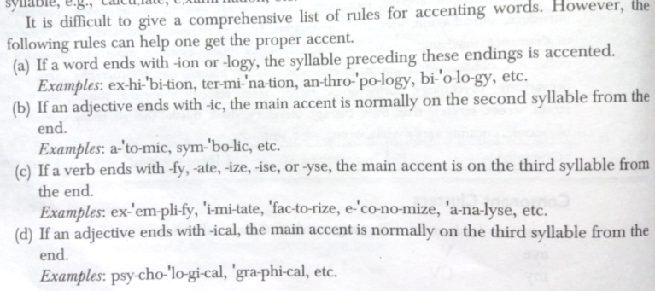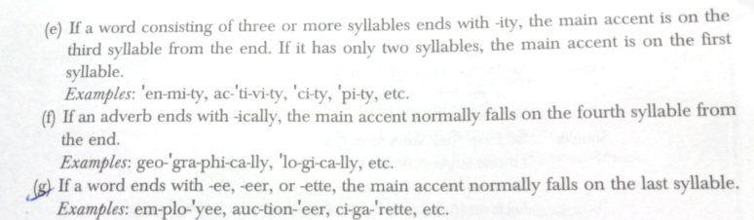

**Sentence Stress:**

In any sentence, some words carry a stress. These are the ‘strong’ or ‘lexical’ words (usually nouns, verbs, adjectives and adverbs). The remaining words are ‘grammatical’ words and are unstressed or ‘weak’ (conjunctions, pronouns, prepositions, auxiliaries, articles). In English sentences, each word does not have the same prominence and some words stand out from the rest due to stress or greater breath force. Just as in a single polysyllabic word, one syllable gets more stress than the others, in a sentence, one or two words get more emphasis than the others. The following are some sentences in which stressing on different words may intend different meanings.

* This is the latest book I have read
* The company produces ten thousand cars every day
* I want you to look into this matter
* I must start in ten minutes

**Rhythm:**

English is a rhythmic language, rhythm being a feature of the phonological structure of English. Rhythm generally refers to the timing pattern. There are two factors that influence the pattern of English – sentence stress and connected speech. Maintaining a rhythm in a speech makes the speech sound natural and fluent.

Words are of two types – content or lexical words and function or grammatical words. The content or lexical words carry meaning by themselves, whereas function or grammatical words do not have any significant meaning in themselves and depend on the content words to derive meaning. Content words that include nouns, verbs, adjectives and adverbs are strong words and carry stress in a sentence, while function words that include determiners, pronouns, prepositions, auxiliary verbs, and interrogatives are weak and unstressed words. The rhythm produced by the stressed and unstressed words in a sentence is a major characteristic of spoken English. Using only the strong forms (i.e. stressing all the words) in sentences may make a speech sound dull and artificial. Moreover, the listener may not understand the intended emphasis or meaning in the speech.

Speed is also a factor in fluency. When we speak quickly, we speak in groups of words which are continuous and may not have pauses between them. This causes changes to the ‘shape’ of words. Unstressed words always sound different when used in a sentence as opposed to being said in isolation.

The most common features of connected speech are the weak forms of grammatical and some lexical words (and, to, of, have, was, were) and contractions, some of which are acceptable in written English (can't, won't, didn't, I'll, he'd, they've, should’ve). However, we often ignore other features which preserve rhythm and make the language sound natural. The most common of these are:

* Elision (losing sounds as in the word ‘listen’)
* Linking (adding or joining sounds between words as in ‘far away’)
* Assimilation (changing sounds when two words are combined as in ‘good girl)

Added to these is the use of the *schwa*, the most common vowel sound in English. Many unstressed vowel sounds tend to become schwa, and because it is an important feature of weak forms, students should be able to recognize and produce it.

Parallel grammatical structure, placing important ideas in the beginning or at the end, using subordinating conjunctions for less important ideas, using appositive and absolute phrases to add details to the main idea – all these bring in rhythm to a speech.

**Rules of pronunciation:**

The production of individual sounds does not follow a strict pattern. It has to be learnt through intensive practice. However, the inflectional endings –s or –es and the past (tense) markers –d or –ed follow a regular pattern. Their pronunciation is guided by the following rules (excerpt from TB2):

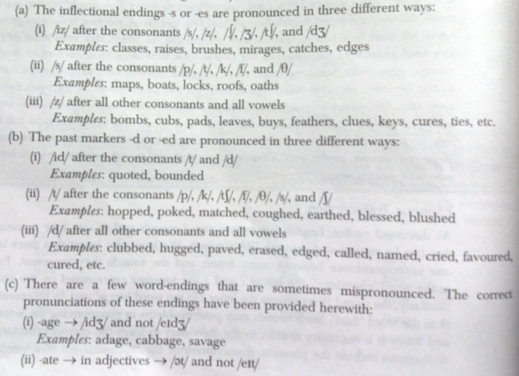

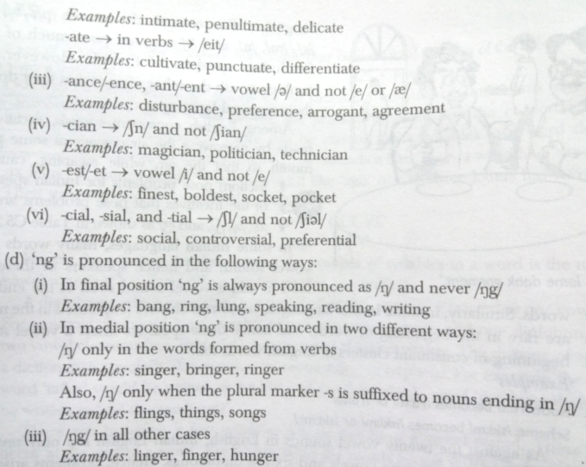

The students can strengthen their knowledge of the sounds of English by referring to links such as:

<http://www.antimoon.com/how/pronunc-soundsipa.htm>

<https://www.learnenglish.de/pronunciationpage.html>

<http://cambridgeenglishonline.com/>

# Session 24 – Common everyday situational conversations

Everybody has the power of transmitting thoughts in some way. An effective conversation is a mutual process, where the thoughts are transmitted not in isolation but in reaction to those that are received as well.

There are **six types of conversations**:

* Chat
* Tête-à-tête
* Dialogue
* Parley
* Colloquy
* Communion

**Strategies for effectiveness**:

Each type of conversation serves a specific well-defined purpose. Certain simple strategies can make conversations more interesting, inspiring and influential.

* Listening intently
* Starting and ending conversations
* Involving everyone in the group
* Arousing and sustaining interest
* Developing ideas adequately
* Using appropriate language

Faculty can show a video clip of a routine conversation in the office such as [this link](https://www.youtube.com/watch?v=2fA836LFytg) and have a class discussion on the strategies given above.

**Dialogue**:

A dialogue is a two-way conversation between people, thus involving listening as well as speaking. Aimed at understanding and responding to the other person’s opinions on a particular communication message, dialogues may involve opposing points of view. We may have to participate in or initiate such conversations and it is important to know how to construct appropriate dialogues. For our dialogues to be effective, we can observe how people talk to each other, what words or phrases they use to provide information, how they ask questions, and how they convince others. There are several occasions that require us to speak to another person for getting or giving information or for getting something done. The dialogues spoken on such occasions are called situational dialogues.

**Types of speaking**:

To grow in the academic or professional career, we must have the ability to carry out effective conversations. It should be convincing, supported with facts and examples and be able to create an impact. Different situations require different conversation strategies that help to achieve the purpose of the conversation. Three significant areas where the speaker could enhance their skills include: Confidence, Clarity and Fluency.

Based on the purposes, we can classify speaking into various types such as:

* Task-oriented speaking – The following are some of the situations that require task-oriented speaking:
  + Collecting data
  + Eliciting information
  + Addressing people to motivate or persuade them
  + Interviewing somebody
  + Enquiring about something
  + Negotiating a deal
* Inter-personal speaking – This is mostly relationship oriented. Conversations, counseling, group discussions, team communication, etc. may be grouped under this category. Inter-personal speaking helps us develop and sustain good relations and plays a vital role in the execution of group-oriented or team-oriented assignments.
* Semi-formal and informal speaking – While we may be effective in our formal speaking because we may plan and prepare for the same, we may not turn out to be that effective in our semi-formal speaking if we take it too lightly. After-dinner speeches, speaking during official picnics, speaking while inaugurating a function not connected with the workplace, etc. may come under semi-formal speaking.
* Extempore speaking

**Persuasive speaking**:

A speaker may need to persuade others for various purposes. These may be:

* To accept a new methodology developed by the speaker to solve a technical problem
* To agree with a speaker’s views on the topic
* To motivate to take immediate action on a certain matter

The following attributes can help in persuasive speaking:

* Credibility – Certain factors contribute to our credibility: intelligence, expertise, knowledge of the subject, sincerity, trustworthiness and concern for the audience
* Evidence – Supporting materials are important. These can be examples, statistics, definitions, testimonies, analogies, etc.
* Reasoning – We can reason by drawing an analogy or explaining the causes and effects. We can also reason from principle, i.e. from a general statement. As against reasoning from specific instances, this method of reasoning, moves from general to specific.
* Emotional appeal – The emotions that are generally evoked by most persuasive speakers are: fear, compassion, pride, anger, guilt and reverence. We may appeal to any of these emotions depending on the topic and the point we wish to make in our speech. We may also use vivid examples and speak with sincerity and conviction when we wish to make an emotional appeal.

**Telephonic conversation**:

In a telephonic conversation, the two parties cannot see each other’s facial expressions and other aspects of body language. This makes it all the more important to incorporate the correct tone and articulation in their voices so that the purpose of the phone call is achieved successfully. Some guidelines that can be followed are:

* Use polite expressions
* If you are the receiver, identify your name/the organization’s name as soon as your pick up the call
* Be clear and precise in your expressions and use a pleasant tone while speaking
* Do not interrupt the caller when he or she is speaking and listen carefully and get unfamiliar terms clarified
* Do not speak too quickly or too slowly. Use an appropriate rate of your voice
* Reduce the background noise (if any)
* If the call is not meant for you, try to guide the caller to the right person
* If you are the caller, ask the other person, “Is it a good time to talk to you?” or “Can I speak to you for five minutes?”
* Always keep a pen and notepad while taking calls
* Before you call up anybody, think what and how to discuss so that you stay focused on your objective
* Be enthusiastic and courteous
* Thank the caller before ending the call
* Do not slam the equipment when the call is ended. Place it softly

This session can end with a discussion on barriers to speaking (during a **conversation**). These could include physical barriers, language barriers, cultural barriers and psychological barriers to communication.

# Session 25 – Communication at Workplace – Formal and Informal

Class discussion can be focused on the below:

* Formal Communication Networks in Organizations
* Flow of Communication along formal Channels
  + Vertical Communication (Upward and Downward)
    - Advantages of Upward Communication
    - Disadvantages of Upward Communication
    - Advantages of Downward communication
    - Disadvantages of Downward communication
  + Horizontal Communication
    - Advantages of Horizontal Communication
    - Disadvantages of Horizontal Communication
  + Diagonal or Cross Channel Communication
    - Advantages of Diagonal Communication
    - Disadvantages of Diagonal Communication
* Informal Network of Communication (Grapevine)
  + Meaning and types of grapevine
    - Single strand
    - Gossip chain
    - Cluster
    - Probability
  + Advantages of grapevine
  + Effective use of grapevine by Managers

Messages flow into, through and out of business organizations in a variety of ways. Internal communication takes place between the people inside an organization whereas external communication refers to interaction with shareholders, regulators, customers and the general public. Every organization has a formal communication network in which ideas and information flow along the lines of command (the hierarchical levels) in the company’s organization structure. A formal communication network mirrors the company’s organization structure.

Throughout the **internal formal network**, information flows in the following directions.

Downward communication flows from executives to employees, conveying executive decisions and providing information that helps employees do their jobs. Downward communication refers to vertical communication in an organization that takes place downwards along the chain of command. It can be used for the transmission of plans and policies of the organization, mission and goals, delegation of responsibilities, instructions and advice to carry out a certain project or assignment. It can also be used to review performance and provide feedback, motivate employees, provide clarifications, address grievances, maintain discipline, increase efficiency and to develop good relations with employees.

Upward communication flows from employees to executives, providing insight into problems, trends, opportunities, grievances and performance – thus allowing executives to solve problems, make intelligent decisions and better policies to address grievances. Communication flows upward along the chain of command such as subordinates sending reports to inform their superiors or to present their findings and suggestions. Upward communication helps the organization understand how employees feel about their job, work environment, etc. The management can come to know whether the employees have understood and followed the directives and instructions issued to the employees. The extent of upward communication, especially that which is initiated from the lowest level will depend on the organizational culture. Upward communication brings harmony if it is prudently balanced with downward communication. Suggestion boxes, employee surveys, informal meetings, grievance procedures, etc. help to integrate upward communication into the work environment. It helps in motivating employees by making them feel that they are part of the decision making process at the organization.

Horizontal communication flows between departments and between hierarchically equivalent employees. Such communication is often necessary to facilitate coordination, save time, and bridge the communication gap among various departments. This type of communication is vital for the growth of an organization as it builds cooperation among the various branches. It plays a greater role in organizations where work is decentralized. Nevertheless, it can also create conflicts when formal vertical channels are bypassed by employees or when superiors find out that they had not been consulted before certain decisions were taken.

Diagonal (cross-wise) communication can flow in all directions and cuts across the various functions and levels in an organization. Thought this form of communication deviates from the normal chain of command, it is quick and efficient and helps to expedite action. It prevents other employees from being used merely as messengers between the actual sender and the receiver. For example a Managing Director could directly call an Assistant Manager and give instructions.

Formal flow of communication in an organization (diagram from TB2)

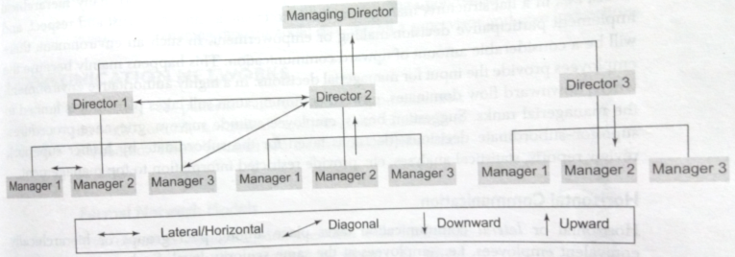

The following guidelines can be discussed in the context of internal and external communication in an organization.

* Organizing ideas and information logically and completely
* Expressing ideas and information coherently and persuasively
  + Give facts rather than vague impressions
  + Present information in a concise efficient manner
  + Clarify expectations and responsibilities
  + Offer compelling, persuasive arguments and recommendations
* Actively listening to others
* Communicating effectively with people from diverse backgrounds and experiences
* Following accepted standards of grammar, spelling and other aspects of good quality writing and speaking
* Using technological tools of communication efficiently and effectively
* Adapting your messages and communication styles to specific audiences and situations (audience-centered approach)
* Communicating in a manner that reflects business etiquette even when dealing with indifferent or hostile audiences
* Ensure giving and responding to feedback in a constructive manner. Constructive feedback focuses on the process and outcomes of communication and not on the people involved
* Communicating ethically even when choices are difficult
* Managing time wisely and using resources efficiently
* Guarding against information overload and against information addiction

**Informal communication** is communication arising from channels outside formal channels and does not follow lines of authority. Informal communication is built around social relationships of members in an organization. It is difficult to fix responsibility about accuracy of information within informal communication channels.

Grapevine is the informal and unsanctioned information network within every organization. The network helps employees make sense of the world around them and consequently provides a release from emotional stress. Informal information is undocumented. Since it is unstructured and not under the complete control of management, it moves through the organization in every direction. It moves upwards, downward, and diagonally, within and outside chains of command, between various levels of hierarchy.

The patterns that emerge during the transmission of messages through grapevine are:

* Single strand
* Gossip chain
* Cluster
* Probability

Informal network models (diagram from TB2)

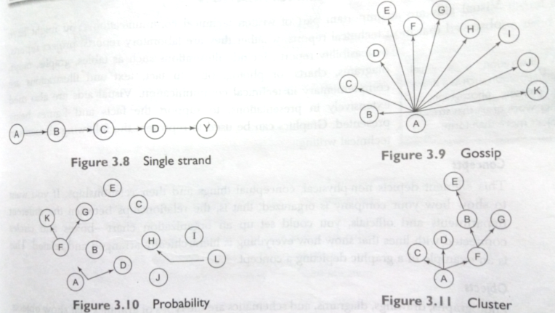

The aspects of grapevine that can help the organization supplement formal communication can be discussed, such as ability to identify rumors and information void and responding accordingly.

The management can identify the group leaders and active people on the grapevine and keep them well informed so that harmful rumors are stopped before they spread. Employees’ participation in decision making can be acquired through the implementation of ideas and suggestions that travel through grapevine. The management can obtain feedback through internal communication about the functioning of the organization and can take effective steps to improve the same. If the management is not able to pass on sensitive information through formal channels then they can use grapevine for this purpose. It can supplement formal channels and if properly cultivated, helps in dealing with the problems that require crossing the boundaries between departments. As messages travel through the grapevine, the language used in the formal channels gets translated into terminology that makes complete sense to the employees. Thus it helps to interpret the information given by the management which is an important aspect of organizational communication. With the help of grapevine, the management can take timely and effective action and solve conflicts as well as address problems before they grow out of proportion.

# Session 26 – Organizational Barriers to Communication

Organizations, irrespective of size, have communication policies and communication techniques and each organization nurtures its own communication climate. In large organizations where the flow of information is mostly downward, feedback is not guaranteed. All organizations have communication policies which describe the protocol to be followed. It is the structure and complexity of this protocol that usually causes barriers to communication.

Regardless of the particular structure a company uses (tall or flat or others), communication efforts will be influenced by the organization’s corporate culture, the mixture of values, traditions and habits that give a company its atmosphere and personality. Successful organizations encourage employee contribution by ensuring that communication flows freely up, down and across the organization chart. Open culture encourage candor and honesty, and allow employees to bring forth their inputs and suggestions and even share negative or unwelcome information.

The main organizational barriers to communication are:

* Too many transfer stations
* Fear of superiors
* Negative tendencies (both traditional and innovative company structures can rely heavily on teamwork and effective communication is essential to meet the objectives of the team channelized towards the goals of the organization)
* Lack of trust in the source of communication
* Use of inappropriate media
* Information overload
* Filtering and distortion

Today’s businesses increasingly reach across international borders to market their products, partner with other businesses and employ workers and executives – an effort known as globalization. As people and products cross borders, organizations are paying more attention to workforce diversity. Successful organizations realize that a diverse workforce can yield a significant competitive advantage by bringing new ideas and new communication skills. However, the more diverse their workforce, the more attention must be paid to communication. In this context, **cultural barriers to communication** (such as stereotyping, attitude towards work, attitude towards personal disclosure, communication style, decision making style, non-verbal aspects of a particular culture, etc.) could also be discussed under the same umbrella.

# Session 27 – Interviews – preparation; and effective communication before, during and after an interview (including telephonic interviews)

Depending on the objective and nature, interviews can be categorized into the following types:

* Job
* Information
* Persuasive
* Conflict resolution
* Disciplinary
* Evaluation
* Counselling
* Termination
* Exit
* Media

Interviews can even be classified as structured and unstructured interviews, panel and group interviews, behavioral, situational, working and stress interviews.

Job interviews can be classified into:

* Campus interviews
* On-site interviews
* Telephonic interviews
* Video-conferencing interviews

An employment interview is a formal meeting during which you and a prospective employer ask questions and exchange information. These meetings have a dual purpose:

1. The organization’s main objective is to find the best person available for the job.
2. Your main objective is to find the job best suited to your goals and capabilities.

The typical sequence of interviews:

* Screening stage
* Selection stage
* Final stage (the objective of this stage is to sell you on the advantages of joining the organization)

**Preparation and effective communication before, during and after an interview**

**I. Before the interview:**

The key to success in an interview is not one’s experience, grades, extracurricular activities, but one’s attitude. To rise above others with better experience, grades, or skills, a highly positive work attitude is needed. The way most employers distinguish among candidates at the entry level is by the candidates’ attitude towards work. The below are some key aspects of preparing for interviews:

* Preparation of resume – The purpose of a resume is to kindle employer interest and generate an interview. The resume needs to be professional and suitably modified as per the requirements of the job and the organization. For every item on the resume, prepare a paragraph worth of information in addition to what is already written on the resume. You could even think of a way in which your strengths and weaknesses are illustrated through the resume. A few guidelines to be kept in mind are:
  + Keep your resume honest
  + Adapt your resume to your audience
  + Write your resume using a simple and direct style and focus on what your reader needs to know
  + Provide the following details:
    - Name and contact information
    - Career objective
    - Qualification summary
    - Career summary
    - Education (present your education background in depth, choosing facts that support your theme)
    - Work experience, skills and accomplishments (be sure to relate them to the needs of potential employers)
    - Include activities and achievements outside of a work context only if they make you a more attractive job candidate.
    - Personal data can be included if there is a specific reason to do so.
    - (Be sure to have a list of several references ready when you begin applying for jobs as you will be asked for it at some point in the selection process. Prepare a list of references using the same design and layout as your resume.)
* Personal attributes – One needs to analyze one’s hard and soft skills, strengths, weaknesses, attitudes, likes and dislikes. Knowing oneself and introspecting one’s qualities and skills is an important step as the common interview question of strengths and weaknesses can be addressed confidently
* Mock interview – A mock interview is an opportunity to practice interviewing technique and answers live. It is also a chance to hear constructive feedback from someone who can guide towards improving the style and presentation during the real interview.
* Knowing the prospective employer – One needs to know the company (size of organization, provision for career growth, competitors, growth pattern, etc.) that one has applied for and information can be collected through the company website, annual report, articles in newspapers, personal contacts in the company (if any), etc.
* Awareness of job description: One needs to acquire a clear idea of the subject knowledge and skills that the job requires and the knowledge of the type of activities one will be required to do. This exercise will enable one to match the requirements with what you have in hand. The job description also gives an idea of the subjects one needs to refresh knowledge about. Knowing the main subjects well before an interview gives one immense confidence as interviewers generally ask basic questions about the subject.
* Other skills: Besides testing the technical skills, interviewers may also asses team skills, decision making ability, leadership skills, problem solving skills, etc. A person preparing for the interview can pick at least four or five examples that show the above mentioned skills and prepare the narration using the STAR (Situation Task Action Result) approach.
* Appropriate dressing and Punctuality
* Questioning the employer: Interviewers expect you to come in with a working knowledge of the company as well as a list of questions. One can base these questions on the job being applied for and one’s prospects in that job.
* Knowing the possible kind of interview questions
  + Open-ended
  + Close-ended
  + Experience questions
  + Credential questions
  + Opinion questions
  + Questions requiring innovative answers
  + Behavioral questions
  + Tough questions – one can also anticipate and give a little extra thought to questions such as
    - What is the hardest decision you’ve ever had to make?
    - What are your greatest weaknesses?
    - What didn’t you like about previous jobs you’ve held?
    - Where do you want to be five years from now?

**II. During the interview:**

The three stages of an interview:

* The warm-up: The warm-up is the most important stage even though it may account for only a small fraction of the time you spend in the interview. Studies suggest that many interviewers, especially those who are poorly trained in interviewing techniques, make up their minds within the first 20 seconds of contact with a candidate. Thus, even what seems like small talk is every bit as important as structured questions. Body language (posture, firm handshake, natural eye contact, etc.) is crucial at this point. Common openers include
  + Why do you want to work here?
  + What do you know about us?
  + Tell me a little about yourself

You could also face substantial questions as soon as the interview starts. So make sure you are prepared and ready to go.

* The question and answer stage: The interviewer will ask you about your qualifications and discuss many of the points mentioned in your resume.
  + Dealing with questions – Let the interviewer lead the conversation and never answer a question before he or she has finished asking it. Think through the implication of the question and tailor your answers to emphasize your strengths.
  + Listening to the interviewer – Paying attention to both verbal and non verbal messages of the interviewer can help you turn the question and answer stage to your advantage.
  + Handling discriminatory questions – Well trained interviewers are aware of questions they shouldn’t ask. However, if your interviewer asks personal questions you might ask how the question is related to your qualification, explain that the information is personal and respond to what you think is the interviewer’s real concern.
* The close: Like the warm up, the end of the interview is more important than its brief duration would indicate.
  + Concluding gracefully – Watch and listen to signs that the interview is about to end. Quickly evaluate how well you have done and correct any misconception the interviewer might have. Conclude an interview with courtesy and enthusiasm.
  + Discussing salary – If you receive an offer during an interview, you will naturally want to discuss salary. However, let the interviewer raise the subject. If you are asked your salary requirements during the interview or on a job application, you can say that your salary requirements are open or negotiable or you would expect a competitive compensation package.

Keeping a notebook or simple database of interview notes in an organized manner will help you compare companies and opportunities and will also help you improve your performance in future. As soon as you leave the interview facility, jot down the names and titles of the people you met. Briefly summarize the interviewer’s answers to your questions. In addition to improving your performance during interviews, interview notes help you keep track of any follow up messages you need to send.

**III. After the interview:**

Staying in contact with a prospective employer after an interview shows that you really want the job and are determined to get it. Doing so also gives you another chance to demonstrate your communication skills and sense of business etiquette.

* Thank you message – The thank you message gives you the opportunity to reinforce the reasons that you are a good choice for the position and it lets you respond to any negatives that might have arisen in the interview. Keep your message brief and organize it like a routine message, demonstrating the you attitude and sounding positive.
* Message of inquiry – This is particularly appropriate if you have received a job offer from a second firm and don’t want to accept it before you have an answer from the first.
* Request for a time extension – If you receive a job offer while other interviews are still pending, you can ask the employer for a time extension. Open with a strong statement of your continued interest in the job, ask for more time to consider the offer, provide specific reasons for the request and assure the reader that you will respond by a specific date.
* Letter of acceptance – When you receive a job offer that you want to accept, reply within five days. Begin by accepting the position and expressing thanks. Identify the job that you are accepting and in the next paragraph, cover any necessary details. Conclude by saying that you look forward to reporting for work.
* Letter declining a job offer – Open warmly, state the reasons for refusing the offer, decline the offer explicitly and close on a pleasant note expressing gratitude.

**Telephonic interviews:**

Telephonic interviews are often not taken as seriously as a face to face interview. However, this first conversation can leave a lasting impression, due to which it is essential to give equal importance to both telephonic interviews and face to face interviews. There are three types of telephonic interviews:

1. You initiate a call to the hiring manager and he/she expresses interest in your background. The call from that point is an interview.
2. A company calls you based on a previous contact. You are likely to be unprepared for the call, but it is still an interview.
3. You have a pre-set time with a company representative to speak further on phone.

One can prepare for the first and third type of interview call mentioned above. In these cases, you will have prior information regarding the date and time and possibly the duration as well of your telephonic interview. The following points will help you be prepared for the call:

* Keep all your documents within easy reach of the phone so that you can refer to them. In this respect, you have a major advantage in a telephonic interview that does not exist in a face to face interview.
* Have a note pad and pen ready to take notes
* Keep a mirror nearby. Look into that mirror consistently throughout the phone call and smile. You will improve your telephonic presence by using this simple technique.
* Always stand up when you are talking with a potential employer on the phone. It gets your blood flowing, improves your posture and improves your response time.
* Try to closely match your speaking rate and pitch with that of the interviewer’s.
* Place a ‘Do not disturb’ note on your door.
* Turn off your stereo, television and any other potential distraction.
* Warm up your voice while waiting for the call. Sing an uplifting song to yourself.
* Have a glass of water handy, since you will not have a chance to take a break during the call.

The telephonic interview comes to an end when you are asked whether you have any questions. Ask questions that will improve your understanding of the job requirements. You could also enquire about the projects you would be likely working on in the first six months. Once the details are confirmed, finish with a request: “If I need any additional information, can I get back to you?” The company representative would give you the required information. However, one should not take advantage of this and call too often. Instead, one well-placed phone call that contains two or three well considered questions will be appreciated.

Faculty can play audio or video clips of mock interviews and follow it up with a class discussion. For instance, refer this [link for a mock interview](https://www.youtube.com/watch?v=9n4DlB2MHWI).

# Session 28 – Formal Presentations

**A. Planning the presentation:**

* Analyze the situation: As with written communication, analyzing the situation for an oral presentation involves defining your purpose and developing an audience profile. The purpose of most business presentations is to inform or persuade. You may also give presentations designed primarily to collaborate with others. Knowing your audience’s state of mind will help you adjust both the message and the delivery. You could study the audience by determining audience size and composition, predicting the audience’s possible reaction and by gauging the audience’s level of understanding.
* Gather information:
* Select the right medium: The task of selecting the right medium can also be based on the audience analysis. For example, a live presentation with a question and answer session for the on-site audience can be conducted and a video archive of this presentation can be posted on your website for audience members in other time zones.
* Organize the information: Organizing a presentation involves the following tasks:
  + Defining the main idea
  + Limiting the scope
  + Choosing the approach
  + Preparing the outline:
    - * State your purpose and main idea
      * Organize your major points and sub-points
      * Identify the introduction, body and close
      * Plan the transitions
      * Prepare your bibliography and be prepared to mention key sources during the presentation
      * Choose a title for the presentation that will set audience member’s expectations, so make it compelling and audience-centered
  + Speaking outline:
    - * Follow the planning outline
      * Condense points and transitions to key words that will prompt your to remember what each point is about so that you speak fluently
      * Add delivery cues – note the places in your outline where you plan to pause for emphasis, speak more slowly, use a visual and so on
      * Arrange your notes – keep them legible and numbered

**B. Composing the presentation:**

Presentations consist of three distinct elements, the introduction, the body and the close:

Introduction:

* Arousing audience interest
  + Unite the audience around a common goal
  + Tell a story that illustrates an important and relevant point
  + Pass around an example
  + Ask a question that will get the audience actively involved
  + Share a startling statistic that will grab the attention of the audience
  + Use humor but in a relevant appropriate and non-offensive manner
* Building your credibility – If you will be introducing yourself, keep your comments simple. At the same time, don’t be afraid to mention your accomplishments. Your listeners will be curious about your qualifications, so tell them briefly who you are and why you are the right person to be giving this presentation.
* Previewing your message – Your preview should summarize the main idea of your presentation, identify major supporting points, and indicate the order in which you will develop those points.

Body:

* Connecting your ideas – Use transitions to repeat key ideas and help the audience follow along, particularly in longer presentations. Every time you shift topics, be sure to stress the connection between ideas. Summarize what’s been said and then preview what’s to come.
* Holding your audience’s attention –
  + Relate your subject to your audience’s needs
  + Anticipate the audience’s questions
  + Use clear vivid language
  + Show how your subject is related to ideas that audience members already understand and give them a way to categorize and remember your points
  + Ask for opinions or pause occasionally for questions or comments
  + Illustrate your ideas with visuals

Close:

* Restate your main points
* Describe next steps – some presentations require audience to reach a decision or agree to take specific action, in which case the close offers an opportunity to verify these steps
* End on a strong note – let the purpose and main idea drive the content and emotional tone of your final statement

Planning the presentation visuals:

* Selecting the type
  + Electronic slides
  + Overhead transparencies
  + Chalk boards and White boards
  + Flipcharts
  + Other visuals
* Creating effective slides
  + Develop the message and text for each slide first and then move on to graphics and special effects
  + Creating effective slides requires both rational and creative instincts
  + Structured slides are usually based on templates that give all the slides in a presentation the same general look; free form slides typically don’t follow any set design plan. Structured slides are usually the best choice for project updates and other routine information presentations, particularly if the slides are intended to be used only once. Freeform slides often have far less content per slide.
  + Limit each slide to one thought, concept or idea
  + Limit text content to four or five lines with four or five words per line. For selected slides it might make sense to exceed these limits, but do so infrequently
  + Write short bulleted phrases rather than long sentences
  + Use the active voice
  + Use words and phrases that help your viewer to process the information you are conveying
  + Many graphics that work quite well in printed form need to be simplified for use in presentations because they are too dense and too complicated to be easily viewed on the screen. One should:
    - * Reduce the detail
      * Simplify
      * Round off numbers where required
      * Limit the amount of data shown
      * Highlight key points
      * Adjust the size of the graphic
  + To design effective slides one needs to consider six principles: consistency, contrast, balance, emphasis, convention and simplicity
  + The color chosen should provide emphasis on important ideas, isolate slide elements, and create contrast. It can also increase readability and retention and can stimulate desired emotional responses.
  + The background should not compete with the foreground and one may also add company logo, the date, the presentation title, and a running slide number to help both the presenter and the audience to follow along.
  + Be consistent with fonts, type styles, colors and sizes. Limit the number of fonts to one or two per slide (if two fonts are used, use one for headings and the other for slide text)
  + Today’s presentation software offers a wide array of options for livening up your slides, including sound, animation, video clips, transition effects from one slide to the next, hyperlinks to websites etc. However, you should always consider the impact that these effects will have on the audience and use only those effects that support the message.
  + Review each slide carefully to make sure it is clear, readable, consistent, simple, audience-centered, concise and grammatical, focused and fully operational. Use the slide sorter view to verify and modify the organization of the slides.

The following questions would help you prepare for the presentation:

* Can you present your material naturally, without reading your slides word for word?
* Is the equipment working and do you know how to operate it?
* Is your timing on track?
* Can you easily pronounce all the words you plan to use?
* Have you decided how you are going to introduce the slides?
* Have you anticipated likely questions and objections?
* Does your message come through clearly?

**C. Completing the presentation:**

Mastering the art of delivery:

A variety of delivery methods are available, some of them are easier to handle than others:

* Memorizing
* Reading
* Speaking from notes
* Impromptu speaking

Regardless of which delivery mode you use, be sure that you are thoroughly familiar with your subject. This is the best way to build self-confidence. Schedule plenty of practice time when you are developing a presentation as practice is the key to the success of a presenter. If possible, record your speech to check the sound of your voice as well as your timing, phrasing and emphasis. If you have the equipment, you could also rehearse on video to see yourself as your audience would. If possible, visit the speaking venue ahead of time to familiarize yourself with the facilities and the equipment.

When you deliver an oral presentation to people from other cultures, you may need to adapt the content of your presentation. It is also important to take into account any cultural preferences for appearance, mannerisms and other cultures.

Handling questions responsively:

The question and answer period is often one of the most important parts of an oral presentation. Anticipate questions you are likely to get and think through the answers you want to give. Six steps you can take to handle questions during a presentation are given below:

* Focusing on the questioner – When someone poses a question, focus your attention on that individual, paying attention to the questioner’s body language and facial expression to help determine what he or she really means. If you are not sure, you can ask the questioner to clarify exactly what he or she would like to know.
* Responding appropriately – If you don’t know the answer, don’t pretend that you do. Instead, say something like, “I don’t have those figures. I’ll get them for you as quickly as possible.” In some cases, you won’t have time to answer every question that is asked: if possible, arrange other means to give people the information they need.
* Maintaining control – You can help maintain control during this period by establishing some ground rules upfront like announcing a time limit or a question limit per person. Engaging as many people as possible is particularly important, especially during online presentations because it is easy to feel excluded as a remote member of the audience.
* Responding honestly and directly to all questions – Divide complicated questions into parts that you can answer simply. State your response accurately and factually and then move on to the next question. Maintain a business-like tone of voice and a pleasant expression even if you face hostile questions.
* Encouraging questions – A situation in which listeners are quiet can be just as uncomfortable as having a noisy, hostile audience. You could ask a question yourself, beginning with “Would you like to know more about…?” or even tell the audience that you would be around afterward to talk.
* Concluding the presentation – When the time allotted for the presentation is up, signal a halt to the question and answer session. Conclude the presentation in a strong confident manner and thank people for their attention.

Using non-verbal communication effectively in presentations:

Non-verbal communication is the inter-personal process of sending and receiving information, both intentionally and unintentionally, without using written or spoken language. Non-verbal signals play a vital role in communication because they can strengthen a verbal message (when they match the spoken words), weaken a verbal message (when they don’t match the words), or replace words entirely. Non-verbal communication skills play a vital role in formal presentations. Paying attention to non-verbal cues will make you both a better speaker and a better listener and will enhance your ability to communicate successfully. However, as you interact with business associates from other backgrounds, you will discover that some non-verbal signals don’t necessarily translate across cultures. The range and variety of non-verbal signals are almost endless, but you can grasp the basics under the below general categories:

* Personal appearance
* Facial expression
* Gesture and posture
* Vocal characteristics
* Time and space

Strategies for reducing stage fright:

* Strategies in advance of the presentation
  + Develop an interest in the topic of your presentation
  + Reserve adequate time for preparation
  + Anticipate easy as well as hard questions and try to work out your answers
  + Practice your opening statement several times
  + Rehearse your entire presentation at least twice
* Strategies just before the presentation
  + Arrive early, check the arrangements, equipment and your PowerPoint slides
  + Concentrate on your ideas
  + Relax yourself by taking deep, even and slow breaths
  + Take a few sips of water
  + Greet some participants and talk to them to help voice flow freely
* Strategies when the presentation begins
  + Feel good about the presentation and walk up to the dias taking a few deep breaths
  + Do not begin immediately or in a hurry. First look at the friendliest faces among the audience and smile
  + Remember that the audience may not realize your nervousness as much as you feel it
  + Never comment on your nervousness during the presentation
  + Do not show explicit signals of nervousness such as clearing throat, drinking full glass of water, wiping forehead, etc.